Grade 6
Unit 5Lesson 12CC BY NC Illustrative Mathematics, based on IM 6–8 Math, CC BY Open Up Resources.
Unit 5, Lesson 12

Dividing Numbers that Result in a Decimal
Let’s find quotients that are not whole numbers.
Grade 6
Unit 5Lesson 12CC BY NC Illustrative Mathematics, based on IM 6–8 Math, CC BY Open Up Resources.

12.1Math Talk: Dividing by 4
Find the value of each quotient mentally.
- $80÷4$
- $12÷4$
- $1.2÷4$
- $81.2÷4$
Grade 6
Unit 5Lesson 12CC BY NC Illustrative Mathematics, based on IM 6–8 Math, CC BY Open Up Resources.

12.2Whole Numbers No More
Here is how Lin calculated $62÷5$.
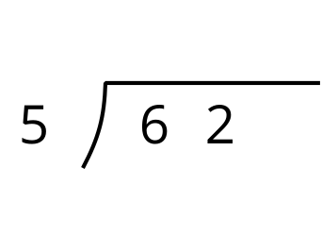
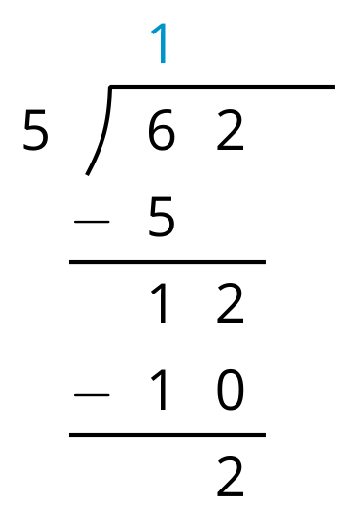
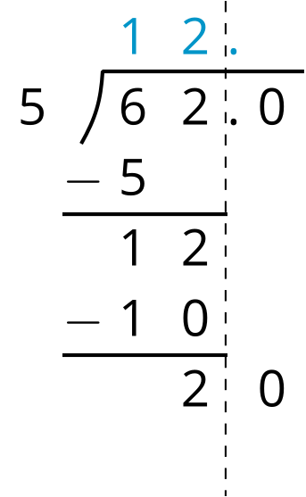
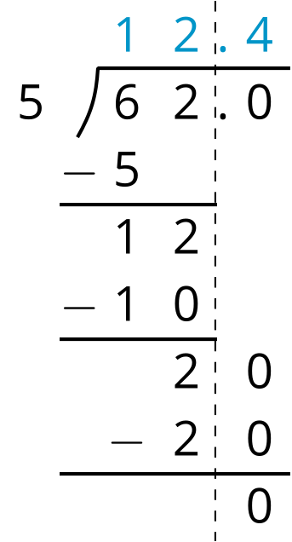
- Discuss with your partner:
  - In the third step, Lin drew a vertical dashed line to the right of the 2 in 62. What do you think that line is for?
  - She also wrote a point and a 0 to the right of 62. Then she put a 0 after the remainder of 2. What do you think the zeros are for?
  - Lin subtracted 5 groups of 4 from 20. What value does the 4 in the quotient represent?
  - What value did Lin find for $62÷5$?
- Use long division to find the value of each expression. Then pause so your teacher can review your work.
  - $126÷8$
  - $90÷12$
- Use long division to show that:
- $5÷4$, or $\frac{5}{4}$, is 1.25.
- $4÷5$, or $\frac{4}{5}$, is 0.8.
- $1÷8$, or $\frac{1}{8}$, is 0.125.

Are you ready for more?
Noah said we cannot use long division to calculate $10÷3$ because there will always be a remainder.
- What do you think Noah meant by “there will always be a remainder”? Explain your reasoning.
- What do you think is the value of $10÷3$?
Grade 6
Unit 5Lesson 12CC BY NC Illustrative Mathematics, based on IM 6–8 Math, CC BY Open Up Resources.

12.3Using Long Division to Divide Decimals
Use long division to answer each question.
- What is the value of $53.8÷4$?
- Five students raised $77.40 for a charity. If everyone raised the same amount, how much money did each student raise?

Lesson 12 Summary
We can use long division to find quotients even when the numbers involved are not whole numbers. Here is the long-division calculation of $86÷4$, which results in a decimal quotient.
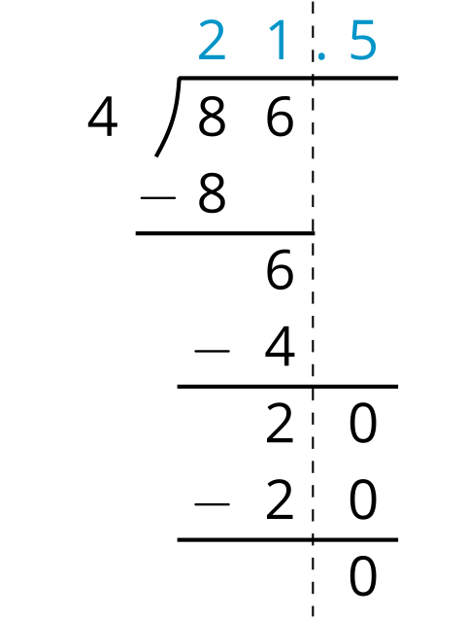
The calculation shows that, after removing 4 groups of 21, there are 2 ones remaining. We can continue dividing by writing a 0 to the right of the 2 and thinking of that remainder as 20 tenths, which can then be divided into 4 groups.
To show that the quotient we are working with now is in the tenths place, we put a decimal point to the right of the 1 (which is in the ones place) at the top. It may also be helpful to draw a vertical line to separate the ones and the tenths.
There are 4 groups of 5 tenths in 20 tenths, so we write 5 in the tenths place at the top. The calculation likewise shows $86÷4=21.5$.

