Grade 2
Unit 5Lesson 7CC BY NC 2024 Illustrative Mathematics®
Unit 5, Lesson 7

Center Day 1
- Let’s use place value to identify numbers and practice adding and subtracting.
Grade 2
Unit 5Lesson 7CC BY NC 2024 Illustrative Mathematics®

Warm-up True or False: Compare to 100
Decide if each statement is true or false. Be prepared to explain your reasoning.
- $100>99$
- $100<99+1$
- $98+3>100$
- $50+50+50>100$
Grade 2
Unit 5Lesson 7CC BY NC 2024 Illustrative Mathematics®

Activity 2Centers: Choice Time
Choose a center.
Jump the Line
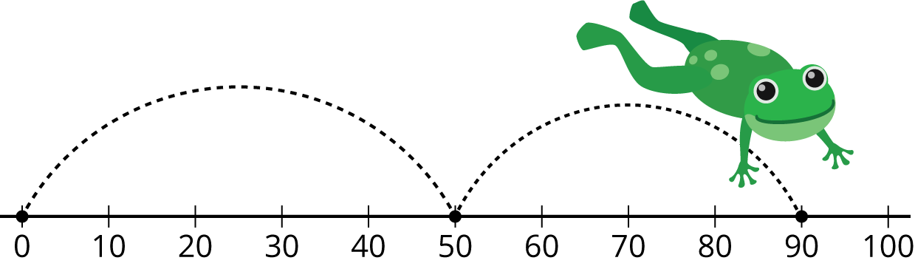
Mystery Number
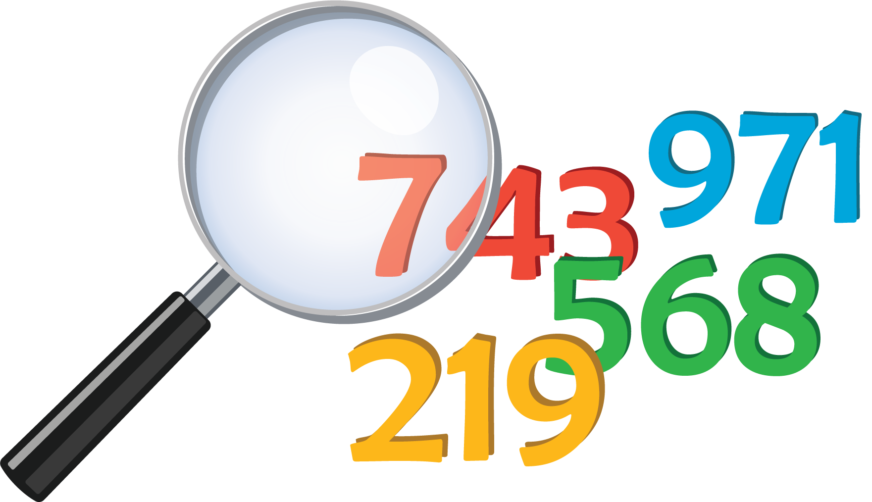
Number Puzzles
