Grade 2
Unit 8Lesson 4CC BY NC 2024 Illustrative Mathematics®
Unit 8, Lesson 4

Decompose Even and Odd Numbers
- Let’s represent even and odd numbers.
Grade 2
Unit 8Lesson 4CC BY NC 2024 Illustrative Mathematics®

Warm-up Number Talk: Equal Addends
Find the value of each expression mentally.
- $6+6$
- $7+7$
- $7+8$
- $8+9$
Grade 2
Unit 8Lesson 4CC BY NC 2024 Illustrative Mathematics®

Activity 1 Share in Different Ways
- Kiran has 12 stickers. He wants to give them all to 2 friends. Show different ways Kiran can share the stickers.
  - Can both friends get the same number of stickers?
  - $12=\underset{_}{}+\underset{_}{}$
  - Can both friends get an even number of stickers?
  - $12=\underset{_}{}+\underset{_}{}$
  - Can both friends get an odd number of stickers?
  - $12=\underset{_}{}+\underset{_}{}$
  - Can 1 friend get an even number of stickers and the other get an odd number?
  - $12=\underset{_}{}+\underset{_}{}$
- Lin has 14 stickers. She wants to give them all to 2 friends.
  - Can both friends get the same number of stickers?
  - $14=\underset{_}{}+\underset{_}{}$
  - Can both friends get an even number of stickers?
  - $14=\underset{_}{}+\underset{_}{}$
  - Can both friends get an odd number of stickers?
  - $14=\underset{_}{}+\underset{_}{}$
  - Can 1 friend get an even number of stickers and the other get an odd number?
  - $14=\underset{_}{}+\underset{_}{}$
- Noah has 15 stickers. He wants to give them all to 2 friends.
  - Can both friends get the same number of stickers?
  - $15=\underset{_}{}+\underset{_}{}$
  - Can both friends get an even number of stickers?
  - $15=\underset{_}{}+\underset{_}{}$
  - Can both friends get an odd number of stickers?
  - $15=\underset{_}{}+\underset{_}{}$
  - Can 1 friend get an even number of stickers and the other get an odd number?
  - $15=\underset{_}{}+\underset{_}{}$
Grade 2
Unit 8Lesson 4CC BY NC 2024 Illustrative Mathematics®

Activity 2 Represent Numbers with 2 Addends
- Pick a number between 0 and 20.
- Tell if your number is even or odd.
- Complete the equation. Show your number as the sum of 2 equal addends. If you can’t, use 2 addends that are as close as possible.
- Repeat for all the numbers 0 to 20.
even
odd
$\underset{_}{}=\underset{_}{}+\underset{_}{}$
$\underset{_}{}=\underset{_}{}+\underset{_}{}$
$\underset{_}{}=\underset{_}{}+\underset{_}{}$
$\underset{_}{}=\underset{_}{}+\underset{_}{}$
$\underset{_}{}=\underset{_}{}+\underset{_}{}$
$\underset{_}{}=\underset{_}{}+\underset{_}{}$
$\underset{_}{}=\underset{_}{}+\underset{_}{}$
$\underset{_}{}=\underset{_}{}+\underset{_}{}$
$\underset{_}{}=\underset{_}{}+\underset{_}{}$
$\underset{_}{}=\underset{_}{}+\underset{_}{}$
$\underset{_}{}=\underset{_}{}+\underset{_}{}$
$\underset{_}{}=\underset{_}{}+\underset{_}{}$
$\underset{_}{}=\underset{_}{}+\underset{_}{}$
$\underset{_}{}=\underset{_}{}+\underset{_}{}$
$\underset{_}{}=\underset{_}{}+\underset{_}{}$
$\underset{_}{}=\underset{_}{}+\underset{_}{}$
$\underset{_}{}=\underset{_}{}+\underset{_}{}$
$\underset{_}{}=\underset{_}{}+\underset{_}{}$
$\underset{_}{}=\underset{_}{}+\underset{_}{}$
$\underset{_}{}=\underset{_}{}+\underset{_}{}$

Section A Summary
We learned that groups of objects have either an even number or an odd number of items.
- An even number of objects can be split into 2 equal-size groups or into groups of 2 with no objects left over.
- An odd number of objects always has 1 object left over when you try to make 2 equal-size groups or groups of 2.
We also represented even numbers as equations with 2 equal addends.
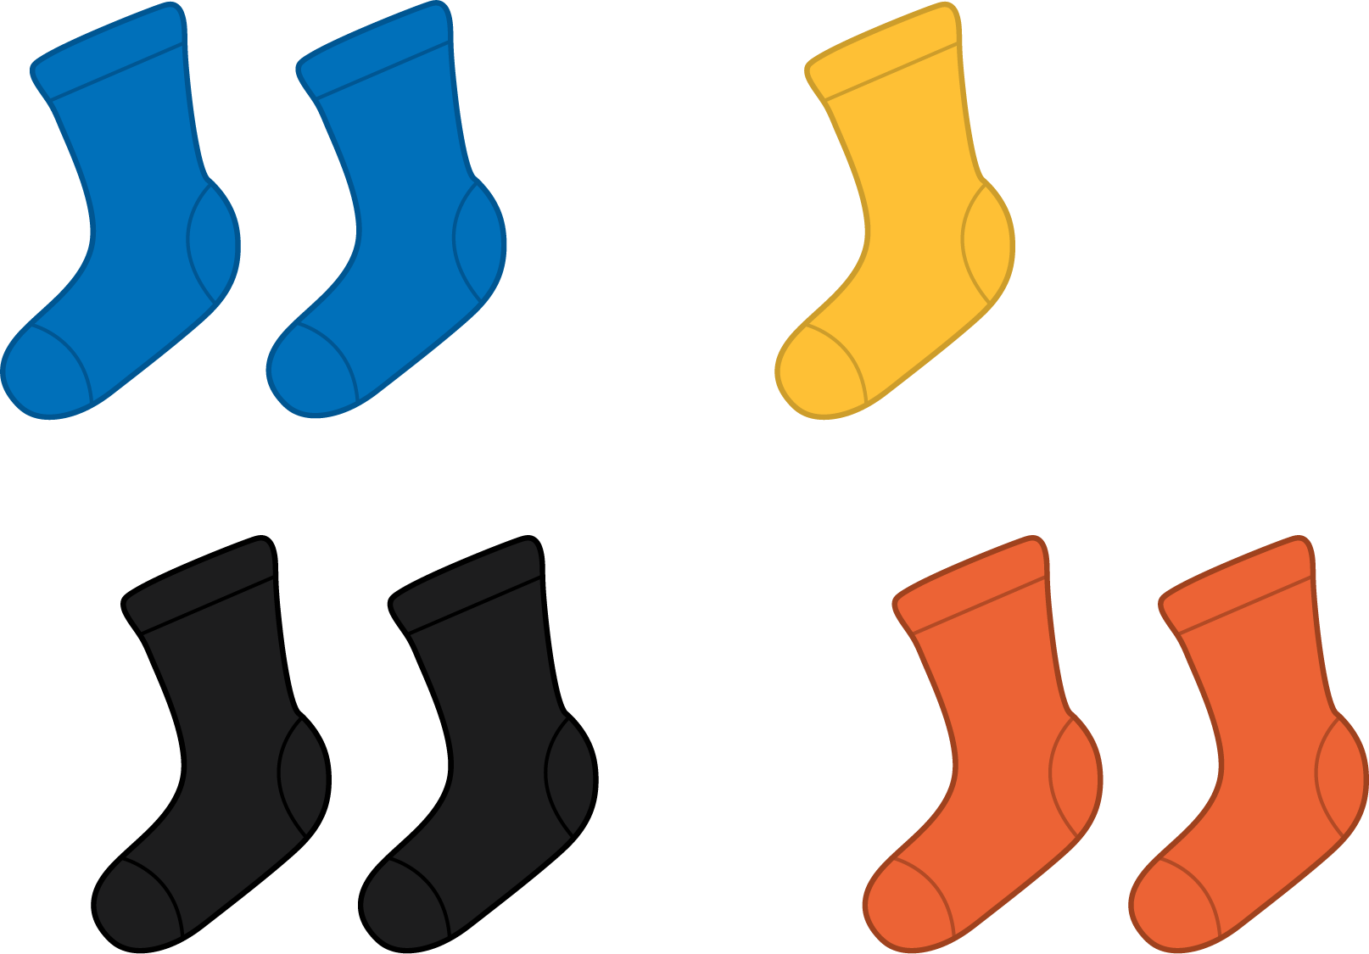
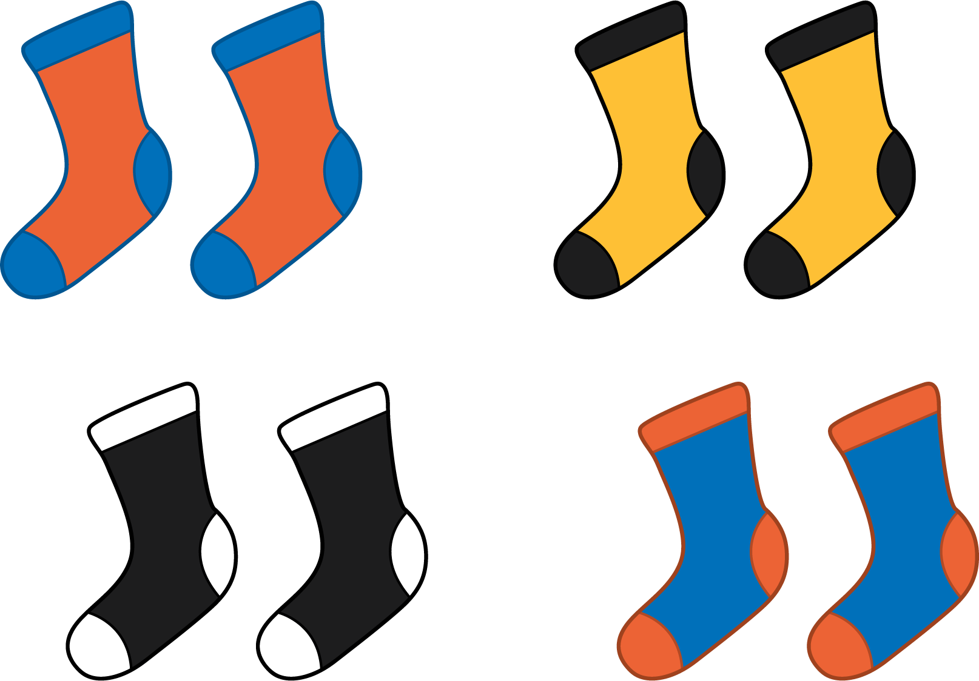
Odd
$3+3+1=7$
Even
$4+4=8$

