Grade 6
Unit 4Lesson 11CC BY NC Illustrative Mathematics, based on IM 6–8 Math, CC BY Open Up Resources.
Unit 4, Lesson 11

Using an Algorithm to Divide Fractions
Let’s divide fractions using the rule we learned.
Grade 6
Unit 4Lesson 11CC BY NC Illustrative Mathematics, based on IM 6–8 Math, CC BY Open Up Resources.

11.1Math Talk: Multiplying Fractions
Find the value of each product mentally.
- $\frac{1}{8}⋅8$
- $\frac{1}{8}⋅\frac{8}{3}$
- $\frac{9}{8}⋅\frac{4}{3}$
- $1\frac{1}{8}⋅\frac{4}{9}$
Grade 6
Unit 4Lesson 11CC BY NC Illustrative Mathematics, based on IM 6–8 Math, CC BY Open Up Resources.

11.2Dividing a Fraction by a Fraction
Work with a partner. One person works on the questions labeled “Partner A” and the other person works on those labeled “Partner B.”
- Partner A: Find the value of each expression by completing the diagram.
  - $\frac{3}{4}÷\frac{1}{8}$
  - How many $\frac{1}{8}$s are in $\frac{3}{4}$?
  - 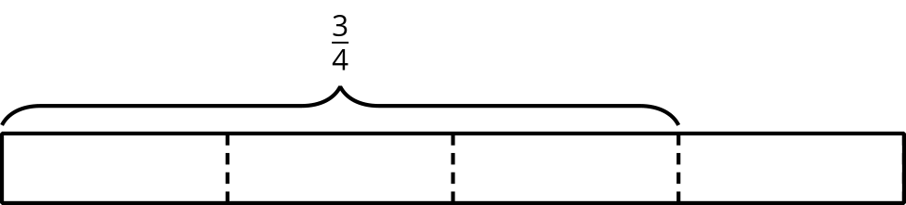
  - $\frac{9}{10}÷\frac{3}{5}$
  - How many $\frac{3}{5}$s are in $\frac{9}{10}$?
  - 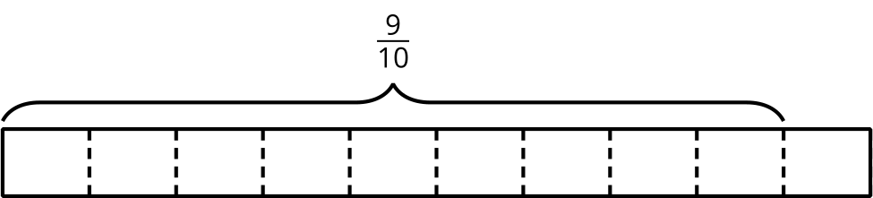
- Partner B:
- Elena said, “If I want to divide 4 by $\frac{2}{5}$, I can multiply 4 by 5 and then divide it by 2 or multiply it by $\frac{1}{2}$.”
- Find the value of each expression using the strategy Elena described.
  - $\frac{3}{4}÷\frac{1}{8}$
  - $\frac{9}{10}÷\frac{3}{5}$
- Discuss with your partner:
  - Where in the diagram for $\frac{3}{4}÷\frac{1}{8}$ can we see the multiplication by the denominator 8?
  - Where in the diagram for $\frac{9}{10}÷\frac{3}{5}$ can we see the division by the numerator 3?
  - Where in each diagram do you see the quotient?
- Complete this sentence based on what you noticed:
- To divide a number $n$ by a fraction $\frac{a}{b}$, we can multiply $n$ by $\underset{_}{​}$ and then divide the product by $\underset{_}{​}$.
- Select all the equations that represent the sentence you completed.
  - $n÷\frac{a}{b}=n⋅b÷a$
  - $n÷\frac{a}{b}=n⋅a÷b$
  - $n÷\frac{a}{b}=n⋅\frac{a}{b}$
  - $n÷\frac{a}{b}=n⋅\frac{b}{a}$
Grade 6
Unit 4Lesson 11CC BY NC Illustrative Mathematics, based on IM 6–8 Math, CC BY Open Up Resources.

11.3Dividing with or without an Algorithm
Calculate at least four quotients. Show your reasoning.
- $\frac{8}{9}÷4$
- $\frac{9}{12}÷\frac{6}{12}$
- $3\frac{1}{3}÷\frac{2}{9}$
- $\frac{9}{2}÷\frac{3}{8}$
- $1\frac{2}{5}÷3$
- $6\frac{1}{4}÷\frac{10}{3}$

Are you ready for more?
Suppose you have a quart of grape juice and a quart of milk. You pour 1 cup of the grape juice into the milk and mix it up. Then you pour 1 cup of this mixture back into the grape juice.
Which liquid is more contaminated? Explain how you know. (Note: 1 quart is equal to 4 cups.)

Lesson 11 Summary
We can think of the division $a÷\frac{3}{4}=?$ in terms of finding the size of 1 group: “If there is $a$ in $\frac{3}{4}$ of a group, how much is in 1 group?” or “If $\frac{3}{4}$ of a number is $a$, what is that number?”
On a tape diagram, we can show $\frac{3}{4}$ of a group having a value of $a$ and the whole group having an unknown value.
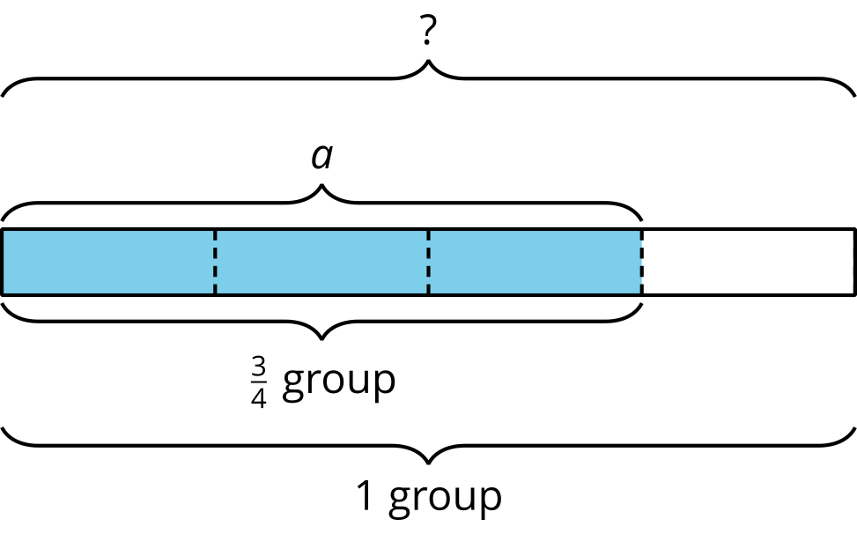
If $\frac{3}{4}$ of a number is $a$, then to find the number, we can first divide $a$ by 3 to find $\frac{1}{4}$ of the number. Then we multiply the result by 4 to find the number.
These steps can be written as: $a÷3⋅4$. Dividing by 3 is the same as multiplying by $\frac{1}{3}$, so we can also write the steps as: $a⋅\frac{1}{3}⋅4$, which is $a⋅\frac{4}{3}$.
In other words:
$a÷\frac{3}{4}=a⋅\frac{4}{3}$
In general, dividing a number by a fraction $\frac{c}{d}$ is the same as multiplying the number by $\frac{d}{c}$, which is the reciprocal of the fraction. Reciprocals are numbers that when multiplied equal 1.

