Unit 2 Lesson 12: Writing and Graphing Systems of Linear Equations

1 Math Talk: A Possible Mix? (Warm up)

Student Task Statement
Diego bought some raisins and walnuts to make trail mix.
Raisins cost $4 a pound and walnuts cost $8 a pound. Diego spent $15 on both ingredients.
Decide if each pair of values could be a combination of raisins and walnuts that Diego bought.
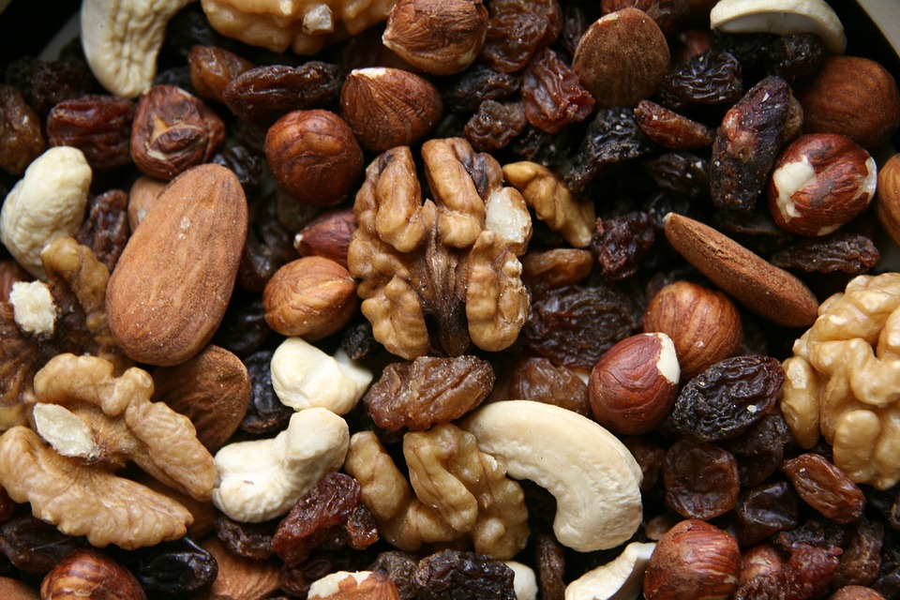
4 pounds of raisins and 2 pounds of walnuts
1 pound of raisins and 1.5 pounds of walnuts
2.25 pounds of raisins and 0.75 pounds of walnuts
3.5 pounds of raisins and 1 pound of walnuts

2 Trail Mix

Student Task Statement
- Here is a situation you saw earlier: Diego bought some raisins and walnuts to make trail mix. Raisins cost $4 a pound and walnuts cost $8 a pound. Diego spent $15 on both ingredients.
  - Write an equation to represent this constraint. Let $x$ be the pounds of raisins and $y$ be the pounds of walnuts.
  - Use graphing technology to graph the equation.
  - Complete the table with the amount of one ingredient Diego could have bought given the other. Be prepared to explain or show your reasoning.
- raisins (pounds) | - walnuts (pounds)
  - 0
  - 0.25
 | - 1.375
 | - 1.25
  - 1.75
  - 3
- Here is a new piece of information: Diego bought a total of 2 pounds of raisins and walnuts combined.
  - Write an equation to represent this new constraint. Let $x$ be the pounds of raisins and $y$ be the pounds of walnuts.
  - Use graphing technology to graph the equation.
  - Complete the table with the amount of one ingredient Diego could have bought given the other. Be prepared to explain or show your reasoning.
- raisins (pounds) | - walnuts (pounds)
- 0
- 0.25
 | - 1.375
 | - 1.25
- 1.75
- 3
- Diego spent $15 and bought exactly 2 pounds of raisins and walnuts. How many pounds of each did he buy? Explain or show how you know.

3 Meeting Constraints

Student Task Statement
Here are some situations that each relates two quantities and involves two constraints. For each situation, find the pair of values that meet both constraints and explain or show your reasoning.
- A dining hall had a total of 25 tables—some long rectangular tables and some round ones. Long tables can seat 8 people. Round tables can seat 6 people. On a busy evening, all 190 seats at the tables are occupied.
- How many long tables, $x$, and how many round tables, $y$, are there?
- A family bought a total of 16 adult and child tickets to a magic show. Adult tickets are $10.50 each and child tickets are $7.50 each. The family paid a total of $141.
- How many adult tickets, $a$, and child tickets, $c$, did they buy?
- At a poster shop, Han paid $16.80 for 2 large posters and 3 small posters of his favorite band. Kiran paid $14.15 for 1 large poster and 4 small posters of his favorite TV shows. Posters of the same size have the same price.
- Find the price of a large poster, $ℓ$, and the price of a small poster, $s$.

Images for Activity Synthesis
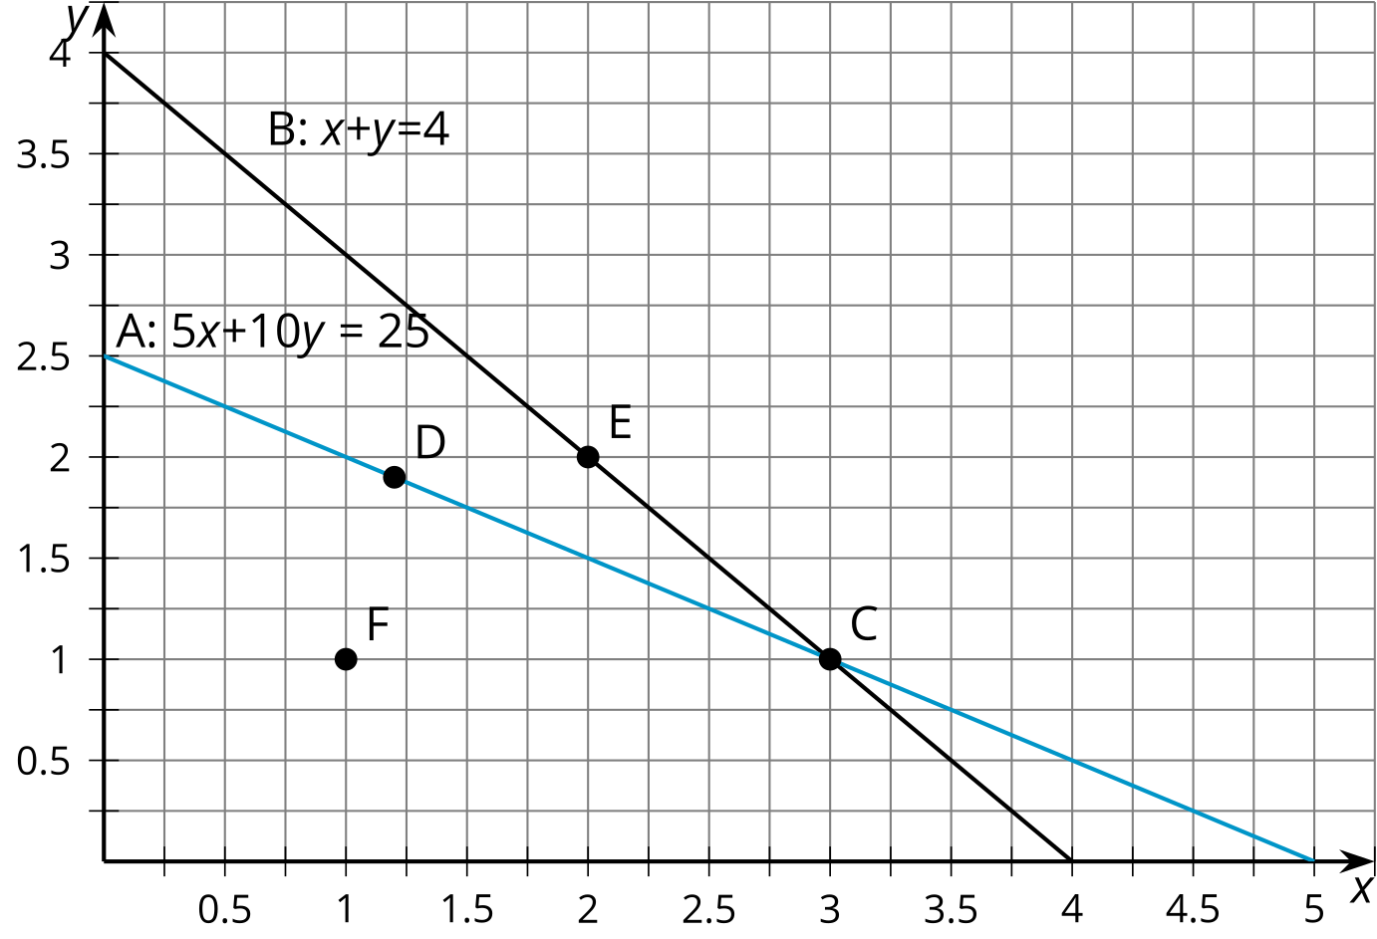
© CC BY 2019 by Illustrative Mathematics®

