Unit 4 Lesson 9: Solve Story Problems

WU How Many Do You See: Finger Addition (Warm up)

Student Task Statement
How many fingers do you see?
How do you see them?




1 Markers at School

Student Task Statement
There were 4 markers at school.
Elena brought 3 more markers to school.
How many markers are at school now?


2 Balls at Recess

Student Task Statement
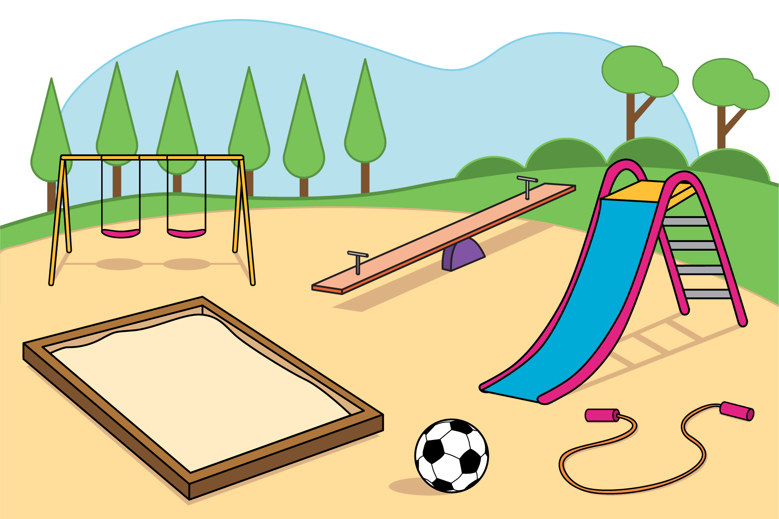
There were 5 balls on the playground.
Diego brought 5 of the balls inside.
How many balls are on the playground now?

Activity Synthesis


3 Introduce Math Fingers, Add 2 Hands

Student Task Statement
Choose a center.
Math Fingers

Math Stories
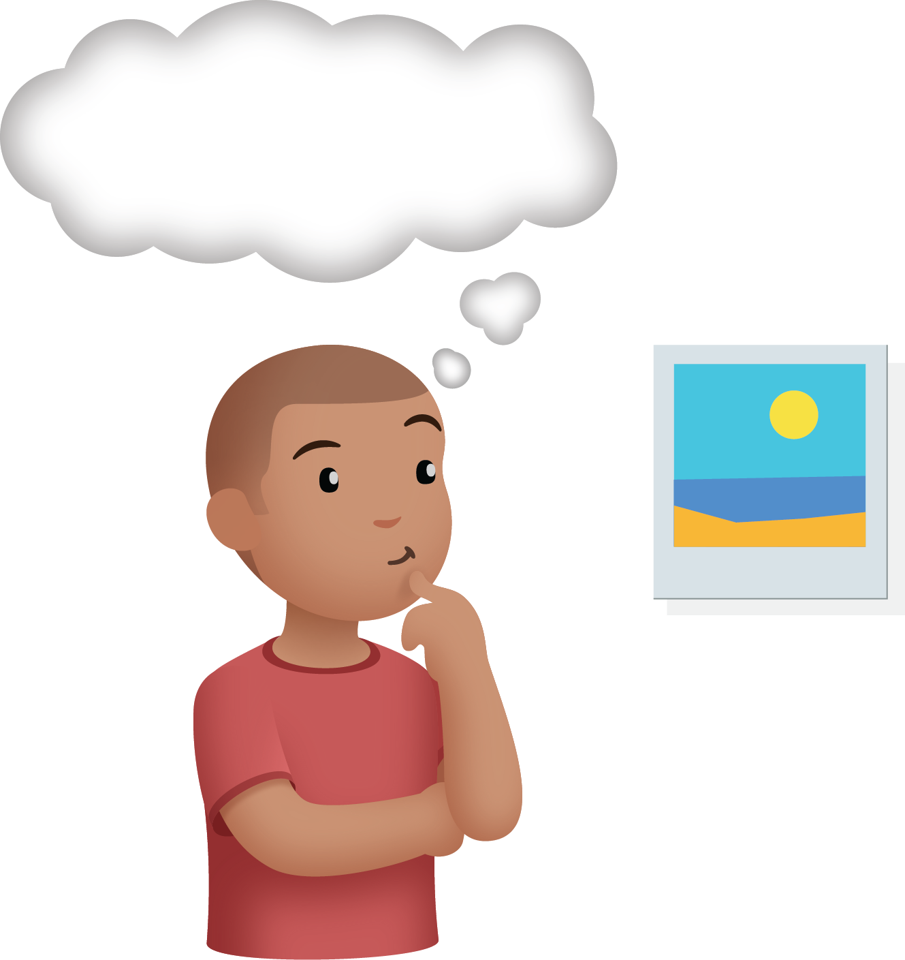
Subtraction Towers
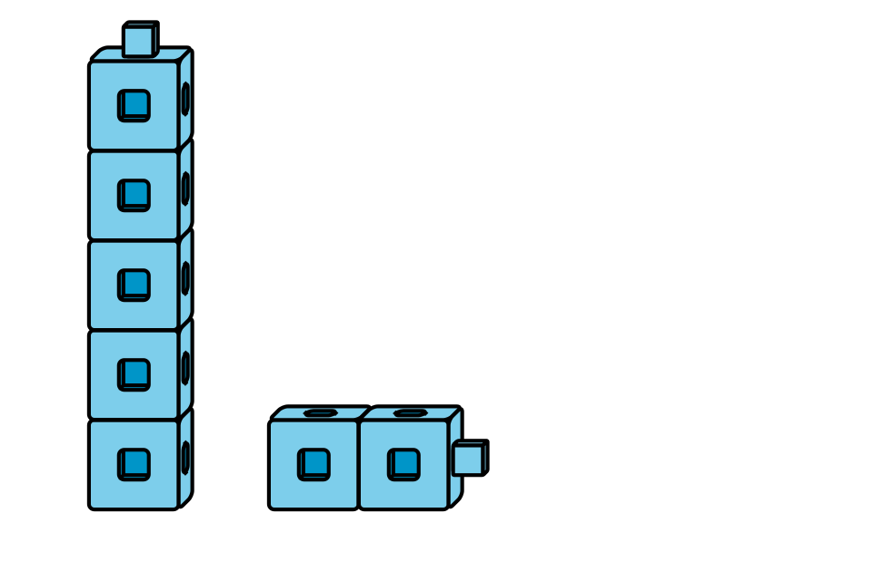
5-frames
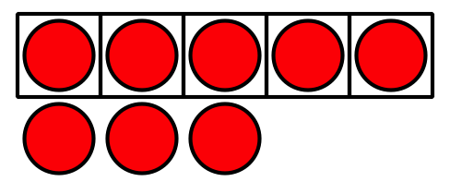
Build Shapes
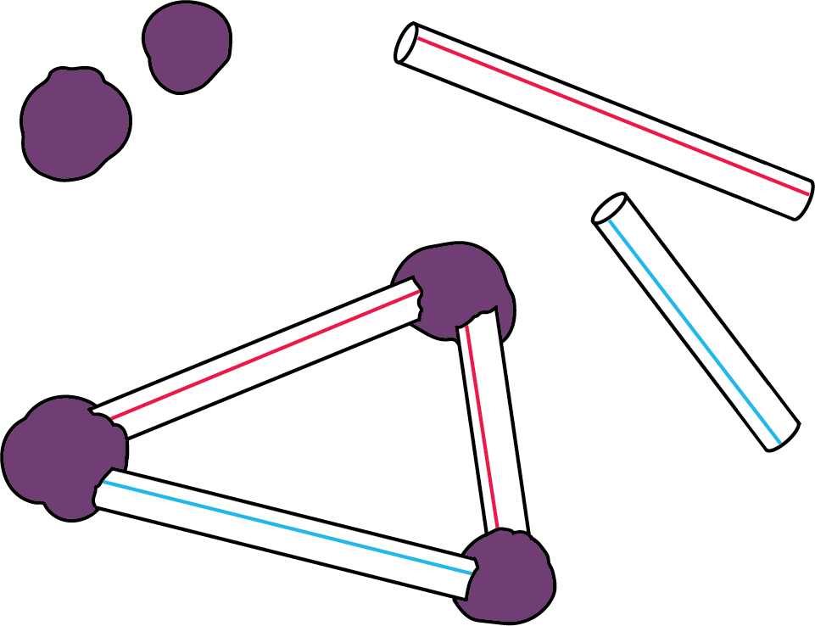
Counting Collections
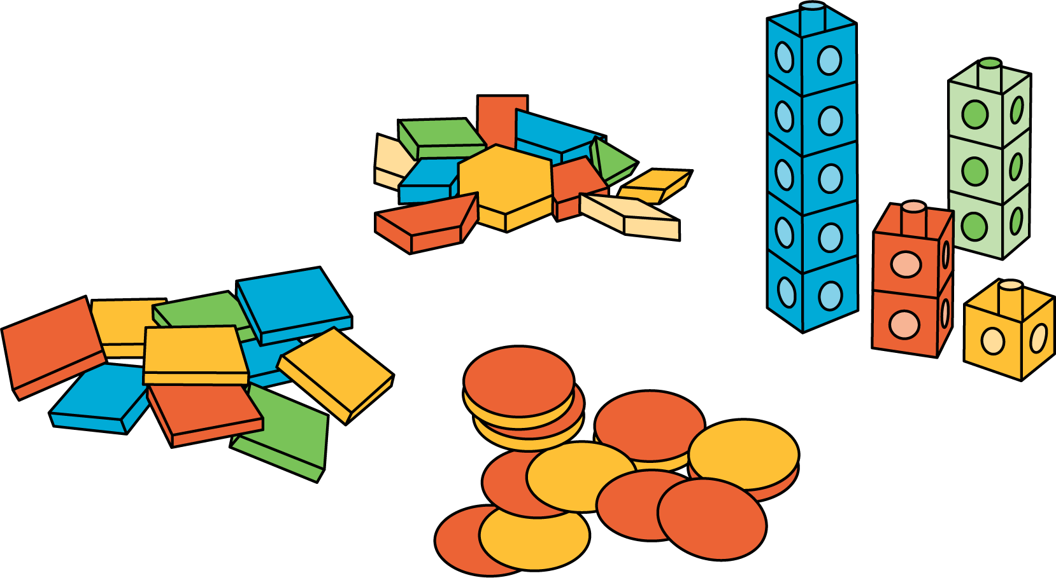

Images for Activity Synthesis
© CC BY 2021 Illustrative Mathematics®

