Unit 2 Lesson 11: Representing Ratios with Tables

1 How Is It Growing? (Warm up)

Student Task Statement
Look for a pattern in the figures.
- How many total tiles will be in:
  - the 4th figure?
  - the 5th figure?
  - the 10th figure?
- How do you see it growing?
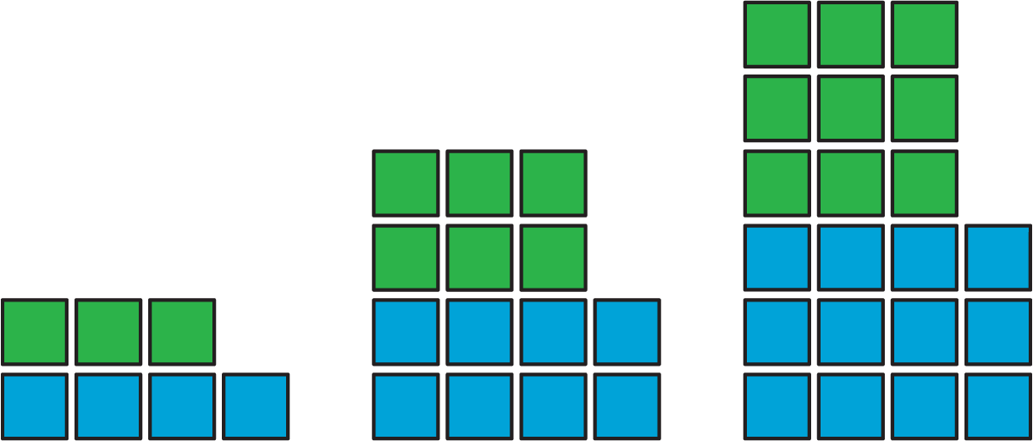

2 A Huge Amount of Sparkling Orange Juice

Images for Launch
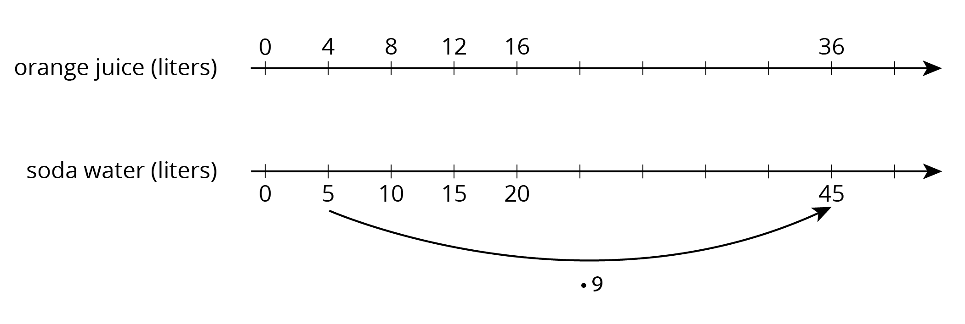

Student Task Statement
Noah’s recipe for one batch of sparkling orange juice uses 4 liters of orange juice and 5 liters of soda water.
- Use the double number line to show how many liters of each ingredient to use for different-sized batches of sparkling orange juice.
- 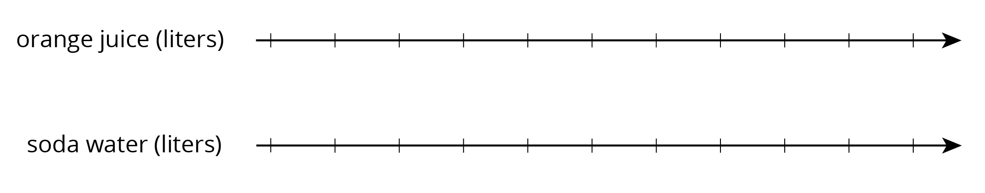
- If someone mixes 36 liters of orange juice and 45 liters of soda water, how many batches would they make?
- If someone uses 400 liters of orange juice, how much soda water would they need?
- If someone uses 455 liters of soda water, how much orange juice would they need?
- Explain the trouble with using a double number line diagram to answer the last two questions.

Activity Synthesis
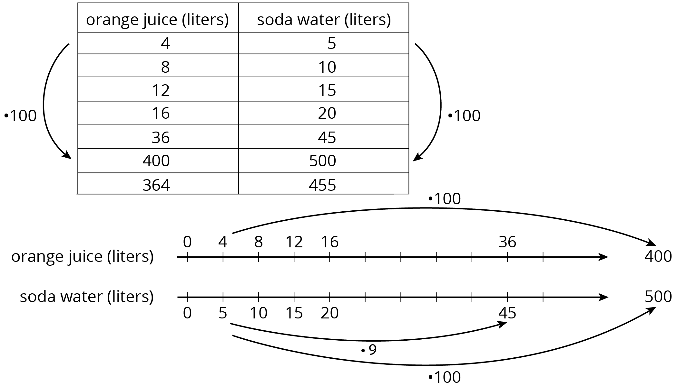

3 Batches of Trail Mix

Student Task Statement
A recipe for trail mix says: “Mix 7 ounces of almonds with 5 ounces of raisins.” Here is a table that has been started to show how many ounces of almonds and raisins would be in different-sized batches of this trail mix.
almonds (oz) | raisins (oz)
7 | 5
28
 | 10
3.5
 | 250
56
- Complete the table so that ratios represented by each row are equivalent.
- What methods did you use to fill in the table?
- How do you know that each row shows a ratio that is equivalent
to $7:5$? Explain your reasoning.
© CC BY Open Up Resources. Adaptations CC BY IM.

