Unit 9 Lesson 4: Another Look at the Standard Algorithm

WU Number Talk: Differences (Warm up)

Student Task Statement
Find the value of each difference mentally.
- $87−24$
- $387−124$
- $6,​387−129$
- $6,​387−4,​329$

1 Lots of Zeros

Student Task Statement
- Find the value of each difference.
- a.
- b.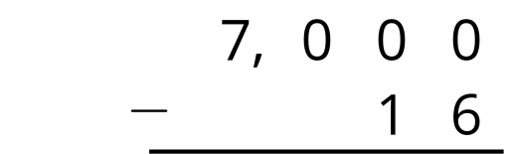
- c.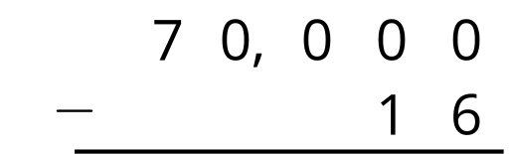
- d.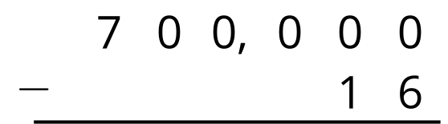
- Find the number that makes each expression true.
- a.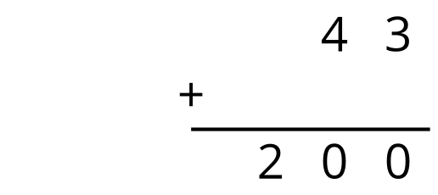
- b.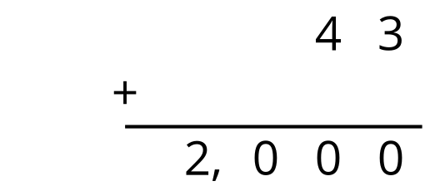
- c.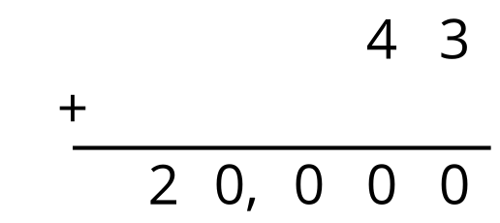
- d.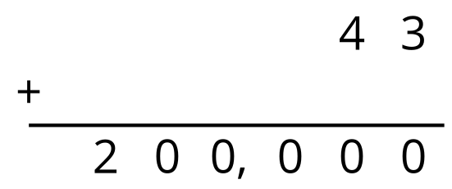

2 Ways of Finding Differences

Student Task Statement
To find the value of $20,​000−472$, Priya and Han set up their calculations differently.
Priya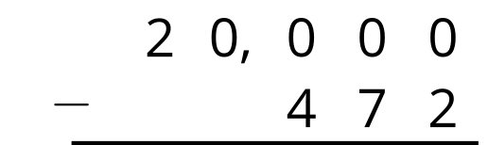
Han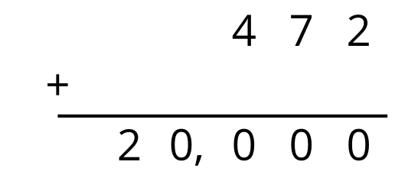
- Use both methods to find the difference of 20,000 and 472.
- Kiran uses another method. Explain how Kiran found the value of $20,​000−472$.
- $\begin{matrix}472+8 & =480 \\ 480+20 & =500 \\ 500+500 & =1,​000 \\ 1,​000+19,​000 & =20,​000\end{matrix}$
- $19,​000+500+20+8=19,​528$
- Which method do you prefer? Or do you prefer another way? Explain your reasoning.
- Find the value of $50,​400−1,​389$. Show your reasoning.

Images for Activity Synthesis
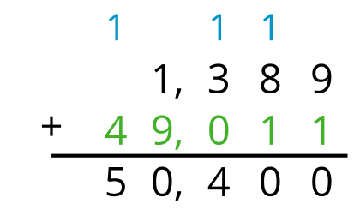
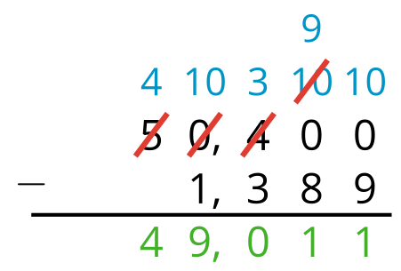
© CC BY 2021 Illustrative Mathematics®

