Grade 2
Unit 2Lesson 8CC BY NC 2024 Illustrative Mathematics®
Unit 2, Lesson 8

Different Ways to Decompose
- Let’s compare different ways to subtract.
Grade 2
Unit 2Lesson 8CC BY NC 2024 Illustrative Mathematics®

Warm-up Number Talk: Multiples of 10
Find the value of each expression mentally.
- $18+10+10$
- $18+20+10$
- $38−20$
- $48−30$
Grade 2
Unit 2Lesson 8CC BY NC 2024 Illustrative Mathematics®

Activity 1Aren’t You Missing Something?
Lin and Clare make base-ten diagrams. They find the value of $71−56$.
Lin
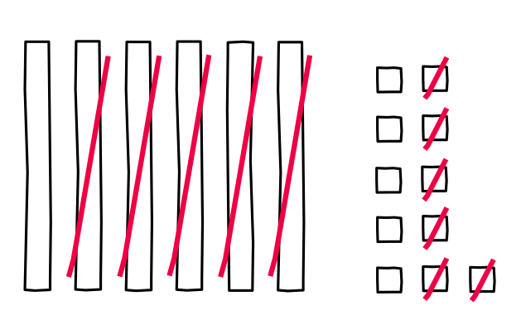
Clare
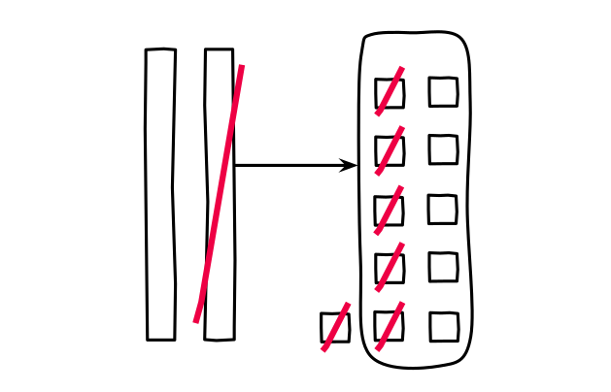
- What do you notice about their work? What do you wonder?
- Lin and Clare write equations to show their thinking. Which group of equations matches Lin’s work? Which group matches Clare’s work? Explain your reasoning.
- A
- B
- $71−50=21$
$21=10+11$
$11−6=5$
$10+5=15$
- $71=60+11$
$11−6=5$
$60−50=10$
$10+5=15$
- How are Lin’s and Clare’s methods alike? How are they different?
Grade 2
Unit 2Lesson 8CC BY NC 2024 Illustrative Mathematics®

Activity 2Different Ways to Decompose
Andre finds the value of $65−28$. He makes a base-ten diagram and writes equations to show his thinking.
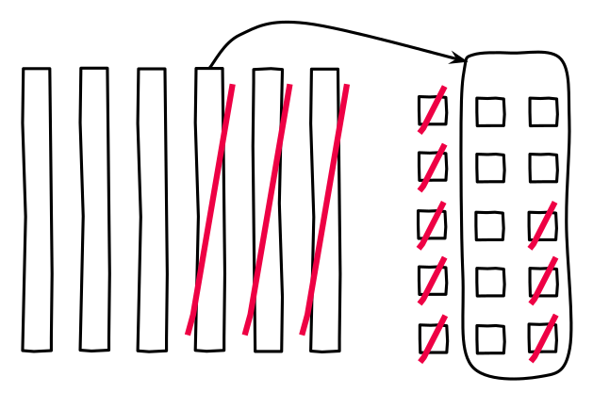
$65−28$
$65−20=45$
$45=30+15$
$15−8=7$
$30+7=37$
- Do you think Andre’s method is more like Clare’s or Lin’s method? Explain your reasoning.
- Find the value of each difference. Show your thinking using drawings, numbers, or words.
  - $34−18$
  - $82−37$
  - $71−53$

