Grade 6
Unit 5Lesson 11CC BY NC Illustrative Mathematics, based on IM 6–8 Math, CC BY Open Up Resources.
Unit 5, Lesson 11

Using Long Division
Let’s use long division.
Grade 6
Unit 5Lesson 11CC BY NC Illustrative Mathematics, based on IM 6–8 Math, CC BY Open Up Resources.

11.1Notice and Wonder: Lin’s Calculations
Here are Lin’s calculations for finding $657÷3$.
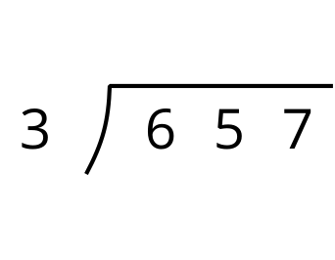
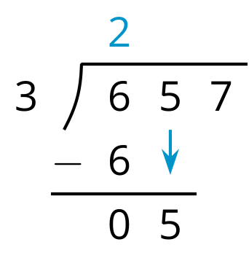
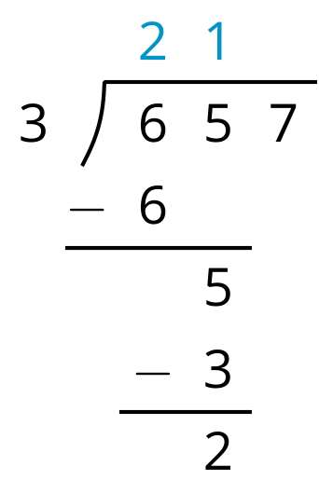
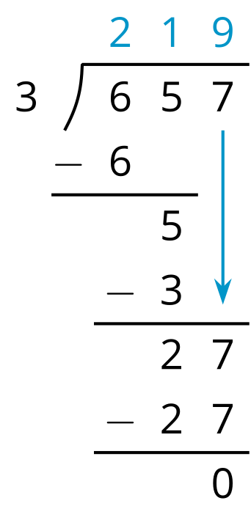
What do you notice? What do you wonder?
Grade 6
Unit 5Lesson 11CC BY NC Illustrative Mathematics, based on IM 6–8 Math, CC BY Open Up Resources.

11.2Lin Uses Long Division
Here is how Lin found the quotient of $657÷3$.
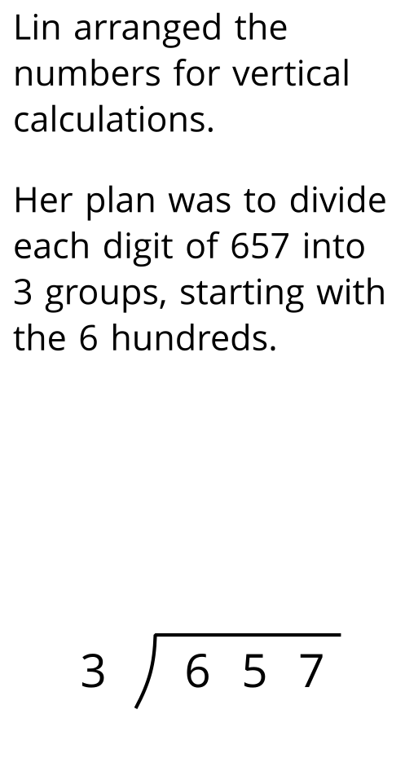
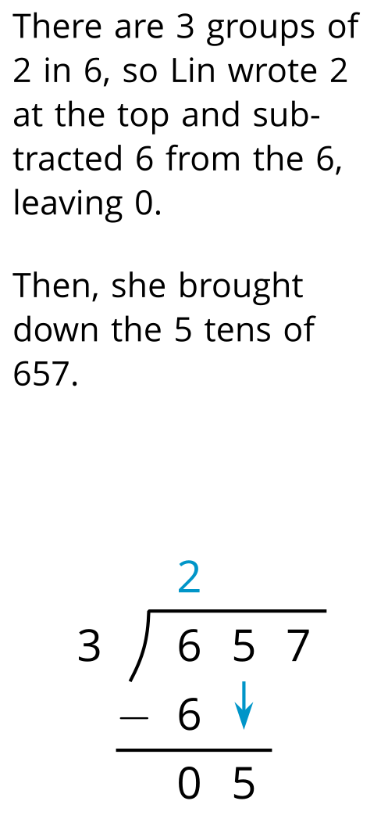
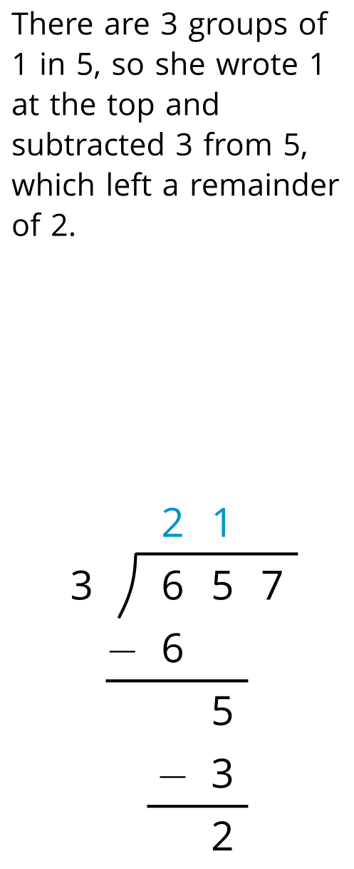
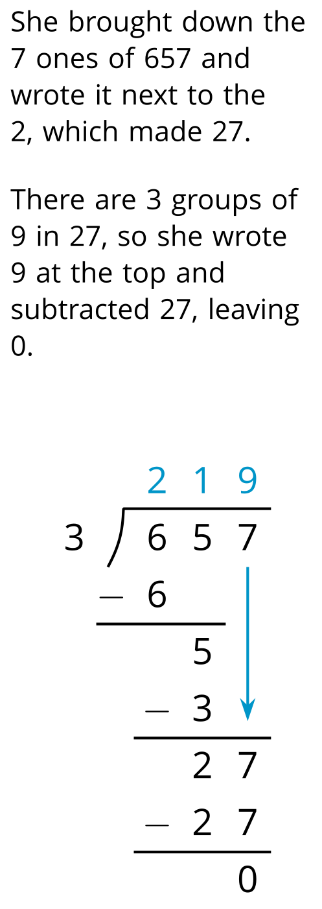
- Study Lin’s steps. Then discuss with your partner:
  - In the first step, Lin divided 6 by 3 to get 2. Why do you think she put the 2 over the 6?
  - Lin subtracted $3⋅2$ then $3⋅1$, and lastly $3⋅9$. Earlier, Andre subtracted $3⋅200$ then $3⋅10$, and lastly $3⋅9$. Why did they have the same quotient?
  - In the third step, why do you think Lin wrote the 7 next to the remainder of 2 rather than adding 7 and 2 to get 9?
- Lin’s method is called long division. Use this method to find the following quotients. Check your answer by multiplying it by the divisor.
  - $846÷3$
  - $1,​816÷4$
  - $768÷12$
Grade 6
Unit 5Lesson 11CC BY NC Illustrative Mathematics, based on IM 6–8 Math, CC BY Open Up Resources.

11.3Dividing Whole Numbers
- Use long division to calculate each quotient.
  - $1001÷7$
  - $2996÷14$
- Here is Priya’s calculation of $906÷3$.
- 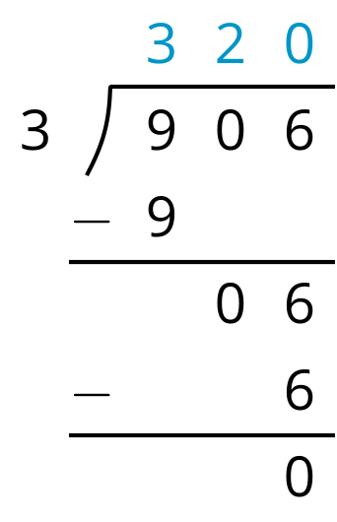
  - Priya wrote 320 for the value of $906÷3$. Check her answer by multiplying it by 3. What product do you get?
  - What does the product tell you about Priya’s answer? Explain your reasoning. If you think her answer is incorrect, describe the error and show the correct calculation and answer.

Lesson 11 Summary
Long division is another method for calculating quotients. It relies on place value to perform and record the division.
When we use long division, we work from left to right and with one digit at a time, starting with the leftmost digit of the dividend. We remove the largest group possible each time, using the placement of the digit to indicate the size of each group.
Here is an example of how to find $948÷3$ using long division.
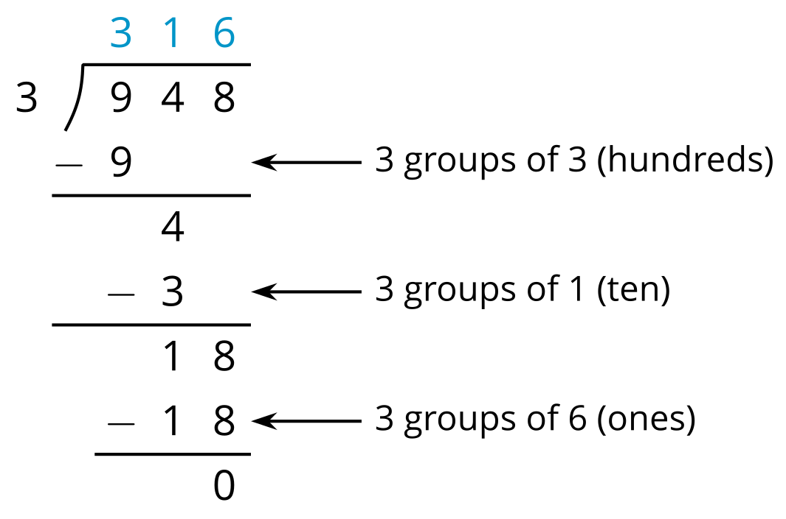
- We start by dividing 9 hundreds into 3 groups, which means 3 hundreds in each group. Instead of writing 300, we simply write 3 in the hundreds place, knowing that it means 3 hundreds.
- There are no remaining hundreds, so we work with the tens. We can make 3 groups of 1 ten out of 4 tens, so we write 1 in the tens place above the 4 of 948. Subtracting 3 tens from 4 tens, we have a remainder of 1 ten.
- We know that 1 ten is 10 ones. Combining these with the 8 ones from 948, we have 18 ones. We can make 3 groups of 6 ones, so we write 6 in the ones place.
In total, there are 3 groups of 3 hundreds, 1 ten, and 6 ones in 948, so $948÷3=316$.

