Grade 6
Unit 7CC BY NC Illustrative Mathematics, based on IM 6–8 Math, CC BY Open Up Resources.

Unit 7 Family Support Materials

Rational Numbers

Section A: Negative Numbers and Absolute Value
This week, your student will work with signed numbers, or positive numbers and negative numbers. We often compare signed numbers when talking about temperatures. For example, -30 degrees Fahrenheit is colder than -10 degrees Fahrenheit. We say “-30 is less than -10” and write: $\text{-}30<\text{-}10$.
We also use signed numbers when referring to elevation, or height relative to the sea level. An elevation of 2 feet (which means 2 feet above sea level) is higher than an elevation of -4 feet (which means 4 feet below sea level). We say, “2 is greater than -4” and write, "$2>\text{-}4$."
We can plot positive and negative numbers on the number line. Numbers to the left are always less than numbers to the right.
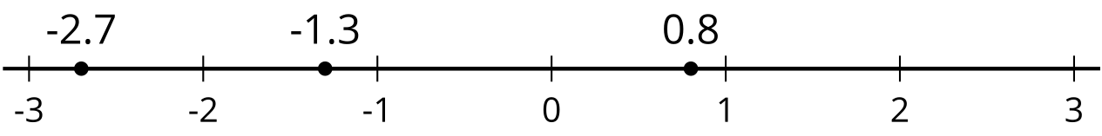
We can see that -1.3 is less than 0.8 because -1.3 is to the left of 0.8, but -1.3 is greater than -2.7 because it is to the right of -2.7.
We can also talk about a number in terms of its absolute value, or its distance from 0 on the number line. Here are some examples:
- 0.8 is 0.8 unit away from 0. To represent this statement, we can write, "$\left|0.8\right|=0.8$."
- -2.7 is 2.7 units away from 0. To represent this statement, we can write, "$\left|\text{-}2.7\right|=2.7$."
- The numbers -3 and 3 are both 3 units away from 0. We can write, "$\left|3\right|=3$ and $\left|\text{-}3\right|=3$."
Here is a task to try with your student:
- A diver is at the surface of the ocean, getting ready to do a dive. What is the diver’s elevation in relation to sea level?
- The diver descends 100 feet to the top of a wrecked ship. What is the diver’s elevation now?
- The diver descends 25 feet more, toward the ocean floor. What is the absolute value of the diver’s elevation now?
- Plot each of these three elevations as a point on a number line. Label each point with its numeric value.
Solution:
- 0, because sea level is 0 feet above or below sea level
- -100, because the diver is 100 feet below sea level
- The new elevation is -125 feet, or 125 feet below sea level, so its absolute value is 125 feet.
- A number line with 0, -100, and -125 marked, as shown:
- 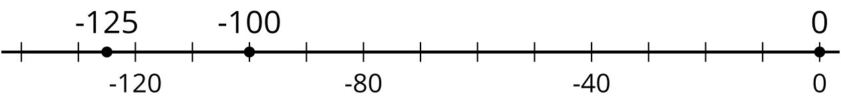

Section B: Inequalities
This week, your student will use the symbols "$<$" and "$>$" to represent situations that involve comparisons. They will also graph the solutions to inequalities, such as $x<1$ or $1>x$, on a number line.
Suppose the temperature, $x$, in degrees Celsius, is less than 1 degree. To represent this situation, we can write the inequality $x<1$ and draw a number line like this:
The diagram shows that all numbers less than 1 are possible values of $x$. Any value of $x$ that makes an inequality true is a solution to the inequality.
This means that for the inequality $p>\text{-}8$, any value for $p$ that is greater than -8 is a solution to the inequality. Likewise, any value of $n$ that is less than 15 could be a solution to the inequality $n<15$.
Depending on the context, the solutions to an inequality might include only certain kinds of numbers. Let's take $n<15$ for example.
- If $n$ represents the number of students in a class, a negative number or a fractional number would not make sense. Only positive whole numbers make sense as solutions to $n<15$.
- If $n$ represents distance, the solutions include both whole and non-whole numbers, but only positive numbers make sense.
- If $n$ represents temperature, the solutions include both whole and non-whole numbers, and both positive and negative numbers make sense.
Here is a task to try with your student:
A sign at a fair says, “You must be taller than 32 inches to ride the Ferris wheel.”
Write and graph an inequality that shows the heights of people who can ride the Ferris wheel.
Solution:
If $h$ represents the height of a person in inches, then the inequality $h>32$ represents the heights of people who can ride the Ferris wheel. We can also write the inequality $32<h$.
The graph of the inequality is:

Section C: The Coordinate Plane
This week, your student will plot and interpret points in the coordinate plane.
In earlier grades, they plotted points where both coordinates were positive, such as point $A$ in the figure. They will now plot points that have one positive coordinate and one negative coordinate, such as point $B$, and points that have two negative coordinates, such as point $C$.
To find the distance between two points that are on the same horizontal or vertical line, we can simply count the grid units between them.
For example, if we plot the point $\left(2,\text{-}4\right)$ on this grid, we can tell that the point will be 7 units away from point $A\left(2,3\right)$.
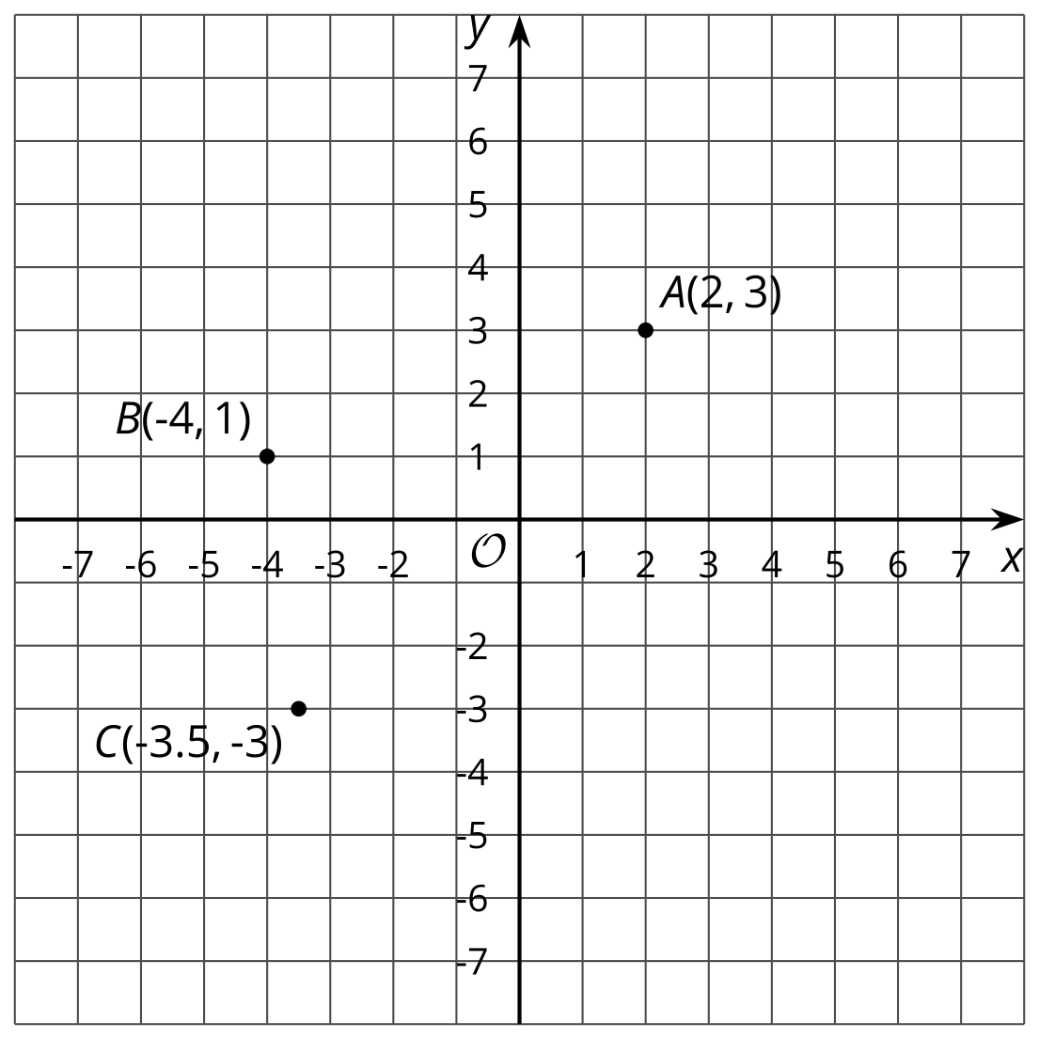
Points in a coordinate plane can also represent situations involving positive and negative numbers.
For instance, the points in this coordinate plane show the temperature in degrees Celsius every hour before and after noon on a winter day. Times before noon are negative and times after noon are positive.
The point $\left(5,10\right)$ tells us that 5 hours after noon, or at 5:00 p.m, the temperature was 10 degrees Celsius.
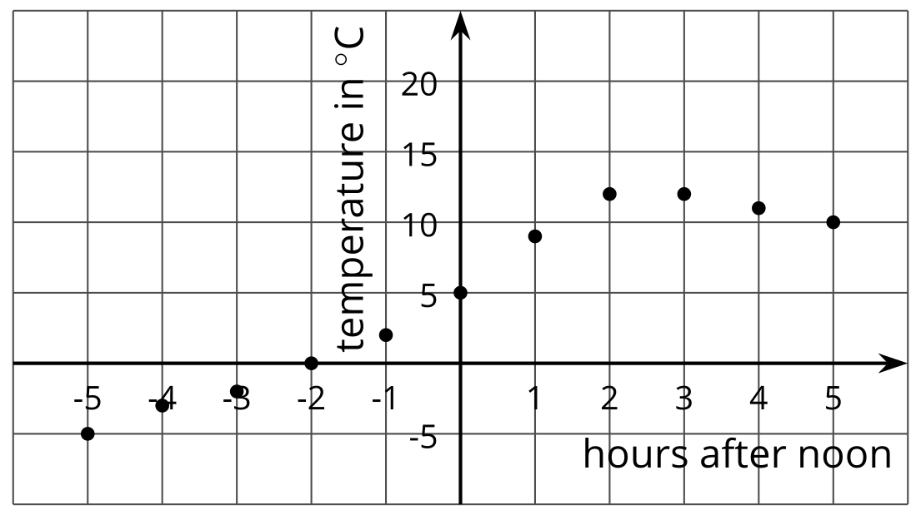
Here is a task to try with your student:
In the graph about temperatures before and after noon:
- What was the temperature at 7 a.m.? Which point represents this information?
- For which recorded times was it colder than 5 degrees Celsius?
Solution:
- It was -5 degrees Celsius at 7:00 a.m. The point $\left(\text{-}5,\text{-}5\right)$ represents this information.
- It was colder than 5 degrees Celsius for all of the recorded times before noon.

Section D: Common Factors and Common Multiples
This week, your student will solve problems that involve factors and multiples.
Because $2⋅6=12$, we say that 2 and 6 are factors of 12. The number 12 has other factors: 1, 3, 4, and 12 itself.
Because $12⋅1=12$, $12⋅2=24$, and $12⋅3=36$, we say that 12, 24, and 36 are multiples of 12. We can continue multiplying whole numbers by 12 to find additional multiples of 12.
Factors and multiples were studied in earlier grades. The focus here is on common factors and common multiples of two whole numbers. For example, 4 is a factor of 8 and a factor of 20, so 4 is a common factor of 8 and 20. 80 is a multiple of 8 and a multiple of 20, so 80 is a common multiple of 8 and 20.
One way to find the common factors of two numbers is to list all of the factors for each number and see which factors they have in common. Sometimes we want to find the greatest common factor. To find the greatest common factor of 18 and 24, we first list all the factors of each number and then look for the greatest one they have in common.
- Factors of 18: 1, 2, 3, 6, 9, 18
- Factors of 24: 1, 2, 3, 4, 6, 8, 12, 24
The common factors are 1, 2, 3, and 6. Of these, 6 is the greatest one, so 6 is the greatest common factor of 18 and 24.
To find the common multiples of two numbers, we can list out some multiples of each number. Sometimes we want to find the least common multiple. Let’s find the least common multiple of 18 and 24.
- Multiples of 18: 18, 36, 54, 72, 90, 108, 126, 144, . . .
- Multiples of 24: 24, 48, 72, 96, 120, 144, 168, 192, . . .
The first two common multiples are 72 and 144. We can see that 72 is the least common multiple.
Here is a task to try with your student:
A cook is making cheese sandwiches to sell. A loaf of bread can make 10 sandwiches. A package of cheese can make 15 sandwiches.
How many loaves of bread and how many packages of cheese should the cook buy so that he can make cheese sandwiches without having any bread or any cheese left over?
Solution:
Since he wants to use the entire loaf of bread, the number of sandwiches he can make will be a multiple of 10: 10, 20, 30, 40, 50, 60, 70, 80, 90, 100, . . . .
Since he wants to use all of the cheese in each package, the number of sandwiches he can make will be a multiple of 15: 15, 30, 45, 60, 75, 90, 105, . . . .
30, 60, and 90 are some of the common multiples.
- To make 30 sandwiches, he will need 3 loaves of bread ($3⋅10=30$) and 2 packages of cheese ($2⋅15=30$).
- To make 60 sandwiches, he will need 6 loaves of bread and 4 packages of cheese.
- To make 90 sandwiches, he will need 9 loaves of bread and 6 packages of cheese.
There are other solutions as well! If he wants to buy the fewest numbers of loaves and cheese packages, then he should make 30 sandwiches.

