Grade 6
Unit 1Lesson 8CC BY NC Illustrative Mathematics, based on IM 6–8 Math, CC BY Open Up Resources.
Unit 1, Lesson 8

Area of Triangles
Let’s use what we know about parallelograms to find the area of triangles.
Grade 6
Unit 1Lesson 8CC BY NC Illustrative Mathematics, based on IM 6–8 Math, CC BY Open Up Resources.

8.1Composing Parallelograms
Here is Triangle M.
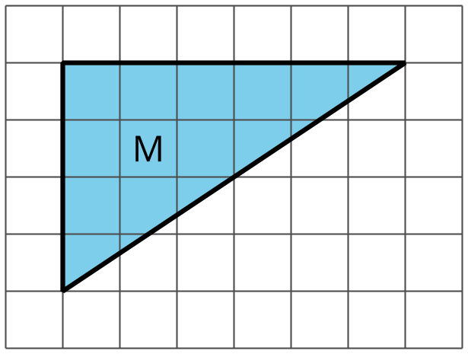
Han made a copy of Triangle M and composed three different parallelograms using the original M and the copy, as shown here.
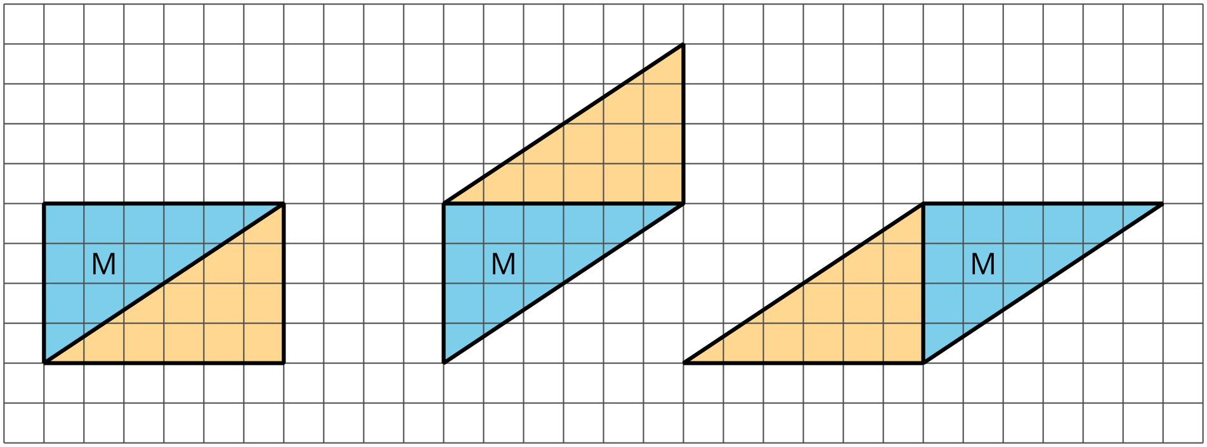
- For each parallelogram that Han composed, identify a base and a corresponding height, and write the measurements on the drawing.
- Find the area of each parallelogram that Han composed. Show your reasoning.
Grade 6
Unit 1Lesson 8CC BY NC Illustrative Mathematics, based on IM 6–8 Math, CC BY Open Up Resources.

8.2More Triangles
Find the areas of at least two of these triangles. Show your reasoning.
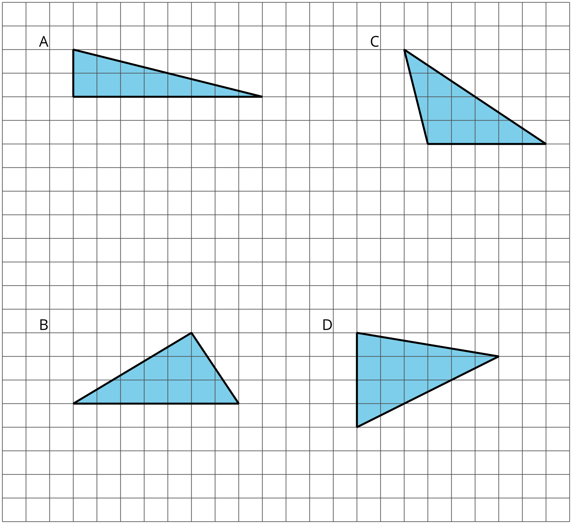

Grade 6
Unit 1Lesson 8CC BY NC Illustrative Mathematics, based on IM 6–8 Math, CC BY Open Up Resources.

8.3Decomposing a Parallelogram
- Your teacher will give you two copies of a parallelogram. Glue or tape one copy of your parallelogram here and find its area. Show your reasoning.
- Decompose the second copy of your parallelogram by cutting along the dotted lines. Take only the small triangle and the trapezoid, and rearrange these two pieces into a different parallelogram. Glue or tape the newly composed parallelogram on your paper.
- Find the area of the new parallelogram that you composed. Show your reasoning.
- What do you notice about the relationship between the area of this new parallelogram and the original one?
- How do you think the area of the large triangle compares to that of the new parallelogram: Is it larger, the same, or smaller? Why is that?
- Glue or tape the remaining large triangle to your paper. Use any part of your work to help you find its area. Show your reasoning.

Are you ready for more?
Can you decompose this triangle and rearrange its parts to form a rectangle? Describe how it could be done.
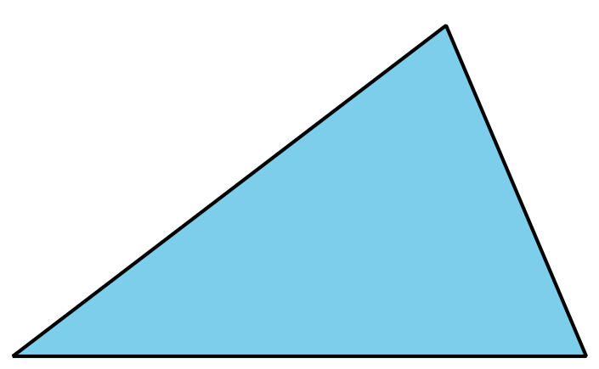

Lesson 8 Summary
We can reason about the area of a triangle by using what we know about parallelograms. Here are three general ways to do this:
- Make a copy of the triangle and join the original and the copy along an edge to create a parallelogram. Because the two triangles have the same area, one copy of the triangle has half the area of that parallelogram.
- 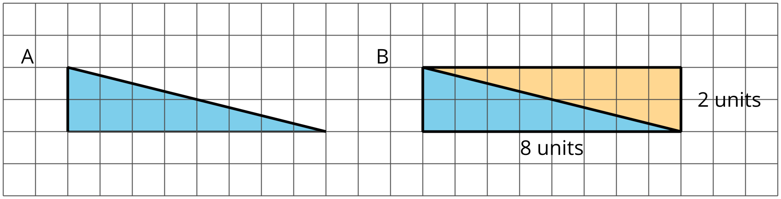
- The area of Parallelogram B is 16 square units because the base is 8 units and the height 2 units. The area of Triangle A is half of that, which is 8 square units.
- 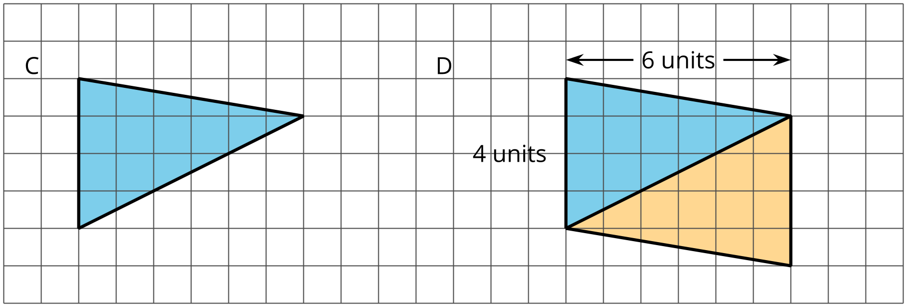
- The area of Parallelogram D is 24 square units because the base is 4 units and the height 6 units. The area of Triangle C is half of that, which is 12 square units.
- Decompose the triangle into smaller pieces and compose them into a parallelogram.
- 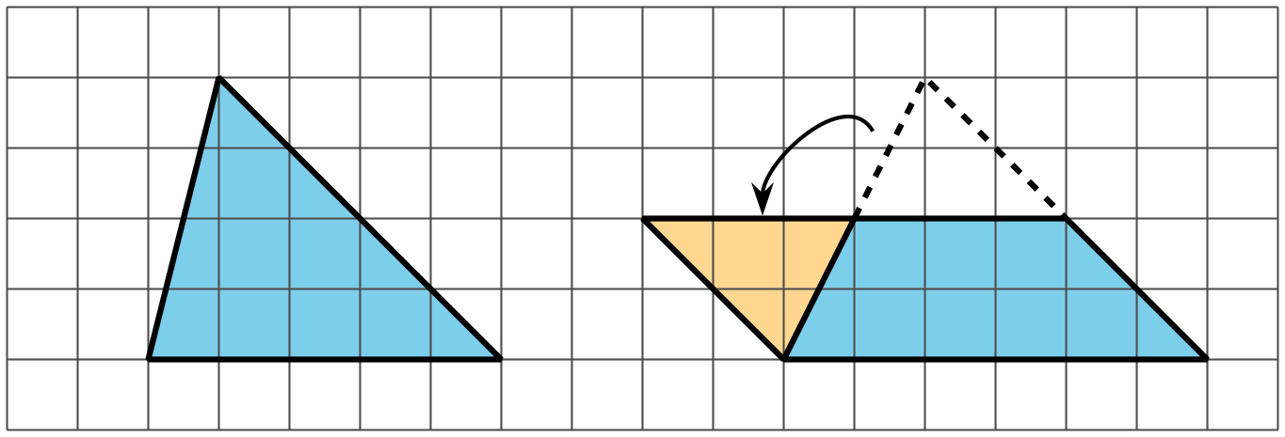
- In the new parallelogram, $b=6$, $h=2$, and $6⋅2=12$, so its area is 12 square units. Because the original triangle and the parallelogram are composed of the same parts, the area of the original triangle is also 12 square units.
- Draw a rectangle around the triangle. Sometimes the triangle has half of the area of the rectangle.
- 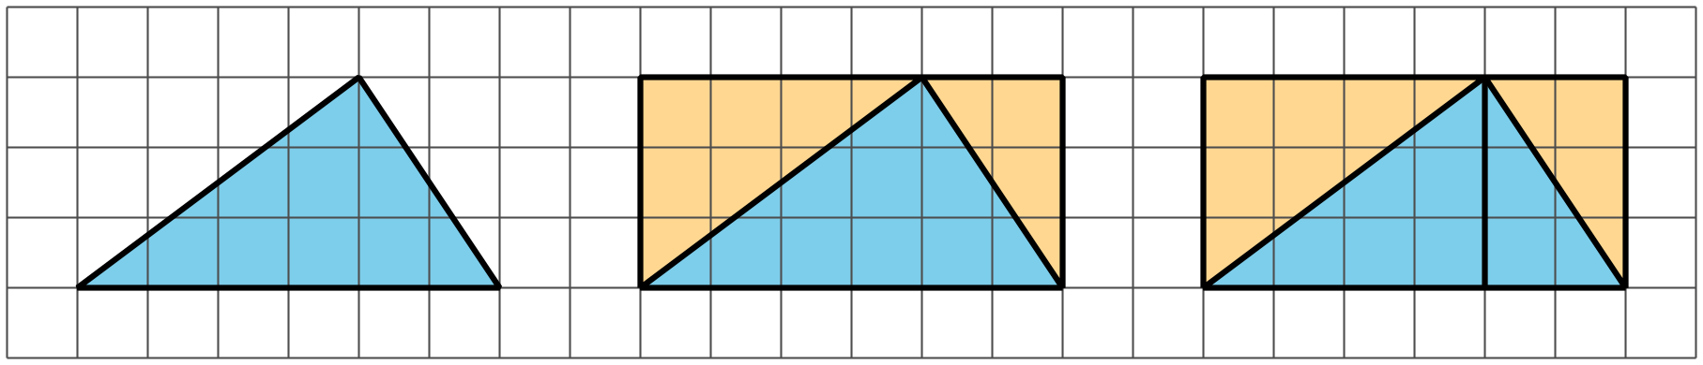
- The large rectangle can be decomposed into smaller rectangles. Each smaller rectangle can be decomposed into two right triangles.
  - The rectangle on the left has an area of $4⋅3$, or 12, square units. Each right triangle inside it is 6 square units in area.
  - The rectangle on the right has an area of $2⋅3$, or 6, square units. Each right triangle inside it is 3 square units in area.
  - The area of the original triangle is the sum of the areas of a large right triangle and a small right triangle: 9 square units.
- Sometimes, the triangle is half of what is left of the rectangle after removing two copies of the smaller right triangles.
- 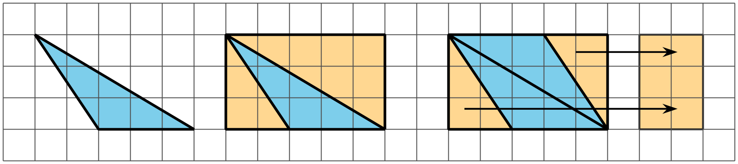
- The right triangles being removed can be composed into a small rectangle with area $\left(2⋅3\right)$ square units. What is left is a parallelogram with area $5⋅3−2⋅3$, which equals $15−6$, or 9, square units.
- Notice that we can compose the same parallelogram with two copies of the original triangle! The original triangle is half of the parallelogram, so its area is $\frac{1}{2}⋅9$, or 4.5, square units.

