Algebra 1
Unit 2Lesson 13CC BY NC 2024 Illustrative Mathematics®
Unit 2, Lesson 13

Solving Systems by Substitution
- Let’s use substitution to solve systems of linear equations.
Algebra 1
Unit 2Lesson 13CC BY NC 2024 Illustrative Mathematics®

13.1What's It Worth?
Find the value of the last line. Be prepared to explain your reasoning.
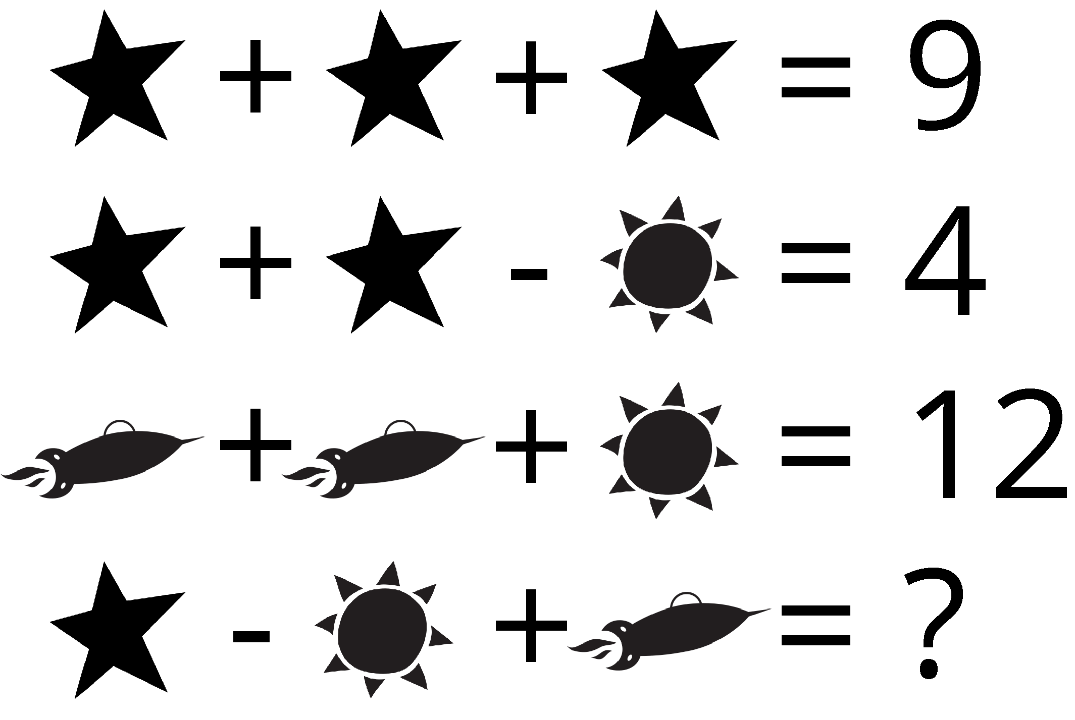
Algebra 1
Unit 2Lesson 13CC BY NC 2024 Illustrative Mathematics®

13.2Four Systems
Here are four systems of equations that you saw earlier. Solve each system by first finding the value of one variable and then using it to find the value of any other variables. Then, check your solutions by substituting them into the original equations to see if the equations are true.
A$\left\{\begin{matrix}x+2y=8 \\ x=\text{-}5\end{matrix}\right.$
B$\left\{\begin{matrix}y=\text{-}7x+13 \\ y=\text{-}1\end{matrix}\right.$
C$\left\{\begin{matrix}3x=8 \\ 3x+y=15\end{matrix}\right.$
D$\left\{\begin{matrix}y=2x−7 \\ 4+y=12\end{matrix}\right.$
Algebra 1
Unit 2Lesson 13CC BY NC 2024 Illustrative Mathematics®

13.3What about Now?
Solve each system without graphing.
A$​​\left\{\begin{matrix}a=b+2 \\ \left(b+2\right)+3=2a\end{matrix}\right.$
B$\left\{\begin{matrix}p=2m+10 \\ 2m−2p=\text{-}6\end{matrix}\right.$
C$\left\{\begin{matrix}w+\frac{1}{7}z=4 \\ z=3w−2\end{matrix}\right.$
D$\left\{\begin{matrix}2d=8f \\ 18−4f=2d\end{matrix}\right.$
E$\left\{\begin{matrix}5x−2y=26 \\ y+4=x\end{matrix}\right.$

Are you ready for more?
Solve this system with four equations.$\left\{\begin{matrix}3x+2y−z+5w=20 \\ y=2z−3w \\ z=w+1 \\ 2w=8\end{matrix}\right.$

Lesson 13 Summary
The solution to a system can usually be found by graphing, but graphing may not always be the most precise or the most efficient way to solve a system.
Here is a system of equations:
$\left\{\begin{matrix}3p+q=71 \\ 2p−q=30\end{matrix}\right.$
The graphs of the equations show an intersection at approximately 20 for $p$ and approximately 10 for $q$.
Without technology, however, it is not easy to tell what the exact values are.
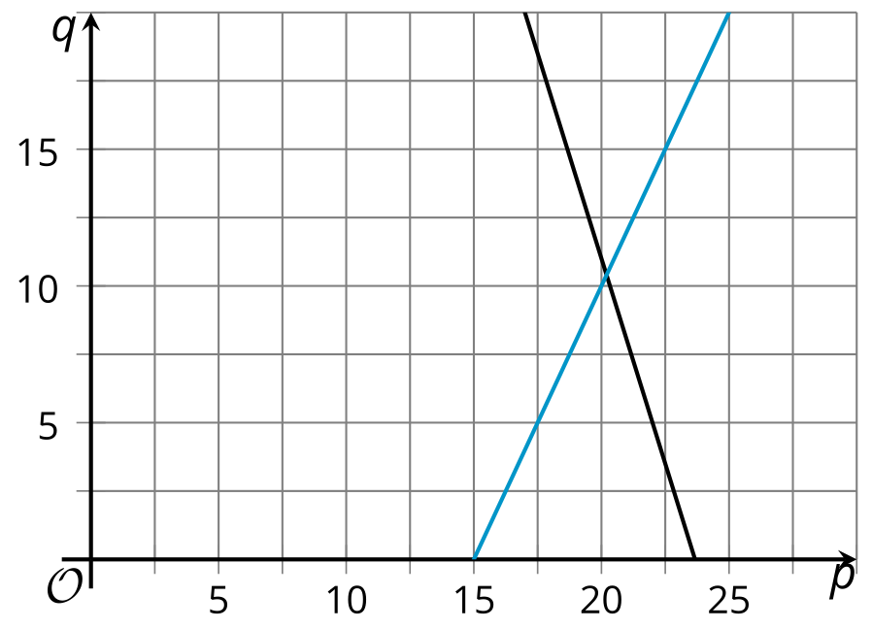
Instead of solving by graphing, we can solve the system algebraically. Here is one way.
If we subtract $3p$ from each side of the first equation, $3p+q=71$, we get an equivalent equation: $q=71−3p$. Rewriting the original equation this way allows us to isolate the variable $q$.
Because $q$ is equal to $71−3p$, we can substitute the expression $71−3p$ in the place of $q$ in the second equation. Doing this gives us an equation with only one variable, $p$, and makes it possible to find $p$.
$\begin{matrix}2p−q & =30 & & \text{original equation} \\ 2p−\left(71−3p\right) & =30 & & \text{substitute }71−3p\text{ for }q \\ 2p−71+3p & =30 & & \text{apply distributive property} \\ 5p−71 & =30 & & \text{combine like terms} \\ 5p & =101 & & \text{add 71 to both sides} \\ p & =\frac{101}{5} & & \text{divide both sides by 5} \\ p & =20.2 & & \end{matrix}$
Now that we know the value of $p$, we can find the value of $q$ by substituting 20.2 for $p$ in either of the original equations and solving the equation.
$\begin{matrix}3\left(20.2\right)+q & =71 \\ 60.6+q & =71 \\ q & =71−60.6 \\ q & =10.4\end{matrix}$​​​​​​
$\begin{matrix}2\left(20.2\right)−q & =30 \\ 40.4−q & =30 \\ \text{-}q & =30−40.4 \\ \text{-}q & =\text{-}10.4 \\ q & =\frac{\text{-}10.4}{\text{-}1} \\ q & =10.4\end{matrix}​​​​​​$
The solution to the system is the pair $p=20.2$ and $q=10.4$, or the point $\left(20.2,10.4\right)$ on the graph.
This method of solving a system of equations is called solving by substitution, because we substituted an expression for $q$ into the second equation.

