Grade 6
Unit 2Lesson 5CC BY NC Illustrative Mathematics, based on IM 6–8 Math, CC BY Open Up Resources.
Unit 2, Lesson 5

Defining Equivalent Ratios
Let’s investigate equivalent ratios some more.
Grade 6
Unit 2Lesson 5CC BY NC Illustrative Mathematics, based on IM 6–8 Math, CC BY Open Up Resources.

5.1Notice & Wonder: Some of This, Some of That
What do you notice? What do you wonder?
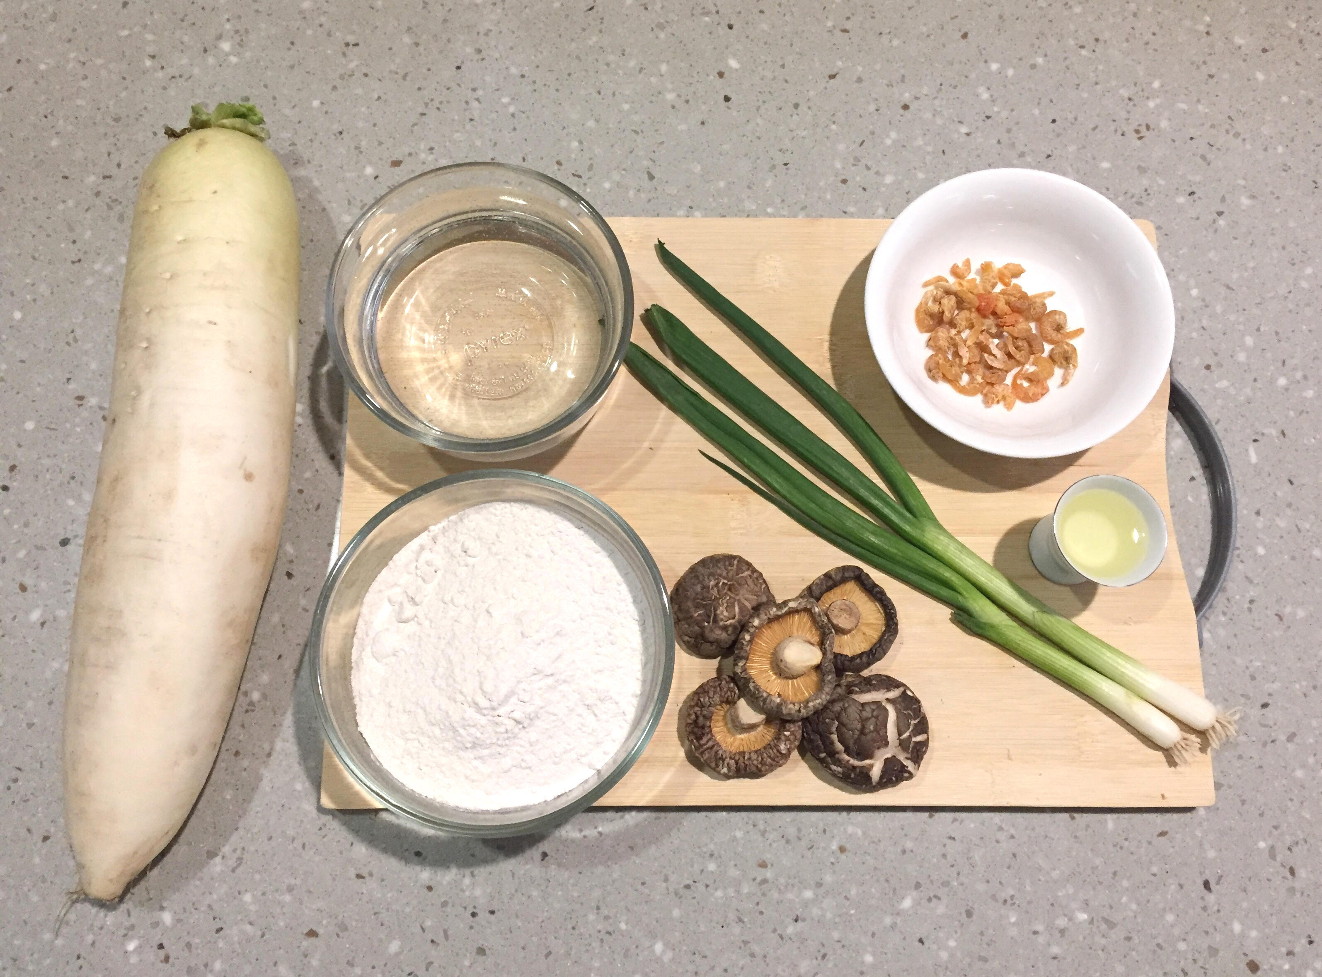
Grade 6
Unit 2Lesson 5CC BY NC Illustrative Mathematics, based on IM 6–8 Math, CC BY Open Up Resources.

5.2Radish Cake
Here is a recipe for luo bo gao (LUOH-boe-gow) or radish cake. It is also called lo bak go (law-buhk-GAW) or Chinese turnip cake.

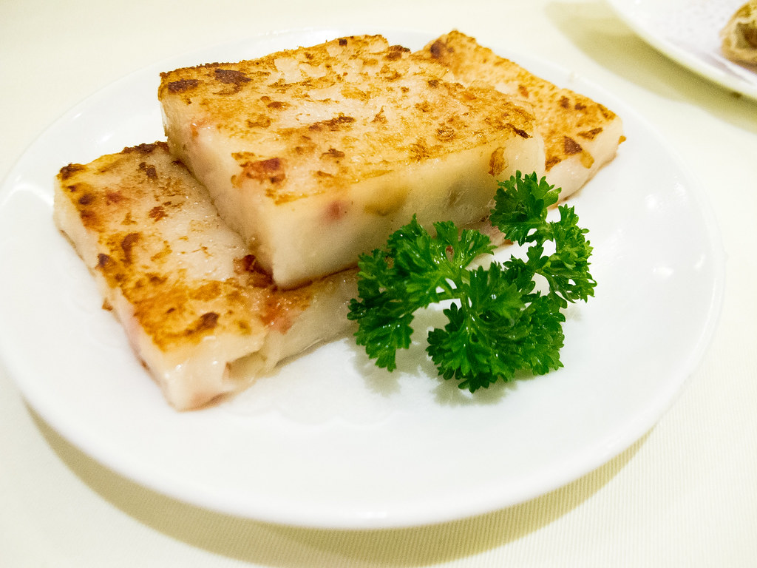
INGREDIENTS
- 20 ounces of radish
- 6 ounces of rice flour
- 5 small shiitake mushrooms
- 3 tablespoons of chopped green onions
- 1 tablespoon of dried shrimp
- 2 tablespoons of vegetable oil
- $1\frac{1}{2}$ cups of water
INSTRUCTIONS
- Peel and shred the radish. Soak the dried shrimp and mushrooms until soft and then chop.
- Pan fry the radish, shrimp, mushrooms, green onions, and oil for 5 minutes. Sprinkle salt and white pepper.
- Mix the rice flour and water and combine with the other ingredients. Pour the batter in a pan. Steam for 50 minutes.
- When the cake cools, cut it into $\frac{3}{4}$-inch slices and pan fry until slightly brown on both sides.

- What is the ratio of the ounces of radish to the ounces of rice flour to the tablespoons of dried shrimp in one batch of radish cake?
- How much of each of these 3 ingredients would be needed to make:
  - Twice the amount of radish cake?
  - Half the amount of radish cake?
  - Five times the amount of radish cake?
  - One-fourth the amount of radish cake?
- What is the ratio of ounces of rice flour to tablespoons of chopped green onions in one batch of radish cake?
- How many batches of radish cake would you make if you used the following amounts of ingredients?
  - 18 ounces of rice flour and 9 tablespoons of green onions
  - 36 ounces of rice flour and 18 tablespoons of green onions
  - 2 ounces of rice flour and 1 tablespoon of green onions
Grade 6
Unit 2Lesson 5CC BY NC Illustrative Mathematics, based on IM 6–8 Math, CC BY Open Up Resources.

5.3What Are Equivalent Ratios?
The ratios $5:3$ and $10:6$ are equivalent ratios.
- Is the ratio $15:12$ equivalent to these? Explain your reasoning.
- Is the ratio $30:18$ equivalent to these? Explain your reasoning.
- Give two more examples of ratios that are equivalent to $5:3$.
- How do you know when ratios are equivalent and when they are not equivalent?
- Write a definition of equivalent ratios.
- Pause here so your teacher can review your work and assign you a ratio to use for your visual display.
- Create a visual display that includes:
  - The title “Equivalent Ratios.”
  - Your best definition of the term "equivalent ratios.”
  - The ratio that your teacher assigned to you.
  - At least two examples of ratios that are equivalent to your assigned ratio.
  - An explanation of how you know that these examples are equivalent.
  - At least one example of a ratio that is not equivalent to your assigned ratio.
  - An explanation of how you know that this example is not equivalent.
- Be prepared to share your display with the class.

Are you ready for more?
An axolotl is a water animal that can be found in some freshwater canals in Mexico. They have external gills for breathing and legs with thin toes.
In an axolotl, the ratio of legs to gills is 2 to 3. The ratio of toes to gills is 3 to 1.
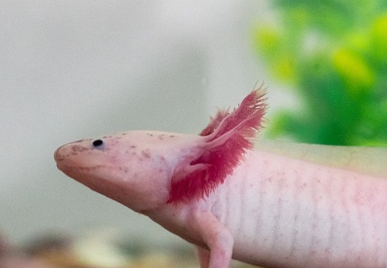
- What is the ratio of legs to toes in an axolotl? Show your reasoning.
- How many legs, toes, and gills does an axolotl have? Consider doing a little research to find out!

Lesson 5 Summary
All ratios that are equivalent to $a:b$ can be made by multiplying both $a$ and $b$ by the same number.
For example, the ratio $18:12$ is equivalent to $9:6$ because both 9 and 6 are multiplied by the same number: 2.
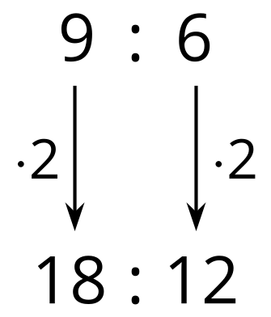
$3:2$ is also equivalent to $9:6$, because both 9 and 6 are multiplied by the same number: $\frac{1}{3}$.
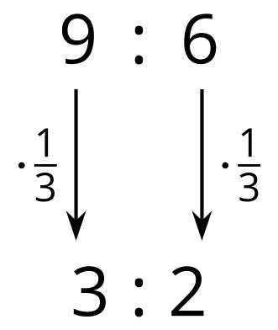
Is $18:15$ equivalent to $9:6$?
No, because 18 is $9⋅2$, but 15 is not $6⋅2$.
