Grade 2
Unit 1Lesson 10CC BY NC 2024 Illustrative Mathematics®
Unit 1, Lesson 10

Represent Data Using Picture Graphs and Bar Graphs
- Let’s make our own bar and picture graphs.
Grade 2
Unit 1Lesson 10CC BY NC 2024 Illustrative Mathematics®

Warm-upWhich Three Go Together: Data
Which 3 go together?
Unable to process <img src="/tikz_files/237778.svg">Failed: rsvg-convert --format png --dpi-x 300 --dpi-y 300 /app/tmp/svgtopng-1786380666.268305.svg --output /app/tmp/svgtopng-1786380666.268305.png Backtrace: /app/app/services/script/runner.rb:34:in `block in run_cmd' <internal:kernel>:90:in `tap' /app/app/services/script/runner.rb:32:in `run_cmd' /app/app/services/script/svg_to_png.rb:27:in `convert_svg_to_png' /app/app/services/script/svg_to_png.rb:17:in `to_png' /app/vendor/bundle/ruby/3.3.0/gems/embeddable_content-1.1.0/app/services/embeddable_content/images/image_downloader.rb:37:in `png_rendered_from_svg' /app/vendor/bundle/ruby/3.3.0/gems/embeddable_content-1.1.0/app/services/embeddable_content/images/image_downloader.rb:33:in `raw_image_data' /app/vendor/bundle/ruby/3.3.0/gems/embeddable_content-1.1.0/app/services/embeddable_content/images/image_downloader.rb:13:in `block in save' <internal:kernel>:90:in `tap' /app/vendor/bundle/ruby/3.3.0/gems/embeddable_content-1.1.0/app/services/embeddable_content/images/image_downloader.rb:13:in `save' Unable to process <img src="/tikz_files/237779.svg">Failed: rsvg-convert --format png --dpi-x 300 --dpi-y 300 /app/tmp/svgtopng-1786380666.3514543.svg --output /app/tmp/svgtopng-1786380666.3514543.png Backtrace: /app/app/services/script/runner.rb:34:in `block in run_cmd' <internal:kernel>:90:in `tap' /app/app/services/script/runner.rb:32:in `run_cmd' /app/app/services/script/svg_to_png.rb:27:in `convert_svg_to_png' /app/app/services/script/svg_to_png.rb:17:in `to_png' /app/vendor/bundle/ruby/3.3.0/gems/embeddable_content-1.1.0/app/services/embeddable_content/images/image_downloader.rb:37:in `png_rendered_from_svg' /app/vendor/bundle/ruby/3.3.0/gems/embeddable_content-1.1.0/app/services/embeddable_content/images/image_downloader.rb:33:in `raw_image_data' /app/vendor/bundle/ruby/3.3.0/gems/embeddable_content-1.1.0/app/services/embeddable_content/images/image_downloader.rb:13:in `block in save' <internal:kernel>:90:in `tap' /app/vendor/bundle/ruby/3.3.0/gems/embeddable_content-1.1.0/app/services/embeddable_content/images/image_downloader.rb:13:in `save'
C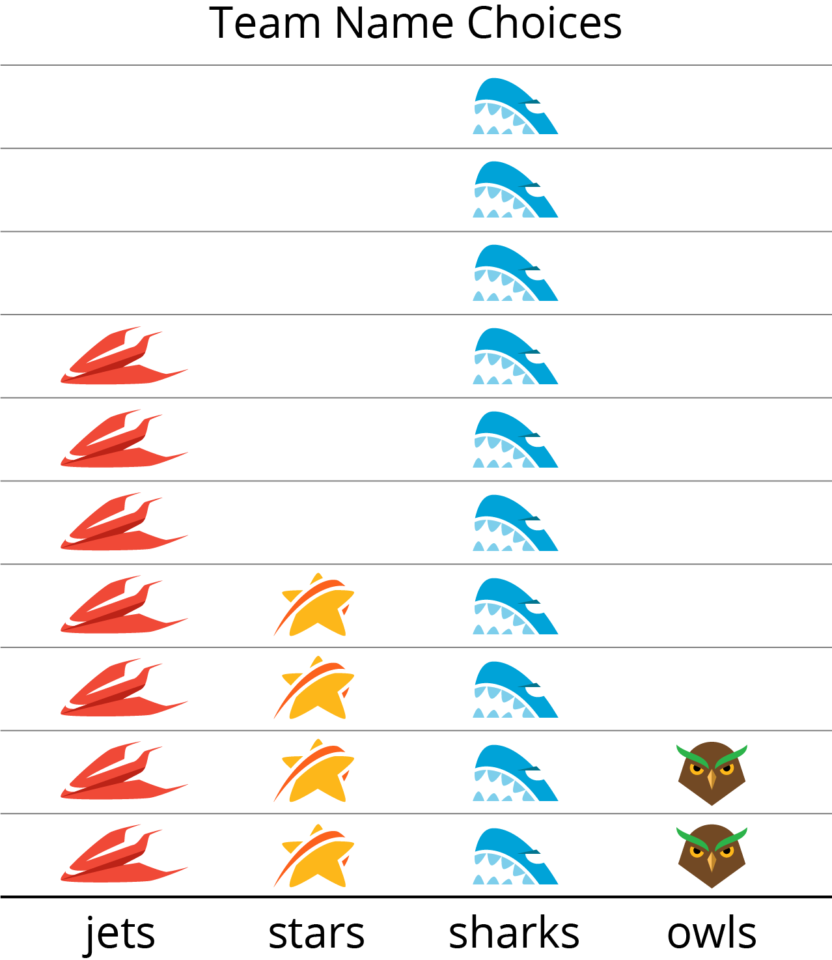
Unable to process <img src="/tikz_files/237780.svg">Failed: rsvg-convert --format png --dpi-x 300 --dpi-y 300 /app/tmp/svgtopng-1786380666.484347.svg --output /app/tmp/svgtopng-1786380666.484347.png Backtrace: /app/app/services/script/runner.rb:34:in `block in run_cmd' <internal:kernel>:90:in `tap' /app/app/services/script/runner.rb:32:in `run_cmd' /app/app/services/script/svg_to_png.rb:27:in `convert_svg_to_png' /app/app/services/script/svg_to_png.rb:17:in `to_png' /app/vendor/bundle/ruby/3.3.0/gems/embeddable_content-1.1.0/app/services/embeddable_content/images/image_downloader.rb:37:in `png_rendered_from_svg' /app/vendor/bundle/ruby/3.3.0/gems/embeddable_content-1.1.0/app/services/embeddable_content/images/image_downloader.rb:33:in `raw_image_data' /app/vendor/bundle/ruby/3.3.0/gems/embeddable_content-1.1.0/app/services/embeddable_content/images/image_downloader.rb:13:in `block in save' <internal:kernel>:90:in `tap' /app/vendor/bundle/ruby/3.3.0/gems/embeddable_content-1.1.0/app/services/embeddable_content/images/image_downloader.rb:13:in `save'
Grade 2
Unit 1Lesson 10CC BY NC 2024 Illustrative Mathematics®

Activity 1Draw Picture Graphs
Unable to process <img src="/tikz_files/237781.svg">Failed: rsvg-convert --format png --dpi-x 300 --dpi-y 300 /app/tmp/svgtopng-1786380666.564428.svg --output /app/tmp/svgtopng-1786380666.564428.png Backtrace: /app/app/services/script/runner.rb:34:in `block in run_cmd' <internal:kernel>:90:in `tap' /app/app/services/script/runner.rb:32:in `run_cmd' /app/app/services/script/svg_to_png.rb:27:in `convert_svg_to_png' /app/app/services/script/svg_to_png.rb:17:in `to_png' /app/vendor/bundle/ruby/3.3.0/gems/embeddable_content-1.1.0/app/services/embeddable_content/images/image_downloader.rb:37:in `png_rendered_from_svg' /app/vendor/bundle/ruby/3.3.0/gems/embeddable_content-1.1.0/app/services/embeddable_content/images/image_downloader.rb:33:in `raw_image_data' /app/vendor/bundle/ruby/3.3.0/gems/embeddable_content-1.1.0/app/services/embeddable_content/images/image_downloader.rb:13:in `block in save' <internal:kernel>:90:in `tap' /app/vendor/bundle/ruby/3.3.0/gems/embeddable_content-1.1.0/app/services/embeddable_content/images/image_downloader.rb:13:in `save'
Represent the table data shown in your table in a picture graph.
Table # _______
Unable to process <img src="/tikz_files/237782.svg">Failed: rsvg-convert --format png --dpi-x 300 --dpi-y 300 /app/tmp/svgtopng-1786380666.6060126.svg --output /app/tmp/svgtopng-1786380666.6060126.png Backtrace: /app/app/services/script/runner.rb:34:in `block in run_cmd' <internal:kernel>:90:in `tap' /app/app/services/script/runner.rb:32:in `run_cmd' /app/app/services/script/svg_to_png.rb:27:in `convert_svg_to_png' /app/app/services/script/svg_to_png.rb:17:in `to_png' /app/vendor/bundle/ruby/3.3.0/gems/embeddable_content-1.1.0/app/services/embeddable_content/images/image_downloader.rb:37:in `png_rendered_from_svg' /app/vendor/bundle/ruby/3.3.0/gems/embeddable_content-1.1.0/app/services/embeddable_content/images/image_downloader.rb:33:in `raw_image_data' /app/vendor/bundle/ruby/3.3.0/gems/embeddable_content-1.1.0/app/services/embeddable_content/images/image_downloader.rb:13:in `block in save' <internal:kernel>:90:in `tap' /app/vendor/bundle/ruby/3.3.0/gems/embeddable_content-1.1.0/app/services/embeddable_content/images/image_downloader.rb:13:in `save'
Grade 2
Unit 1Lesson 10CC BY NC 2024 Illustrative Mathematics®

Activity 2Draw Bar Graphs
Unable to process <img src="/tikz_files/237786.svg">Failed: rsvg-convert --format png --dpi-x 300 --dpi-y 300 /app/tmp/svgtopng-1786380666.6630557.svg --output /app/tmp/svgtopng-1786380666.6630557.png Backtrace: /app/app/services/script/runner.rb:34:in `block in run_cmd' <internal:kernel>:90:in `tap' /app/app/services/script/runner.rb:32:in `run_cmd' /app/app/services/script/svg_to_png.rb:27:in `convert_svg_to_png' /app/app/services/script/svg_to_png.rb:17:in `to_png' /app/vendor/bundle/ruby/3.3.0/gems/embeddable_content-1.1.0/app/services/embeddable_content/images/image_downloader.rb:37:in `png_rendered_from_svg' /app/vendor/bundle/ruby/3.3.0/gems/embeddable_content-1.1.0/app/services/embeddable_content/images/image_downloader.rb:33:in `raw_image_data' /app/vendor/bundle/ruby/3.3.0/gems/embeddable_content-1.1.0/app/services/embeddable_content/images/image_downloader.rb:13:in `block in save' <internal:kernel>:90:in `tap' /app/vendor/bundle/ruby/3.3.0/gems/embeddable_content-1.1.0/app/services/embeddable_content/images/image_downloader.rb:13:in `save'

Represent your table data in a bar graph.
Table # _______
Unable to process <img src="/tikz_files/237782.svg">Failed: rsvg-convert --format png --dpi-x 300 --dpi-y 300 /app/tmp/svgtopng-1786380666.8409674.svg --output /app/tmp/svgtopng-1786380666.8409674.png Backtrace: /app/app/services/script/runner.rb:34:in `block in run_cmd' <internal:kernel>:90:in `tap' /app/app/services/script/runner.rb:32:in `run_cmd' /app/app/services/script/svg_to_png.rb:27:in `convert_svg_to_png' /app/app/services/script/svg_to_png.rb:17:in `to_png' /app/vendor/bundle/ruby/3.3.0/gems/embeddable_content-1.1.0/app/services/embeddable_content/images/image_downloader.rb:37:in `png_rendered_from_svg' /app/vendor/bundle/ruby/3.3.0/gems/embeddable_content-1.1.0/app/services/embeddable_content/images/image_downloader.rb:33:in `raw_image_data' /app/vendor/bundle/ruby/3.3.0/gems/embeddable_content-1.1.0/app/services/embeddable_content/images/image_downloader.rb:13:in `block in save' <internal:kernel>:90:in `tap' /app/vendor/bundle/ruby/3.3.0/gems/embeddable_content-1.1.0/app/services/embeddable_content/images/image_downloader.rb:13:in `save'

