Lesson 1: Let’s Make a Box
- Let’s investigate volumes of different boxes.

1.1: Which One Doesn’t Belong: Boxes
Which one doesn’t belong?
A.
length: 4 cm
width: 8 cm
height: 10 cm
B.
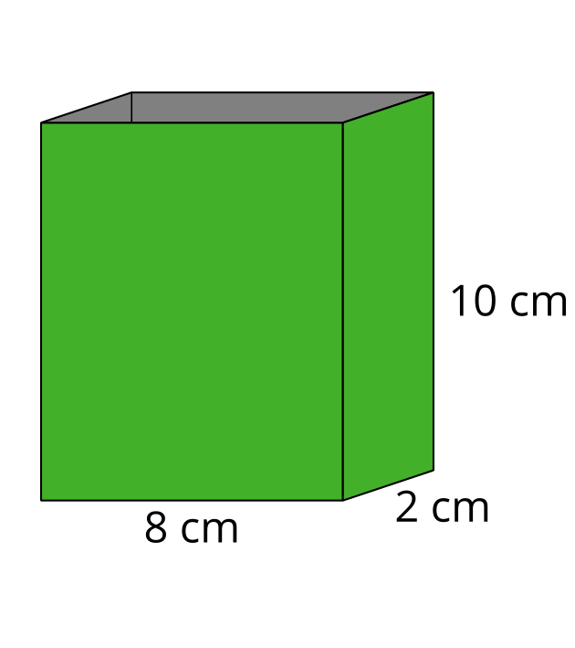
C.
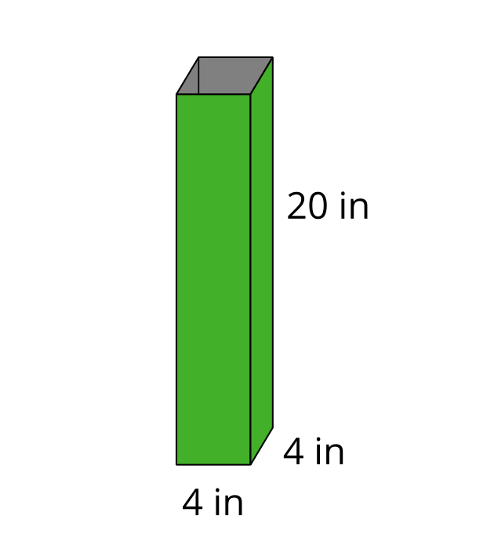
D.
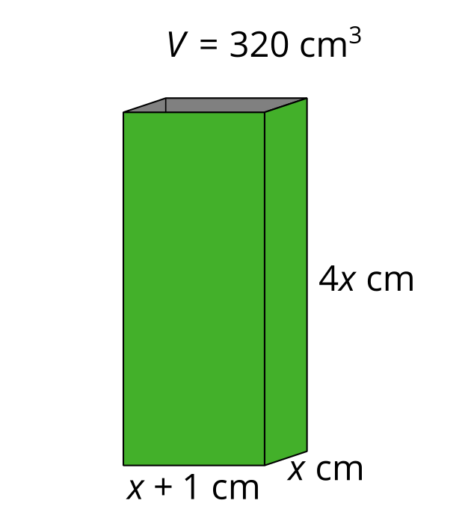

1.2: Building Boxes
Your teacher will give you some supplies.
- Construct an open-top box from a sheet of paper by cutting out a square from each corner and then folding up the sides.
- Calculate the volume of your box, and complete the table with your information.
side length of square cutout (in) | length (in) | width (in) | height (in) | volume of box (in³)
1

1.3: Building the Biggest Box

- The volume $V\left(x\right)$ in cubic inches of the open-top box is a function of the side length $x$ in inches of the square cutouts. Make a plan to figure out how to construct the box with the largest volume.
- Pause here so your teacher can review your plan.
- Write an expression for $V\left(x\right)$.
- Use graphing technology to create a graph representing $V\left(x\right)$. Approximate the value of $x$ that would allow you to construct an open-top box with the largest volume possible from one piece of paper.

Are you ready for more?
The surface area $A\left(x\right)$ in square inches of the open-top box is also a function of the side length $x$ in inches of the square cutouts.
- Find one expression for $A\left(x\right)$ by summing the area of the five faces of our open-top box.
- Find another expression for $A\left(x\right)$ by subtracting the area of the cutouts from the area of the paper.
- Show algebraically that these two expressions are equivalent.

Lesson 1 Summary
Polynomials can be used to model lots of situations. One example is to model the volume of a box created by removing squares from each corner of a rectangle of paper.
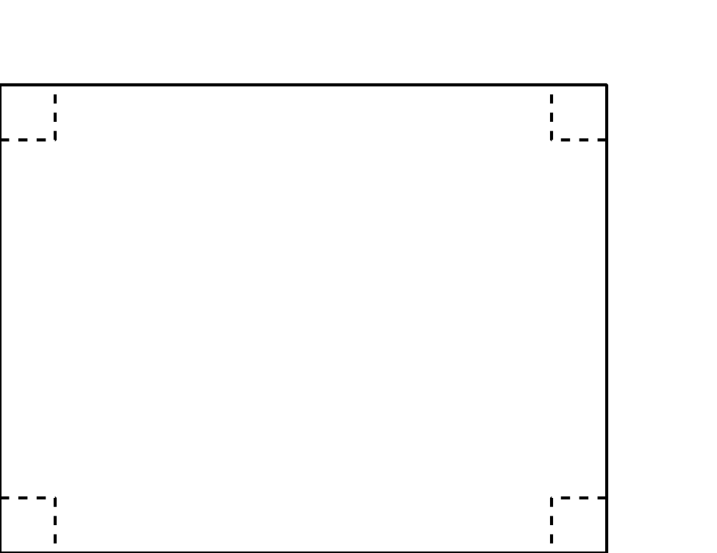
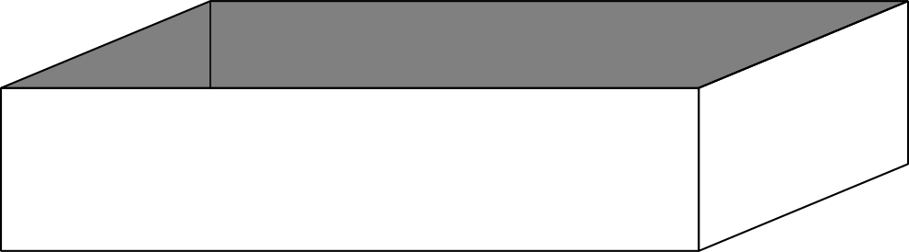
Let $V\left(x\right)$ be the volume of the box in cubic inches where $x$ is the side length in inches of each square removed from the four corners.
To define $V$ using an expression, we can use the fact that the volume of a cube is $\left(length\right)\left(width\right)\left(height\right)$. If the piece of paper we start with is 3 inches by 8 inches, then:
$V\left(x\right)=\left(3−2x\right)\left(8−2x\right)\left(x\right)$
What are some reasonable values for $x$? Cutting out squares with side lengths less than 0 inches doesn’t make sense, and similarly, we can’t cut out squares larger than 1.5 inches, since the short side of the paper is only 3 inches (since $3−1.5⋅2=0$). You may remember that the name for the set of all the input values that make sense to use with a function is the domain. Here, a reasonable domain is somewhere larger than 0 inches but less than 1.5 inches, depending on how well we can cut and fold!
By graphing this function, it is possible to find the maximum value within a specific domain. Here is a graph of $y=V\left(x\right)$. It looks like the largest volume we can get for a box made this way from a 3 inch by 8 inch piece of paper is about 7.4 in³.
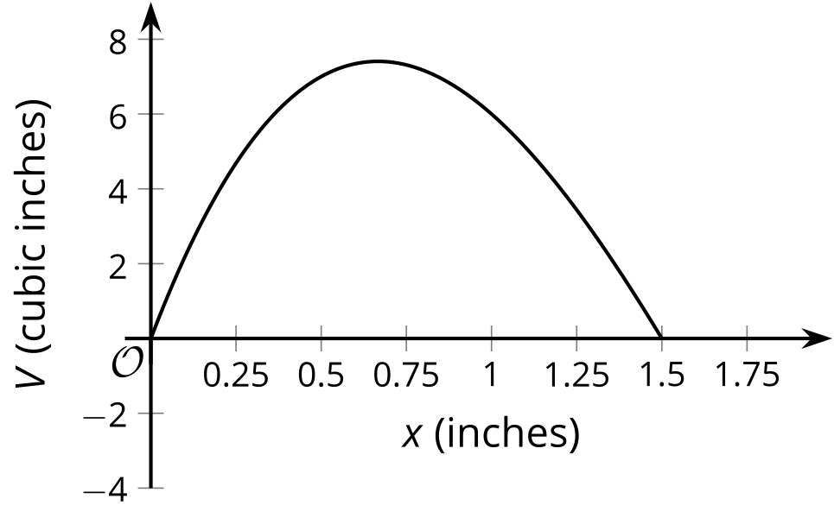
© CC BY 2019 by Illustrative Mathematics®

