Lesson 11 Practice Problems
- Select all the polygons.
- 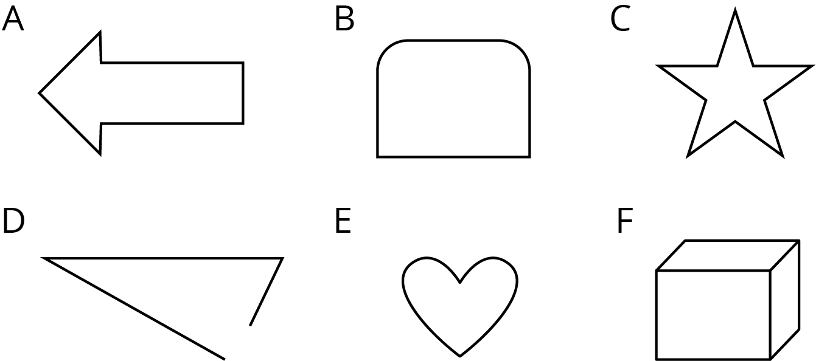
  - A
  - B
  - C
  - D
  - E
  - F
- Mark each vertex with a large dot. How many edges and vertices does this polygon have?
- 
- Find the area of this trapezoid. Explain or show your strategy.
- 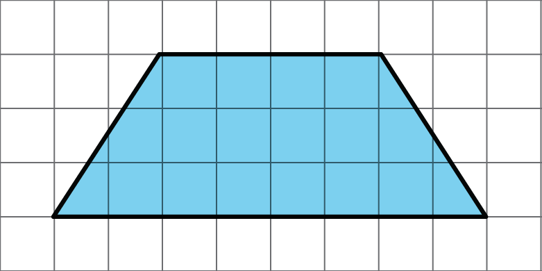

- Lin and Andre used different methods to find the area of a regular hexagon with 6-inch sides. Lin decomposed the hexagon into six identical, equilateral triangles. Andre decomposed the hexagon into a rectangle and two triangles.
- 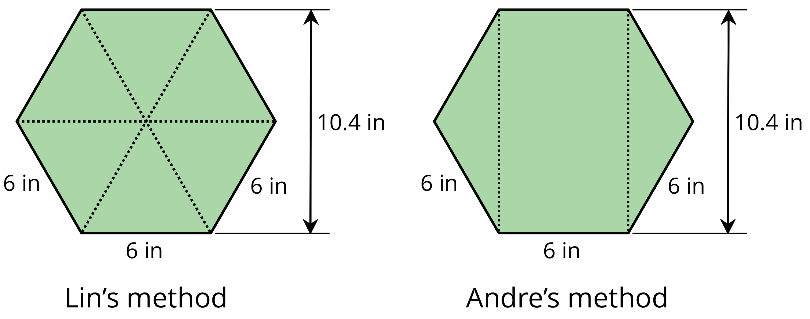
- Find the area of the hexagon using each person’s method. Show your reasoning.

  - Identify a base and a corresponding height that can be used to find the area of this triangle. Label the base $b$ and the corresponding height $h$.
  - 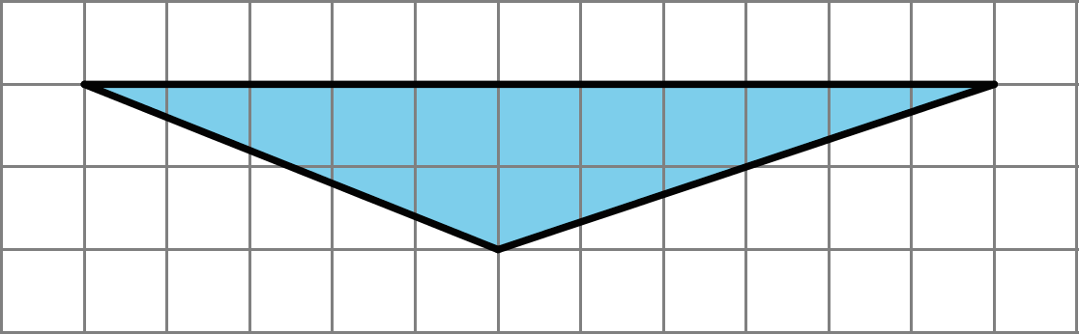
  - Find the area of the triangle. Show your reasoning.
- (From Unit 1, Lesson 9.)
- On the grid, draw three different triangles with an area of 8 square units. Label the base and height of each triangle.
- 
- (From Unit 1, Lesson 10.)
© CC BY Open Up Resources. Adaptations CC BY IM.

