Grade 2
Unit 2Lesson 9CC BY NC 2024 Illustrative Mathematics®
Unit 2, Lesson 9

Add and Subtract within 100
- Let’s find the difference in our own way.
Grade 2
Unit 2Lesson 9CC BY NC 2024 Illustrative Mathematics®

Warm-upWhich Three Go Together: Tens and Ones
Which 3 go together?
A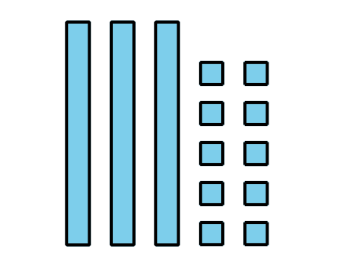
B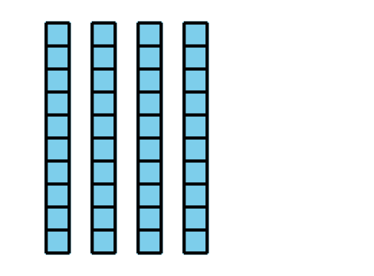
C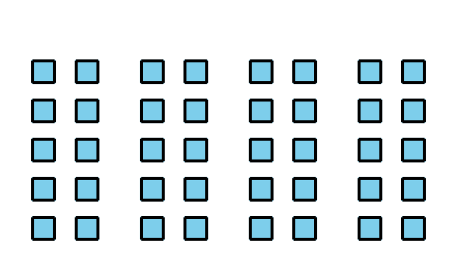
D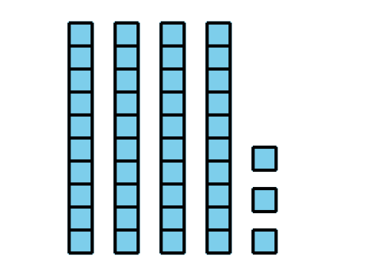
Grade 2
Unit 2Lesson 9CC BY NC 2024 Illustrative Mathematics®

Activity 1Card Sort: Sort and Find the Value
Your teacher will give you a set of cards that show expressions and diagrams.
- Match each expression to a diagram. Be ready to explain your reasoning.
- Choose 1 addition expression. Find the value of the sum.
- Choose 1 subtraction expression. Find value of the difference.
Grade 2
Unit 2Lesson 9CC BY NC 2024 Illustrative Mathematics®

Activity 2Add or Subtract
Find the value of each expression. Show your thinking using objects, drawings, numbers, or words.
- $27+47$
- $55−27$
- $36+38$
- $82−39$

Section B Summary
We added two-digit numbers. We composed 1 ten by putting 10 ones together. We also subtracted two-digit numbers. We decomposed 1 ten by breaking it apart into 10 ones. We used base-ten blocks and base-ten diagrams to show our thinking.
$63−18$
