Grade 6
Unit 3Lesson 8CC BY NC Illustrative Mathematics, based on IM 6–8 Math, CC BY Open Up Resources.
Unit 3, Lesson 8

Solving Rate Problems
Let’s investigate the Burj Khalifa building.
Grade 6
Unit 3Lesson 8CC BY NC Illustrative Mathematics, based on IM 6–8 Math, CC BY Open Up Resources.

8.1Notice and Wonder: Heights
What do you notice? What do you wonder?
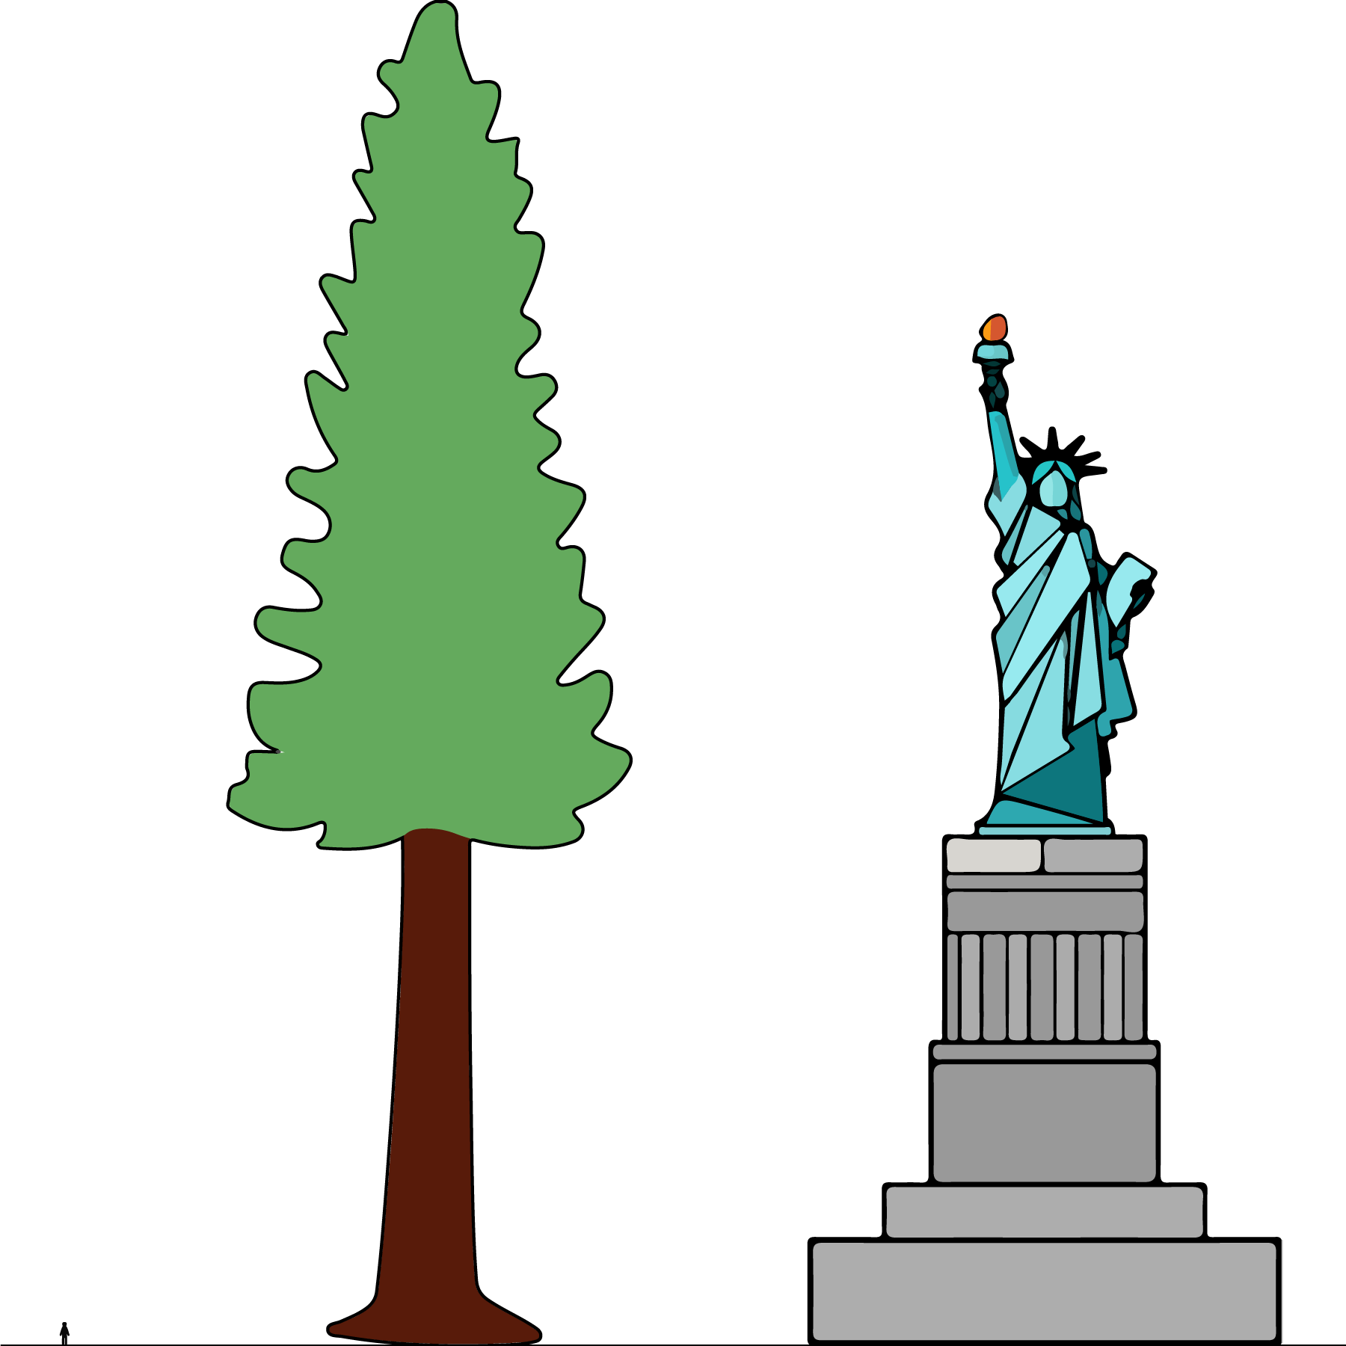

Grade 6
Unit 3Lesson 8CC BY NC Illustrative Mathematics, based on IM 6–8 Math, CC BY Open Up Resources.

8.2Climbing the Burj Khalifa
In 2011, a professional climber, Alain Robert, scaled the outside of the Burj Khalifa, making it all the way to 828 meters (the highest point on which a person can stand) in 6 hours.
Assuming that he climbed at the same rate the whole way:
- How far did he climb in the first 2 hours?
- How far did he climb in 5 hours?
- How far did he climb in the final 15 minutes?

Are you ready for more?
The 160th floor of the Burj Khalifa is 2,909 steps from the ground floor. If you were to climb all the way to that top floor, how long would it take you?
To get an idea of your climbing rate, try timing yourself going up a set of stairs in your school or in your neighborhood.
Grade 6
Unit 3Lesson 8CC BY NC Illustrative Mathematics, based on IM 6–8 Math, CC BY Open Up Resources.

8.3Window Washing
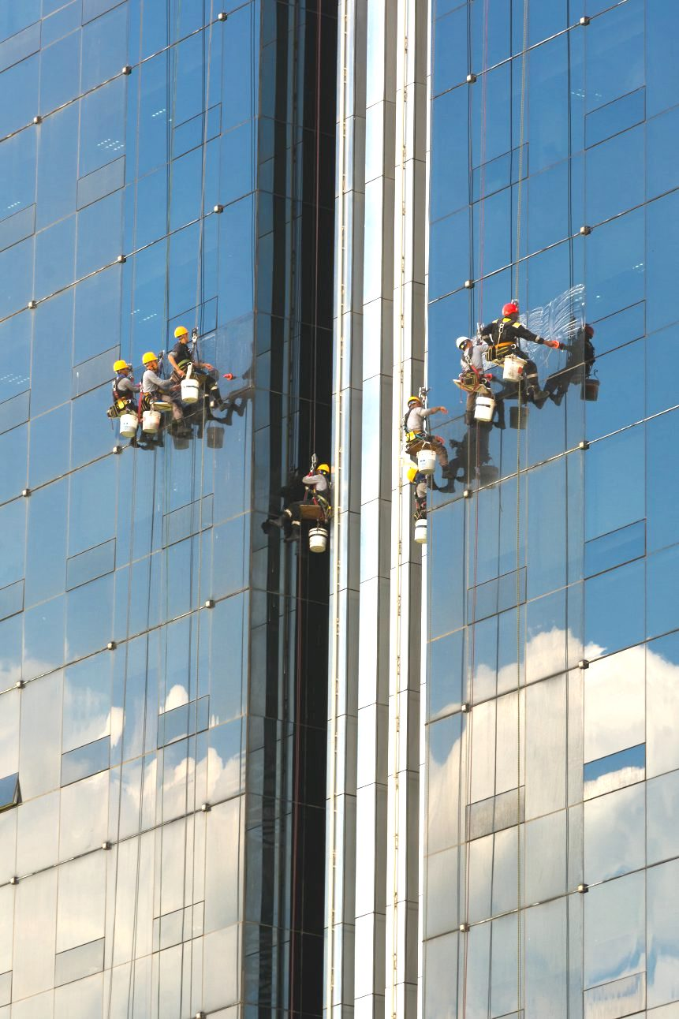
A window-washing crew can wash 15 windows in 18 minutes.
At this rate, how long will it take this crew to wash all the windows on the Burj Khalifa?

Lesson 8 Summary
There are many real-world situations in which something keeps happening at the same rate. In these situations, we can use equivalent ratios or unit rates to make predictions or to answer questions about the quantities.
For example, the school cafeteria serves 600 students in 40 minutes. At this rate, how long will it take the cafeteria to serve 750 students?
We can use a table or a double number line diagram to find ratios that are equivalent to the given ratio.
Both the double number line diagram and table show that it will take the cafeteria 50 minutes to serve 750 students.
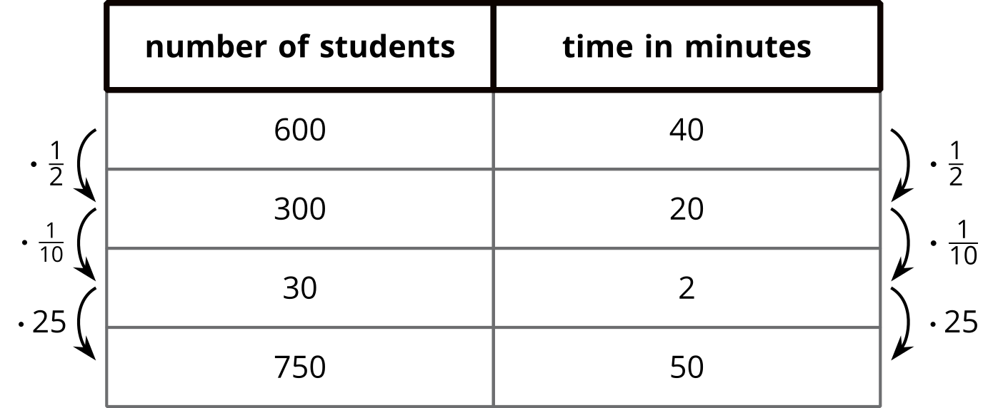
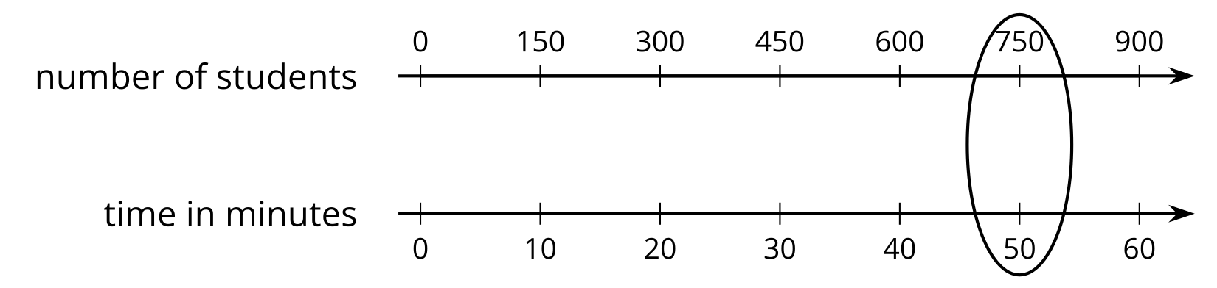
How many students can the cafeteria serve in 27 minutes?
In this case, it is helpful to find a unit rate—the number of students the cafeteria can serve per minute. Dividing the number of students, 600, by the number of minutes, 40, gives us this unit rate. $600÷40=15$, so the cafeteria can serve 15 students per minute. This means that in 27 minutes it can serve $27⋅15$, or 405 students.

