Grade 6
Unit 7Lesson 18CC BY NC Illustrative Mathematics, based on IM 6–8 Math, CC BY Open Up Resources.
Unit 7, Lesson 18

Using Common Multiples and Common Factors
Let’s use common factors and common multiples to solve problems.
Grade 6
Unit 7Lesson 18CC BY NC Illustrative Mathematics, based on IM 6–8 Math, CC BY Open Up Resources.

18.1Keeping a Steady Beat
Your teacher will give you instructions to create a class rhythm. As you participate, think about these questions:
- When will the two sounds happen at the same time?
- How does this game relate to common factors or common multiples?
Grade 6
Unit 7Lesson 18CC BY NC Illustrative Mathematics, based on IM 6–8 Math, CC BY Open Up Resources.

18.2Factors and Multiples
Work with your partner to solve the following problems.
- Party. Elena is buying cups and plates for her party. Cups are sold in packs of 8, and plates are sold in packs of 6. She wants to have the same number of plates and cups.
  - Find the smallest number of plates and cups that meets her requirement.
  - How many packs of each supply will she need to buy to get that number?
  - Name two other quantities of plates and cups she could get to meet her requirement.
- ​Tiles. A restaurant owner is creating a mural on one wall made entirely with square tiles. The tiles will be laid side-by-side to cover the entire wall with no gaps, and none of the tiles can be cut. The wall is a rectangle that measures 18 feet by 12 feet.
  - What is the side length, in feet, of the largest possible tile she could use? Explain or show your reasoning.
  - How many of these largest size tiles are needed?
  - Name the side lengths, in feet, of two other tile sizes that can be used.
- Stickers. To celebrate the first day of spring, Lin is putting stickers on some of the 100 pages in her math notebook. She puts a skateboard sticker on every 4th page, and a kite sticker on every 5th page.
  - Find three page numbers that will get both stickers.
  - Will the 30th page have no stickers, 1 sticker, or 2 stickers? Explain or show your reasoning.
- Kits. The school nurse is assembling first-aid kits for the teachers. She has 75 small bandages and 90 large bandages. All the kits must have the same number of each size bandage, and all bandages must be used.
  - What is the largest number of kits the nurse can make?
  - How many small bandages and large bandages will be in each kit?
- Put a checkmark in the appropriate column to show what kind of mathematical work was involved in each problem situation.
- problem | - finding multiples | - finding least  common multiple | - finding factors | - finding greatest  common factor
- Party
- Tiles
- Stickers
- Kits

Are you ready for more?
You probably know how to draw a five-pointed star without lifting your pencil. One way to do this is to start with five dots arranged in a circle, then connect every second dot.
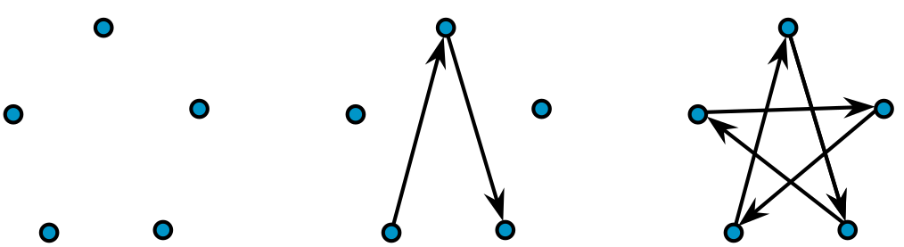
If you try the same thing with six dots arranged in a circle, you will have to lift your pencil. Once you make the first triangle, you’ll have to find an empty dot and start the process over. Your six-pointed star has two pieces that are each drawn without lifting the pencil.
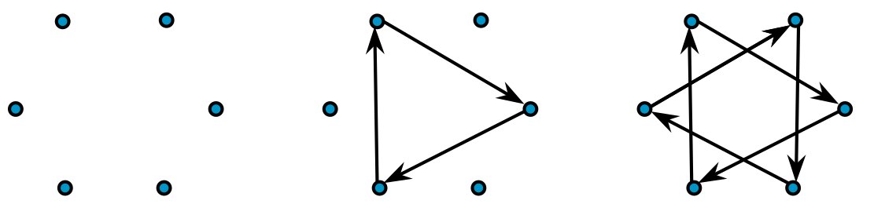
With twelve dots arranged in a circle, we can make some twelve-pointed stars.
- Start with one dot and connect every second dot, as if you were drawing a five-pointed star. Can you draw the twelve-pointed star without lifting your pencil? If not, how many pieces does the twelve-pointed star have?
- 
- This time, connect every third dot. Can you draw this twelve-pointed star without lifting your pencil? If not, how many pieces do you get?
- 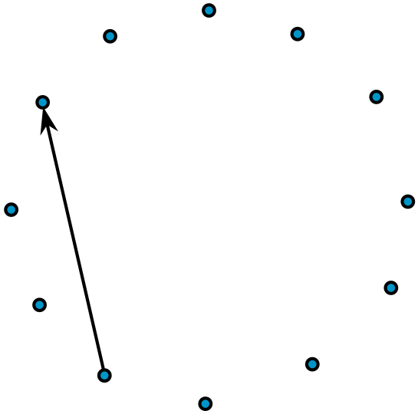
- What do you think will happen if you connect every fourth dot? Try it. How many pieces do you get?
- Do you think there is any way to draw a twelve-pointed star without lifting your pencil? Try it out.
- ​
- Now investigate eight-pointed stars, nine-pointed stars, and ten-pointed stars. What patterns do you notice?
Grade 6
Unit 7Lesson 18CC BY NC Illustrative Mathematics, based on IM 6–8 Math, CC BY Open Up Resources.

18.3More Factors and Multiples
Read and discuss each problem with your group. Without solving, predict whether each problem involves finding common multiples or finding common factors. Circle one or more options to show your prediction.
Then your teacher will assign one problem to your group. Work with your group to solve the problem. Then create a visual display that explains your group’s mathematical thinking while solving the problem. Your display may include a diagram, lists, tables, equations, descriptions, and math vocabulary.
- Soccer. Diego and Andre are both in a summer soccer league. During the month of August, Diego has a game every 3rd day, starting August 3rd, and Andre has a game every 4th day, starting August 4th.
  - common multiples
  - least common multiple
  - common factors
  - greatest common factor
  - What is the first date that both Diego and Andre will have a game?
  - How many of their games fall on the same date in the month of August?
- Performances. During a performing arts festival, students from elementary and middle schools will be grouped together for various performances. There are 32 elementary students and 40 middle-school students. The arts director wants identical groups for the performances, with students from both schools in each group. Each student must be in a group and can be a part of only one group.
  - common multiples
  - least common multiple
  - common factors
  - greatest common factor
  - Name all the possible groupings of elementary- and middle-school students.
  - What is the largest number of groups that can be formed? How many elementary-school students and how many middle-school students will be in each group?
- Lights. A string of lights has red, gold, and blue lights. The red lights are set to blink every 12 seconds, the gold lights are set to blink every 8 seconds, and the blue lights are set to blink every 6 seconds. The lights are on an automatic timer that starts each day at 7:00 p.m. and stops at midnight.
  - common multiples
  - least common multiple
  - common factors
  - greatest common factor
  - How often will all 3 colors of lights blink at the exact same time?
  - How many total times will this happen in one day?
- Banners. Noah is making identical square banners for students to hold during the Opening Day game. He has two square pieces of cloth—one is 72 inches wide, and the other is 90 inches wide. He wants to use up all the cloth and make the largest square banners possible.
  - common multiples
  - least common multiple
  - common factors
  - greatest common factor
  - How wide should he cut the banners?
  - How many banners can he cut?
- Dancers. Elena is part of a recital where 48 dancers perform in the dark. All the dancers enter the stage in a straight line wearing glow-in-the-dark accessories. Every 3rd dancer wears a glow-in-the-dark headband, every 5th dancer wears a glow-in-the-dark belt, and every 9th dancer wears a set of glow-in-the-dark gloves.
  - common multiples
  - least common multiple
  - common factors
  - greatest common factor
  - If Elena is the 30th dancer, what accessories will she wear?
  - Will any of the dancers wear all 3 accessories? If so, which one(s)?
  - How many of each accessory will the dance teacher need to order?
Grade 6
Unit 7Lesson 18CC BY NC Illustrative Mathematics, based on IM 6–8 Math, CC BY Open Up Resources.

18.4Factors and Multiples Bingo
Your teacher will explain the directions for a bingo game.
- Share one bingo board and some bingo chips with a partner.
- Your teacher will read some statements out loud. Work with your partner to decide which numbers fit each statement.
- For each number you cover with a chip, be prepared to identify which statement it corresponds to and to share your reasoning.

Lesson 18 Summary
If a problem requires dividing two whole numbers by the same whole number, solving it involves looking for a common factor. If it requires finding the largest number that can divide into the two whole numbers, we are looking for the greatest common factor.
Suppose we have 12 bagels and 18 muffins and want to make bags so that each bag has the same combination of bagels and muffins. The common factors of 12 and 18 tell us possible number of bags that can be made.
The common factors of 12 and 18 are 1, 2, 3, and 6. For these numbers of bags, here are the number of bagels and muffins per bag.
- 1 bag: 12 bagels and 18 muffins
- 2 bags: 6 bagels and 9 muffins
- 3 bags: 4 bagels and 6 muffins
- 6 bags: 2 bagels and 3 muffins
We can see that the largest number of bags that can be made, 6, is the greatest common factor.
If a problem requires finding a number that is a multiple of two given numbers, solving it involves looking for a common multiple. If it requires finding the first instance the two numbers share a multiple, we are looking for the least common multiple.
Suppose forks are sold in boxes of 9 and spoons are sold in boxes of 15, and we want to buy an equal number of each. The multiples of 9 tell us how many forks we could buy, and the multiples of 15 tell us how many spoons we could buy.
- Forks: 9, 18, 27, 36, 45, 54, 63, 72, 90,. . .
- Spoons: 15, 30, 45, 60, 75, 90,. . .
If we want as many forks as spoons, our options are 45, 90, 135, and so on, but the smallest number of each utensil that we could buy is 45, the least common multiple. This means we would buy 5 boxes of forks ($5⋅9=45$) and 3 boxes of spoons ($3⋅15=45$).

