Lesson 17 Practice Problems
- The relationship between a bacteria population $p$, in thousands, and time $d$, in days, since it was measured to be 1,000 can be represented by the equation $d=\log_{2}p$.
- Select all statements that are true about the situation.
  - Each day, the bacteria population grows by a factor of 2.
  - The equation $p=2^{d}$ also defines the relationship between the population in thousands and time in days.
  - The population reaches 7,000 after $\log_{2}7,​000$ days.
  - The expression $\log_{2}10$ tells us when the population reaches 10,000.
  - The equation $d=\log_{2}p$ represents a logarithmic function.
  - The equation $7=\log_{2}128$ tells us that the population reaches 128,000 in 7 days.
- Here is the graph of a logarithmic function.
- 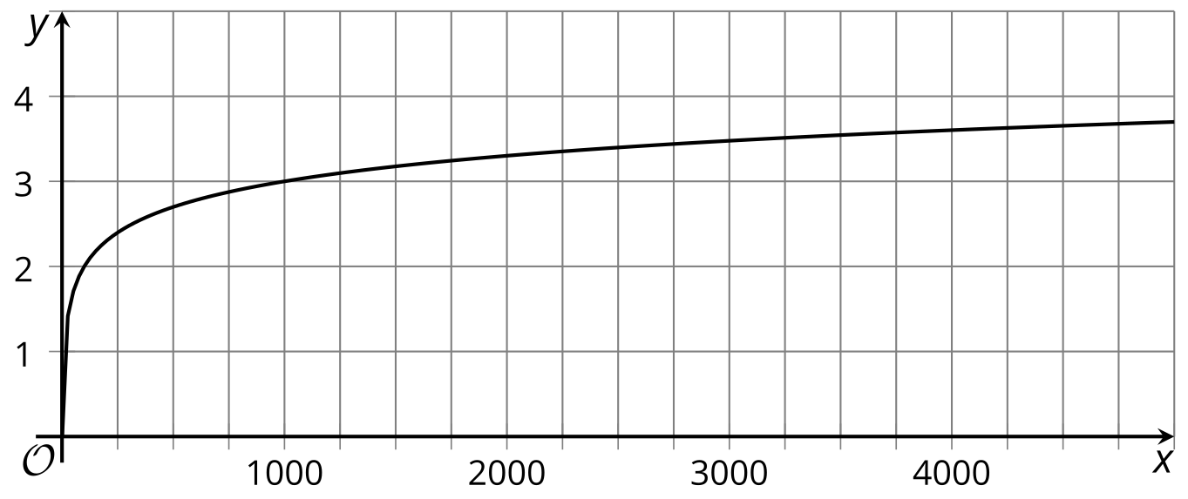
- What is the base of the logarithm? Explain how you know.
- Match each equation with a graph that represents it.
- 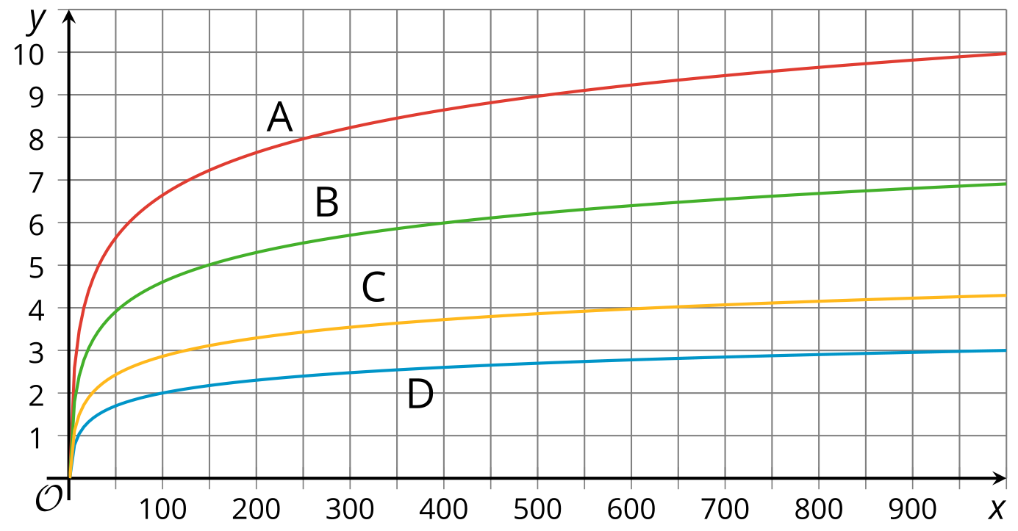
  - A
  - B
  - C
  - D
  - $f\left(x\right)=\log_{2}x$
  - $g\left(x\right)=\log_{10}x$
  - $h\left(x\right)=\log_{5}x$​​
  - $j\left(x\right)=lnx$
- The graph represents the cost of a medical treatment, in dollars, as a function of time, $d$, in decades since 1978.
- The expression $150⋅{\left(1.35\right)}^{3}$ represents the cost of the medical treatment sometime after 1978. Which year does it represent?
- 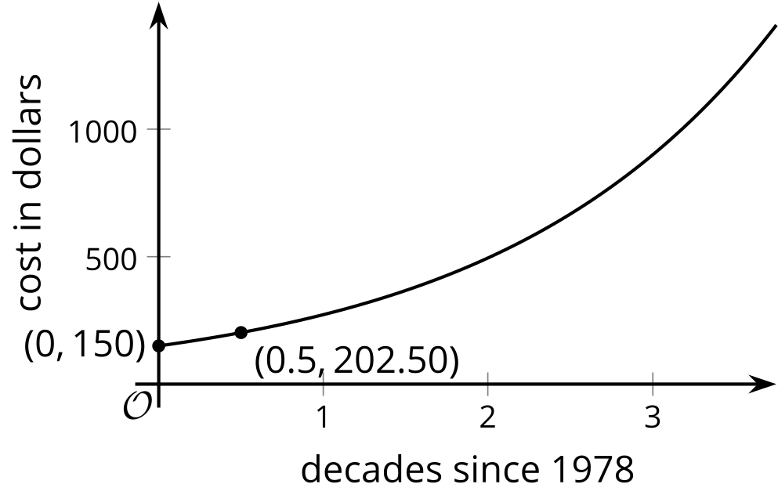
  - 1986
  - 1993
  - 1998
  - 2018
- (From Unit 4, Lesson 5.)
- The equation $A\left(w\right)=180⋅e^{\left(0.01w\right)}$ represents the area, in square centimeters, of a wall covered by mold as a function of $w$, time in weeks since the area was measured.
- Explain or show that we can approximate the area covered by mold in 8 weeks by multiplying $A\left(7\right)$ by 1.01.
- (From Unit 4, Lesson 13.)
- Solve each equation without using a calculator. Some solutions will need to be expressed using log notation.
  - ${10}^{\left(n−3\right)}=10$
  - $\frac{1}{2}⋅{10}^{x}=0.05$
  - ${10}^{\frac{1}{3}t}=100$
  - ${10}^{2x}=48$
- (From Unit 4, Lesson 14.)
- Technology required. The population of Mali can be represented by $m\left(t\right)=17⋅e^{\left(0.03t\right)}$. The population of Saudi Arabia can be represented by $s\left(t\right)=31⋅e^{\left(0.015t\right)}$. In both models, $t$ represents years since 2014 and the populations are measured in millions.
  - Which country had a higher population in 2014? Explain how you know.
  - Which country has a higher growth rate? Explain how you know.
  - Use graphing technology to graph both equations on the same axes.
  - Do the two graphs intersect? If so, estimate their point of intersection and explain what it means in this situation. If not, explain what it means that the two graphs don’t intersect.
- (From Unit 4, Lesson 16.)
© CC BY 2019 by Illustrative Mathematics®

