Lesson 4: Interpretemos expresiones de división

Standards Alignments
Addressing | 3.NBT.A.2, 3.OA.A.2

Teacher-facing Learning Goals
- Interpret division expressions.
- Understand that the same division expression can be used to represent both types of division situations.

Student-facing Learning Goals
- Démosle sentido a expresiones de división.

Lesson Purpose
The purpose of this lesson is for students to interpret division expressions and understand that the same division expression can be used to represent both types of division situations.
Students first match a division expression to a situation that it could represent. Then, students learn that the same division expression can match both “how many groups?” and “how many in each group?” problems depending on how the divisor, the number we are dividing by, is interpreted. Students then have a chance to match drawings and expressions to situations before they write their own division expressions in a subsequent lesson.

Access for:

Students with Disabilities
- Representation (Activity 1)

English Learners
- MLR2 (Activity 2)

Instructional Routines
Number Talk (Warm-up)

Lesson Timeline
Warm-up | 10 min
Activity 1 | 10 min
Activity 2 | 10 min
Activity 3 | 15 min
Lesson Synthesis | 10 min
Cool-down | 5 min

Teacher Reflection Question
What aspects of today’s lesson allowed each of your students to see themselves as productive mathematical reasoners?

Cool-down
(to be completed at the end of the lesson) 5min
Los trompos de Han

Standards Alignments
Addressing | 3.OA.A.2

Student-facing Task Statement
Han tiene 14 trompos. Él reparte los trompos equitativamente en 2 cajas. ¿Cuántos trompos habrá en cada caja?
Selecciona todas las formas en las que podemos representar la situación.
A.

B.
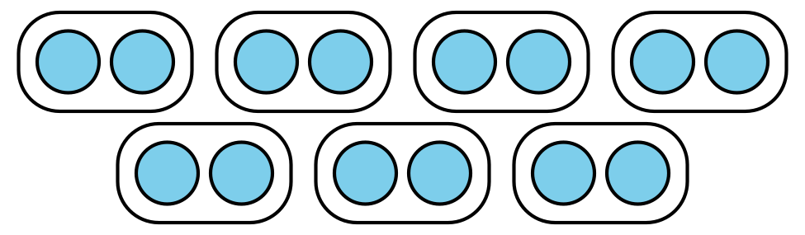
C.
$14÷2$
D.
$14÷7$

Student Responses
A, C

