Lesson 16 Practice Problems
- The revenues of two companies can be modeled with exponential functions $f$ and $g$. Here are the graphs of the two functions. In each function, the revenue is in thousands of dollars and time, $t$, is measured in years. The $y$-coordinate of the intersection is 215.7. Select all statements that correctly describe what the two graphs reveal about the revenues.
- 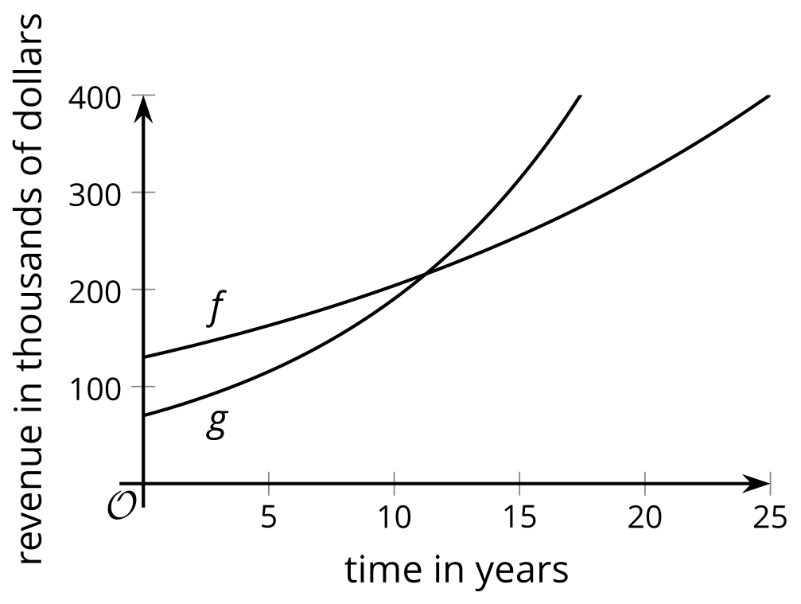
  - The intersection of the graphs tells us when the revenues of the two companies grow by the same factor.
  - The intersection tells us when the two companies have the same revenue.
  - At the intersection, $f\left(t\right)>g\left(t\right)$.
  - At the intersection, $f\left(t\right)=215.7$ and $g\left(t\right)=215.7$.
  - We need to know both expressions that define $f$ and $g$ to find the value of $t$ at the intersection.
  - If we know at least one of the expressions that define $f$ and $g$, we can calculate the value of $t$ at the intersection.
- The population of a fast-growing city in Texas can be modeled with the equation $p\left(t\right)=82⋅e^{\left(0.078t\right)}$. The population of a fast-growing city in Tennessee can be modeled with $q\left(t\right)=132⋅e^{\left(0.047t\right)}$. In both equations, $t$ represents years since 2016 and the population is measured in thousands. The graphs representing the two functions are shown. The point where the two graphs intersect has a $y$-coordinate of about 271.7.
- 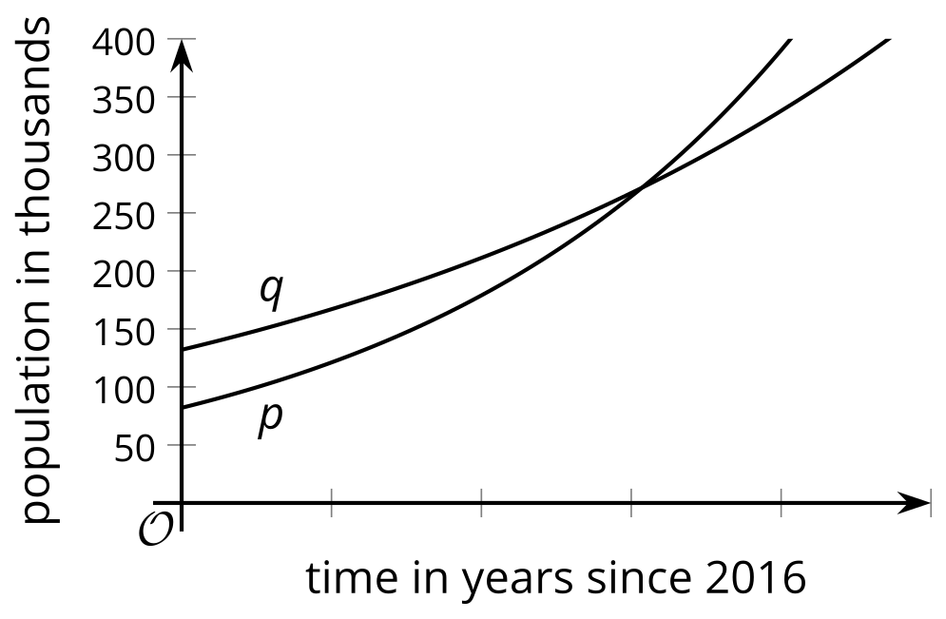
  - What does the intersection mean in this situation?
  - Find the $x$-coordinate of the intersection point by solving each equation. Show your reasoning.
    - $p\left(t\right)=271.7$
    - $q\left(t\right)=271.7$
  - Explain why we can find out the $t$ value at the intersection of the two graphs by solving $p\left(t\right)=q\left(t\right)$.
- The function $f$ is given by $f\left(x\right)=100⋅3^{x}$. Select all equations whose graph meets the graph of $f$ for a positive value of $x$.
  - $y=10⋅e^{x}$
  - $y=500⋅e^{x}$
  - $y=500⋅e^{\text{-}x}$
  - $y=1,​000⋅2^{x}$
  - $y=600⋅{10}^{x}$
- The half-life of nickel-63 is 100 years. A students says, “An artifact with nickel-63 in it will lose a quarter of that substance in 50 years.”
- Do you agree with this statement? Explain your reasoning.
- (From Unit 4, Lesson 7.)
- Technology required. Estimate the value of each expression and record it. Then, use a calculator to find its value and record it.
- expression | - estimate | - calculator value
- $log123$
- $log110,​000$
- $log1.1$
- (From Unit 4, Lesson 11.)
- Here are graphs of the functions $f$ and $g$ given by $f\left(x\right)=100⋅{\left(1.2\right)}^{x}$ and $g\left(x\right)=100⋅e^{0.2x}$.
- Which graph corresponds to each function? Explain how you know.
- 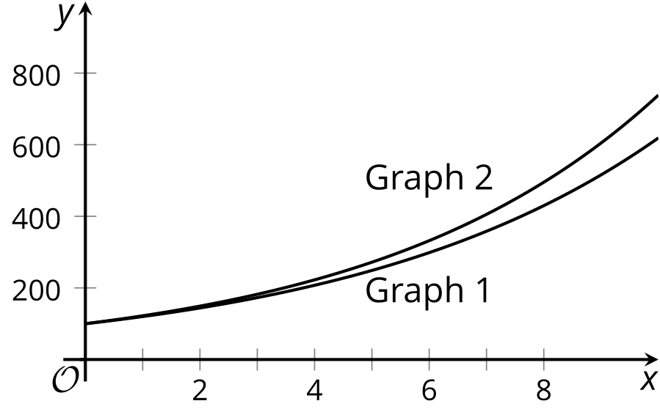
- (From Unit 4, Lesson 13.)
- Here is a graph that represents $f\left(x\right)=e^{x}$.
- 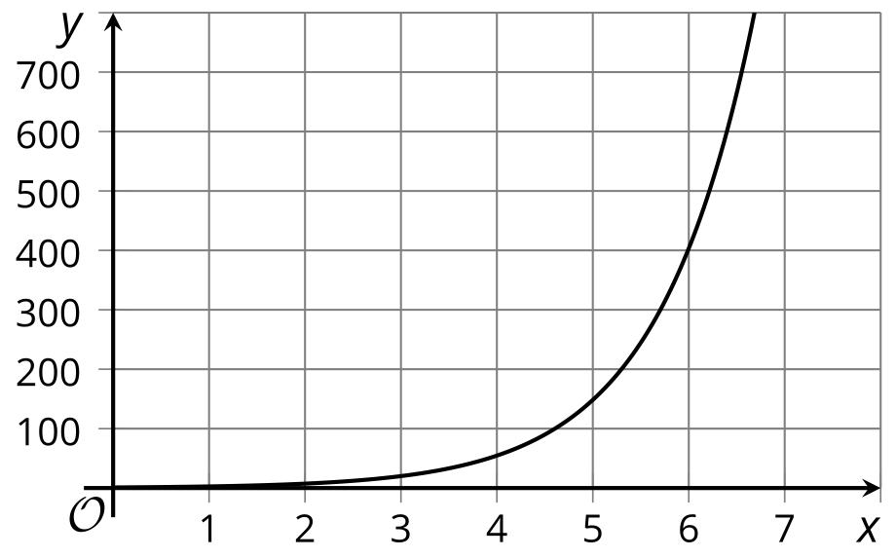
- Explain how we can use the graph to estimate:
  - The solution to an equation such as $300=e^{x}$.
  - The value of $ln700$.
- (From Unit 4, Lesson 15.)
© CC BY 2019 by Illustrative Mathematics®

