Lesson 5 Practice Problems
- The table shows the monthly revenue of a business rising exponentially since it opened an online store.
- months since online  store opened | - monthly revenue  in dollars
- 0 | - 72,000
- 1
- 3 | - 90,000
- 4
- 6 | - 112,500
  - Describe how the monthly revenue is growing.
  - Write an equation to represent the revenue, $R$, as a function of months, $m$, since the online store opened.
  - Find the monthly revenue 1 month after the online store opened. Record the value in the table. Explain your reasoning.
  - Explain how we can use the value of $R\left(1\right)$ to find $R\left(4\right)$.
- At 7 a.m., a colony of 100 bacteria is placed on a petri dish where the population will triple every 6 hours.
- Select all statements that are true about the bacteria population.
  - When the bacteria population reaches 900, 12 hours have passed since the colony was placed on the petri dish.
  - Three hours after the colony is placed on the petri dish, there are 200 bacteria.
  - Three hours after the colony is placed on the petri dish, there are about 173 bacteria in the colony.
  - In the first hour the colony is placed on the petri dish, the population grows by a factor of $3^{\frac{1}{6}}$.
  - Between 8 a.m. and 9 a.m., the population grows by a factor of $3^{\frac{2}{3}}$.
- The graph represents the cost of a medical treatment, in dollars, as a function of time, $d$, in decades since 1978.
- Find the cost of the treatment, in dollars, when $d=1$. Show your reasoning.
- 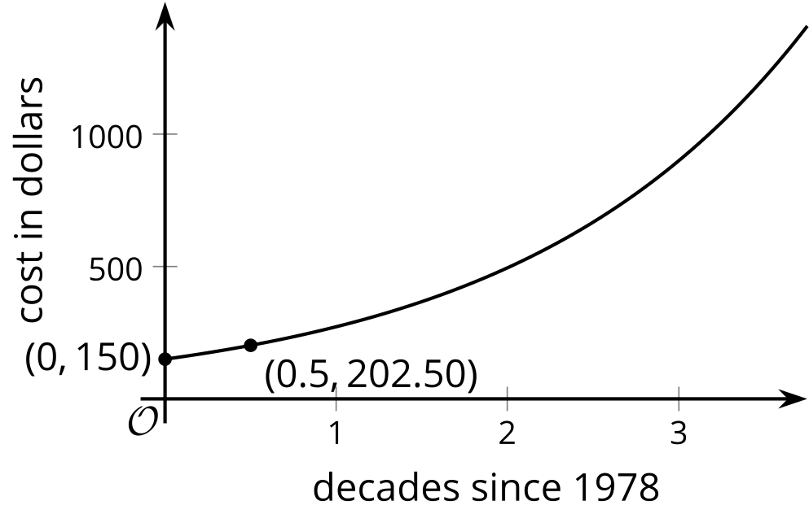
- The exponential function $f$ is given by $f\left(x\right)=3^{x}$.
  - By what factor does $f$ increase when the exponent $x$ increases by 1? Explain how you know.
  - By what factor does $f$ increase when the exponent $x$ increases by 2? Explain how you know.
  - By what factor does $f$ increase when the exponent $x$ increases by $\frac{1}{2}$? Explain how you know.
- A piece of paper has area 93.5 square inches. How many times does it need to be folded in half before the area is less than 1 square inch? Explain how you know.
- (From Unit 4, Lesson 1.)
- The area covered by an invasive tropical plant triples every year. By what factor does the area covered by the plant increase every month?
- (From Unit 4, Lesson 4.)
© CC BY 2019 by Illustrative Mathematics®

