Lesson 3 Practice Problems
- Pentagon $A^{′}B^{′}C^{′}D^{′}E^{′}$ is the image of pentagon $ABCDE$ after a dilation centered at $F$. What is the scale factor of this dilation?
- 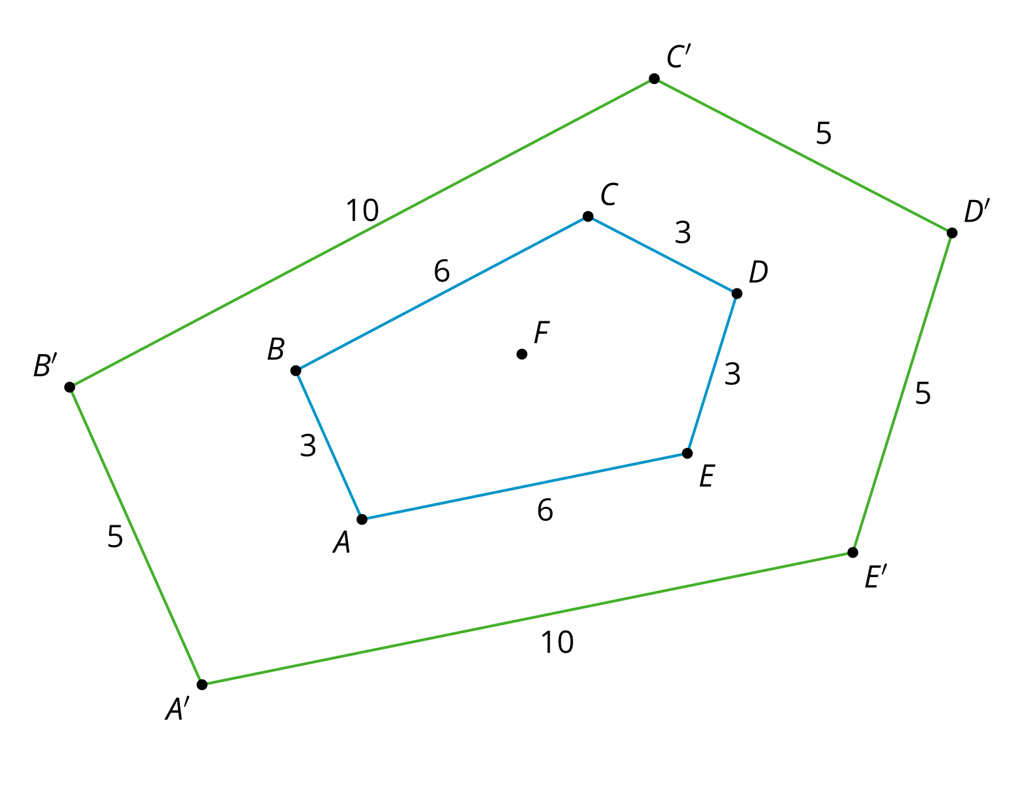
- A polygon has perimeter 12 units. It is dilated with a scale factor of $\frac{3}{4}$. What is the perimeter of its image?
  - 9 units
  - 12 units
  - 16 units
  - It cannot be determined.
- Triangle $ABC$ is taken to triangle $A^{′}B^{′}C^{′}$ by a dilation. Which of these scale factors for the dilation would result in an image that was larger than the original figure?
  - $\frac{3}{5}$
  - $\frac{13}{17}$
  - 1
  - $\frac{4}{3}$
- Dilate quadrilateral $ABCD$ using center $D$ and scale factor 2.
- 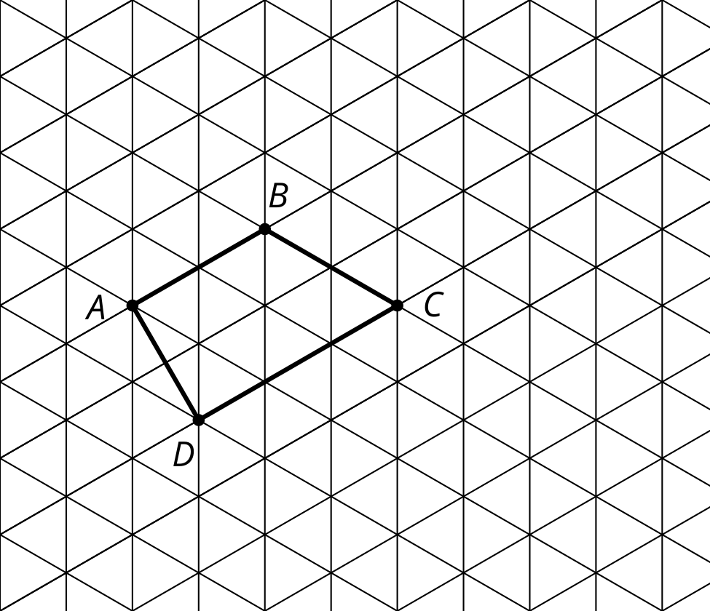
- (From Unit 3, Lesson 2.)
- Dilate Figure $G$ using center $B$ and scale factor 3.
- 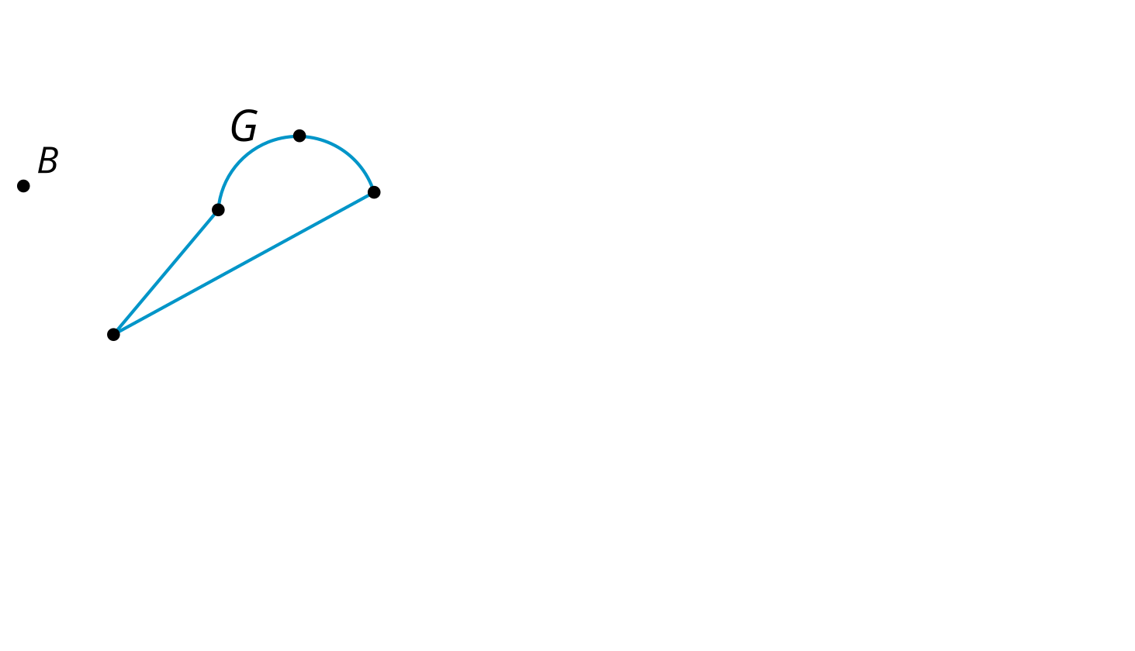
- (From Unit 3, Lesson 2.)
- Polygon Q is a scaled copy of Polygon P.
- 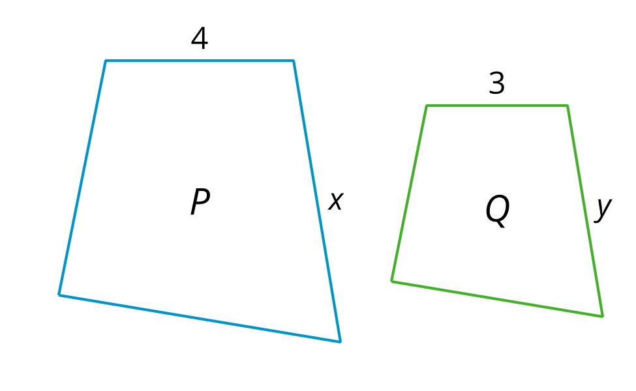
- The value of $x$ is 6, what is the scale factor?
  - $\frac{3}{4}$
  - $\frac{4}{3}$
  - 3
  - 4
- (From Unit 3, Lesson 1.)
- Prove that segment $AD$ is congruent to segment $BC$.
- 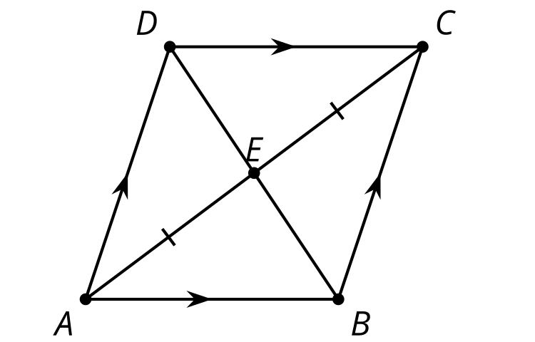
- (From Unit 2, Lesson 10.)
© CC BY 2019 by Illustrative Mathematics®

