Lesson 17 Practice Problems
- Here the graph of quadratic function $f$.
- Andre uses the expression ${\left(x−5\right)}^{2}+7$ to define $f$.
- Noah uses the expression ${\left(x+5\right)}^{2}−7$ to define $f$.
- Do you agree with either of them? Explain your reasoning.
- 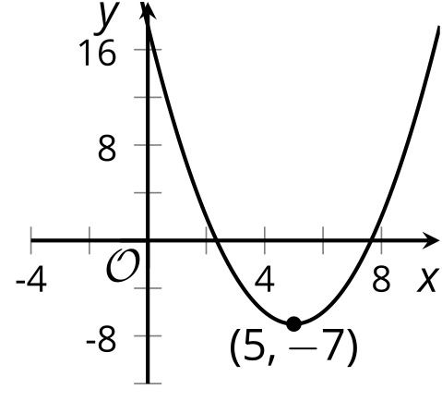
- ​​​​​​
- Here are the graphs of $y=x^{2}$, $y=x^{2}−5$, and $y={\left(x+2\right)}^{2}−8$.
  - How do the 3 graphs compare?
  - 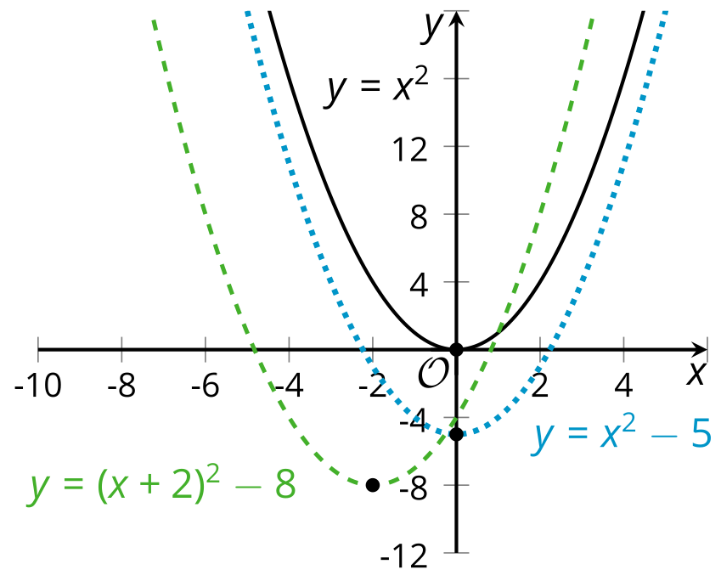
  - Compare the graphs of $y=x^{2}$ and $y=x^{2}−5$. What role does the -5 play in the comparison?
  - Compare the graphs of $y=x^{2}$ and $y={\left(x+2\right)}^{2}−8$. What role does the +2 play in the comparison?
- Which equation represents the graph of $y=x^{2}+2x−3$ moved 3 units to the left?
  - $y=x^{2}+2x−6$
  - $y={\left(x+3\right)}^{2}+2x−3$
  - $y={\left(x+3\right)}^{2}+2\left(x+3\right)$
  - $y={\left(x+3\right)}^{2}+2\left(x+3\right)−3$
- Select all the equations with a graph whose vertex has both a positive $x$- and a positive $y$-coordinate.
  - $y=x^{2}$
  - $y={\left(x−1\right)}^{2}$
  - $y={\left(x−3\right)}^{2}+2$
  - $y=2{\left(x−4\right)}^{2}−5$
  - $y=0.5{\left(x+2\right)}^{2}+6$
  - $y=\text{-}{\left(x−4\right)}^{2}+3$
  - $y=\text{-}2{\left(x−3\right)}^{2}+1$
- The height in feet of a soccer ball is modeled by the equation $g\left(t\right)=2+50t−16t^{2}$ , where time $t$ is measured in seconds after it was kicked.
  - How far above the ground was the ball when kicked?
  - What was the initial upward velocity of the ball?
  - Why is the coefficient of the squared term negative?
- (From Unit 6, Lesson 14.)

  - What is the vertex of the graph of the function $f$ defined by $f\left(x\right)=\text{-}{\left(x−3\right)}^{2}+6$?
  - Identify the $y$-intercept and one other point on of the graph of this function.
  - Sketch the graph of $f$.
- 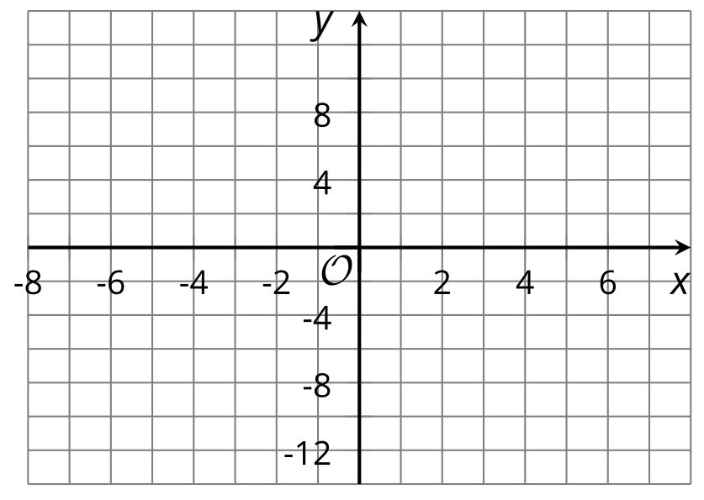
- (From Unit 6, Lesson 16.)
- At 6:00 a.m., Lin began hiking. At noon, she had hiked 12 miles. At 4:00 p.m., Lin finished hiking with a total trip of 26 miles.
- During which time interval was Lin hiking faster? Explain how you know.
- (From Unit 4, Lesson 7.)
- Kiran bought a smoothie every day for a week. Smoothies cost $3 each. The amount of money he spends, in dollars, is a function of the number of days of buying smoothies.
  - Sketch a graph of this function. Be sure to label the axes.
  - Describe the domain and range of this function.
- 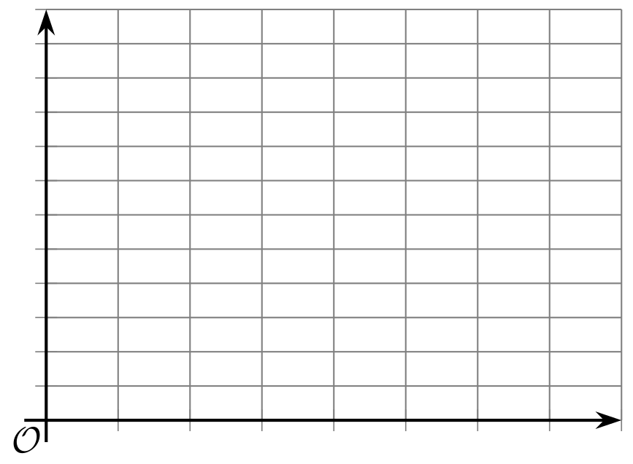
- (From Unit 4, Lesson 11.)
- A deposit of $500 has been made in an interest-bearing account. No withdrawals or other deposits (aside from earned interest) are made for 5 years.
- Write an expression to represent the account balance for each of the following situations.
  - 6.5% annual interest calculated monthly
  - 6.5% annual interest calculated every two months
  - 6.5% annual interest calculated quarterly
  - 6.5% annual interest calculated semi-annually
- (From Unit 5, Lesson 18.)
- Technology required. Function $h$ is defined by $h\left(x\right)=5x+7$ and function $k$ is defined by $k\left(x\right)={\left(1.005\right)}^{x}$.
  - Complete the table with values of $h\left(x\right)$ and $k\left(x\right)$. When necessary, round to 2 decimal places.
  - Which function do you think eventually grows faster? Explain your reasoning.
  - Use graphing technology to verify your answer to the previous question.
- $x$ | - $h\left(x\right)$ | - $k\left(x\right)$
- 1
- 10
- 50
- 100
- (From Unit 5, Lesson 19.)
© CC BY 2019 by Illustrative Mathematics®

