Algebra 1
Unit 7Lesson 1CC BY NC 2024 Illustrative Mathematics®
Unit 7, Lesson 1

A Different Kind of Change
- Let’s find the rectangle with the greatest area.
Algebra 1
Unit 7Lesson 1CC BY NC 2024 Illustrative Mathematics®

1.1Notice and Wonder: Three Tables
Look at the patterns in the three tables. What do you notice? What do you wonder?
$x$ | $y$
1 | 0
2 | 5
3 | 10
4 | 15
5 | 20

$x$ | $y$
1 | 3
2 | 6
3 | 12
4 | 24
5 | 48

$x$ | $y$
1 | 8
2 | 11
3 | 10
4 | 5
5 | -4
Algebra 1
Unit 7Lesson 1CC BY NC 2024 Illustrative Mathematics®

1.2Measuring a Garden
Noah has 50 meters of fencing to completely enclose a rectangular garden in the backyard.
- Draw some possible diagrams of Noah’s garden. Label the length and width of each rectangle.
- 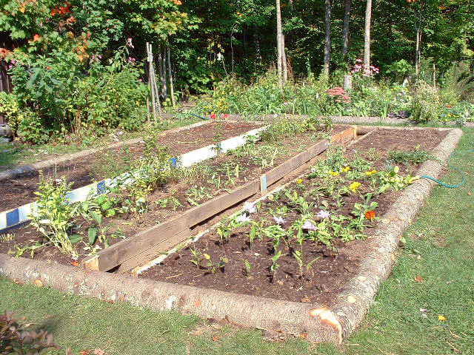
- Find the length and width of such a rectangle that would produce the largest possible area. Explain or show why you think that pair of length and width gives the largest possible area.
Algebra 1
Unit 7Lesson 1CC BY NC 2024 Illustrative Mathematics®

1.3Plotting the Measurements of the Garden
- Plot some values for the length and area of Noah's garden, with a perimeter of 50 meters, on the coordinate plane.
- 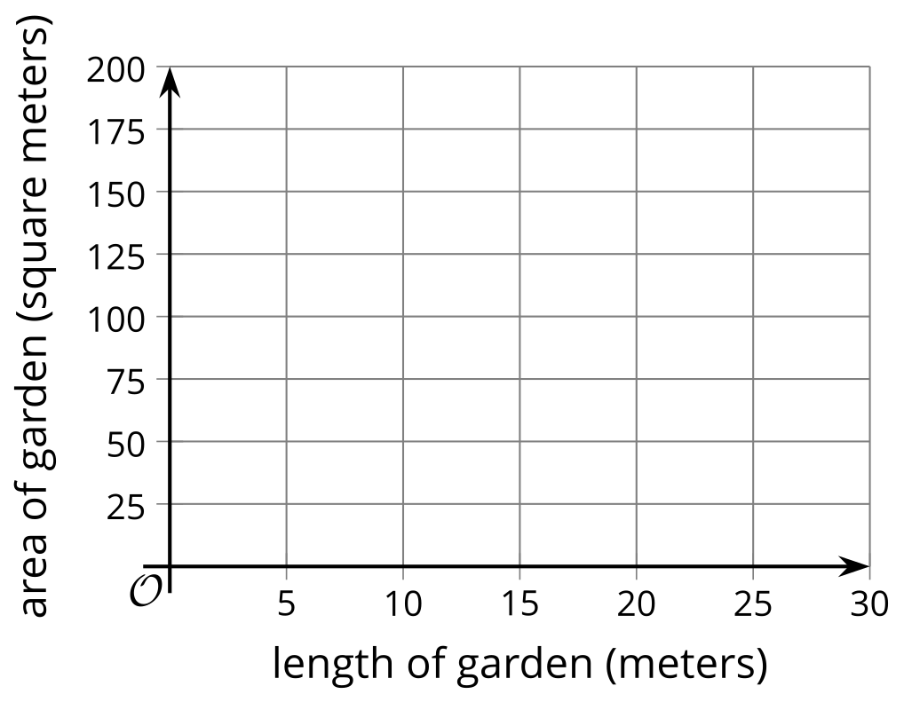
- What do you notice about the plotted points?
- The points $\left(3,66\right)$ and $\left(22,66\right)$ each represent the length and area of the garden. Plot these 2 points on the coordinate plane, if you haven’t already done so. What do these points mean in this situation?
- Could the point $\left(1,25\right)$ represent the length and area of the garden? Explain how you know.

Are you ready for more?
What does the graph look like if you use width and area instead of length and area? What do you notice about how this graph compares to the graph using length?

Lesson 1 Summary
In this lesson, we looked at the relationship between the side lengths and the area of a rectangle when the perimeter is unchanged.
If a rectangle has a perimeter of 40 inches, we can represent some of the possible lengths and widths as shown in the table.
We know that twice the length and twice the width must equal 40, which means that the length plus width must equal 20, or $ℓ+w=20$.
length (inches) | width (inches)
2 | 18
5 | 15
10 | 10
12 | 8
15 | 5
To find the width given a length $ℓ$, we can write: $w=20−ℓ$.
The relationship between the length and the width is linear. If we plot the points from the table representing the length and the width, they form a line.
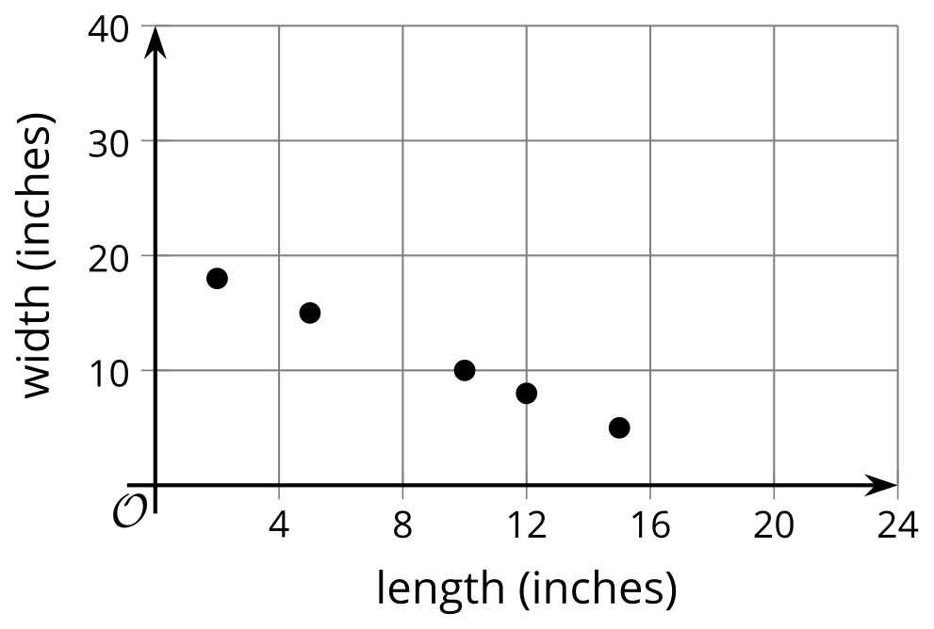
What about the relationship between the side lengths and the area of rectangles with a perimeter of 40 inches?
Here are some possible areas of different rectangles that have a perimeter of 40 inches.
length (inches) | width (inches) | area (square inches)
2 | 18 | 36
5 | 15 | 75
10 | 10 | 100
12 | 8 | 96
15 | 5 | 75
Here is a graph of the lengths and areas from the table:
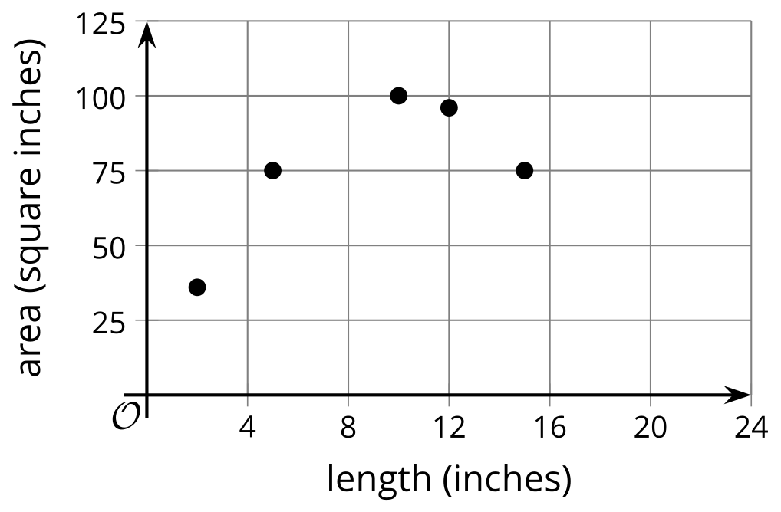
Notice that, initially, as the length of the rectangle increases (for example, from 5 to 10 inches), the area also increases (from 75 to 100 square inches). Later, however, as the length increases (for example, from 12 to 15), the area decreases (from 96 to 75).
We have not studied relationships like this yet and will investigate them further in this unit.

