Grade 6
Unit 6CC BY NC Illustrative Mathematics, based on IM 6–8 Math, CC BY Open Up Resources.

Unit 6 Family Support Materials

Expressions and Equations

Section A: Equations in One Variable
This week your student will be learning to visualize, write, and solve equations. In previous grades, they did this work with numbers. In grade 6, they begin to use a letter called a variable to represent a number whose value is unknown.
Diagrams can help us make sense of how known and unknown quantities are related. Here is an example:
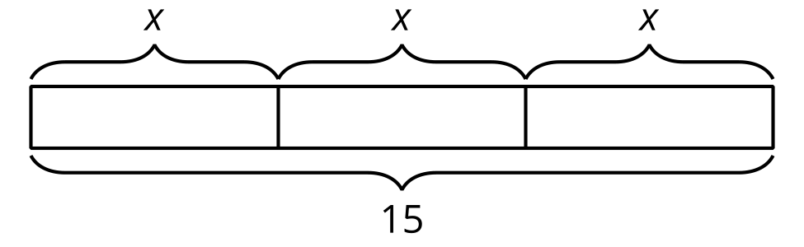
The three pieces in the diagram are labeled with the same variable, $x$, so each piece represents the same number. We can write equations to represent the same relationship as shown in the diagram—for instance, $x+x+x=15$ and $15=3x$.
A solution to an equation is a number that is used in place of the variable and that makes the equation true. In the given example, the solution is 5. Substituting 5 for $x$ in each equation gives a true statement: $5+5+5=15$ and $15=3⋅5$. We can tell that, for example, 4 is not a solution, because $4+4+4$ does not equal 15.
Solving an equation is a process for finding a solution. An equation like $15=3x$ can be solved by dividing the expression on each side of the equal sign by 3. Doing this gives $15÷3$, or 5, on one side and $3x÷3$, or $x$, on the other. $5=x$ is the solution to the equation.
Here is a task to try with your student:
Draw a diagram to represent each equation. Then, solve each equation.
$2y=11$
$11=x+2$
Solution:
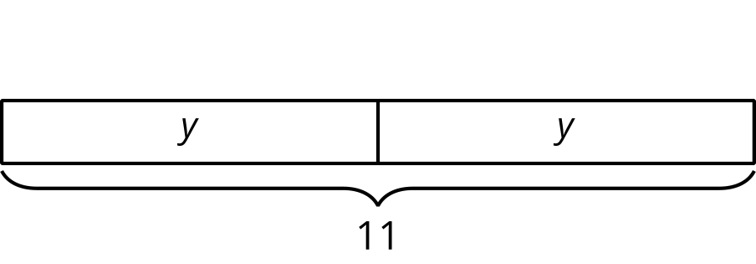
$y=5.5$, or $y=\frac{11}{2}$
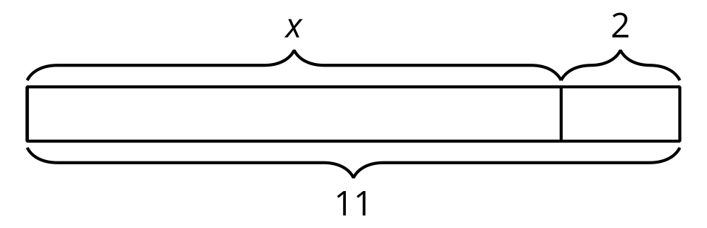
$x=9$

Section B: Equal and Equivalent
This week your student will write mathematical expressions and think about what it means for expressions to be equivalent.
In earlier grades, students learned that to find $4⋅15$, we can calculate $4⋅10$ and $4⋅5$ separately and then combine the products. This process is like finding the area of a rectangle that is 4 units wide by 15 units long, with the 15-unit-long side decomposed into 10 and 5.
We know that the expressions $4⋅\left(10+5\right)$ and $4⋅10+4⋅5$ are equivalent because they have the same value, 60, and represent the area of the same rectangle.
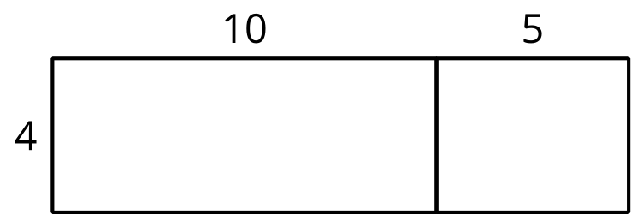
Expressions with variables can also be equivalent. Again, diagrams can help us understand why.
In this diagram, one side length of the large rectangle is 3 units, and the other is $x+2$ units. The area of the large rectangle is $3⋅\left(x+2\right)$
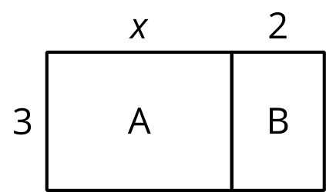
- The large rectangle can be partitioned into two smaller rectangles, A and B, with no overlap.
- The area of A is $3⋅x$, and the area of B is $3⋅2$.
- The area of the large rectangle is $3⋅x+3⋅2$.
The expressions $3⋅\left(x+2\right)$ and $3⋅x+3⋅2$ represent the area of the same rectangle. They have the same value no matter the value of $x$. The two expressions are equivalent. We can write:
$3⋅\left(x+2\right)=3⋅x+3⋅2$
or
$3\left(x+2\right)=3x+6$
This is an example of the distributive property of multiplication. In this case, the multiplication of 3 is “distributed” to each term in $x+2$.
Here is a task to try with your student:
Draw and label a partitioned rectangle to show that each of these equations is always true, no matter the value of the letters.
$5x+2x=\left(5+2\right)x$
$3\left(a+b\right)=3a+3b$
Solution:
Sample responses:
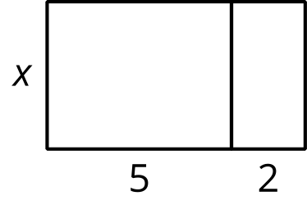
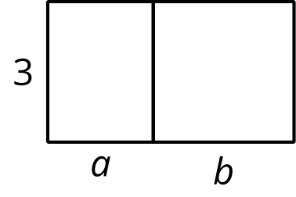

Section C: Expressions with Exponents
This week your student will be working with exponents. In an expression like $7^{n}$, we call $n$ the exponent. It tells us how many factors to multiply. For example, $7^{4}$ is equal to $7⋅7⋅7⋅7$.
Students write expressions in which the exponents are whole numbers and the factors may be:
- Whole numbers, such as $7^{4}$.
- Fractions, such as ${\left(\frac{1}{7}\right)}^{4}$.
- Decimals, such as ${\left(7.7\right)}^{4}$.
- Variables, such as $x^{4}$.
Students also find solutions to equations that involve exponents. For example, 2 is a solution to $x^{5}=30+x$ because substituting 2 for $x$ makes the equation true: $2^{5}$ means $2⋅2⋅2⋅2⋅2$, which is 32 and is equal to $30+2$. On the other hand, 1 is not a solution because $1^{5}$ does not equal $30+1$.
Here is a task to try with your student:
Find the solution to each equation from the provided list of values.
- $n^{2}=49$
- $4^{n}=64$
- $4^{n}=4$
- ${\left(\frac{3}{4}\right)}^{2}=n$
- ${\left(0.2\right)}^{3}=n$
- $n^{4}=\frac{1}{16}$
- $1^{n}=1$
List:
0 | 0.008 | $\frac{1}{2}$ | $\frac{9}{16}$ | $\frac{6}{8}$ | 0.8 | 1 | 2
3 | 4 | 5 | 6 | 7

Solution:
- 7, because $7^{2}=49$. (Note that -7 is also a solution, but multiplication of negative numbers is not studied in grade 6.)
- 3, because $4^{3}=64$
- 1, because $4^{1}=4$
- $\frac{9}{16}$, because ${\left(\frac{3}{4}\right)}^{2}$ means $\left(\frac{3}{4}\right)⋅\left(\frac{3}{4}\right)$
- 0.008, because ${\left(0.2\right)}^{3}$ means $\left(0.2\right)⋅\left(0.2\right)⋅\left(0.2\right)$
- $\frac{1}{2}$, because ${\left(\frac{1}{2}\right)}^{4}=\frac{1}{16}$
- Any number! $1^{n}=1$ is true no matter what number you use in place of $n$.

Section D: Relationships Between Quantities
This week your student will study relationships between two quantities in which one quantity affects the other.
For example, the number of quarters, $n$, and the value of the quarters in cents, $v$, are related.
Knowing that a quarter is worth 25 cents, we can represent the relationship between these two quantities with a table like this:
number of coins, $n$ | value in cents, $v$
1 | 25
2 | 50
3 | 75
Equations and graphs can also represent this relationship. There are two equations and two graphs we can create:
If we know the number of quarters, $n$, we can find the value of the coins in cents by multiplying $n$ by 25, or we can write:
$v=25n$
On this graph, the point at $\left(3,75\right)$ tells us that when there are 3 quarters, the value is 75 cents.
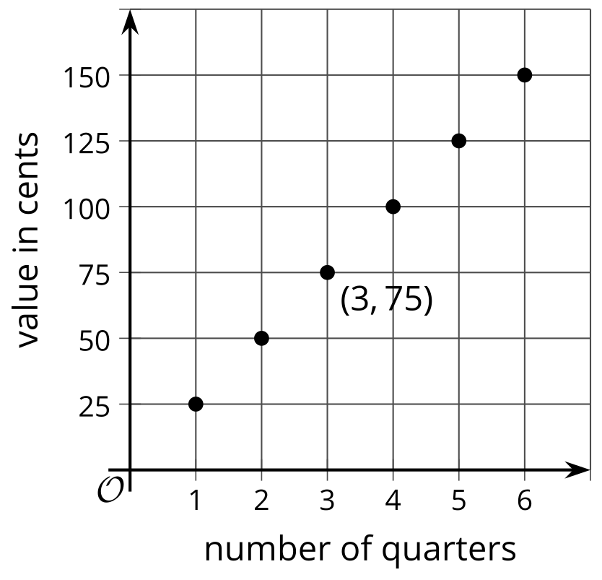
If we know the value of the quarters in cents, $v$, we can find how many coins there are by dividing $v$ by 25, or we can write:
$n=v÷25$
On this graph, the point $\left(75,3\right)$ tells us that when the value is 75 cents, there are 3 quarters.
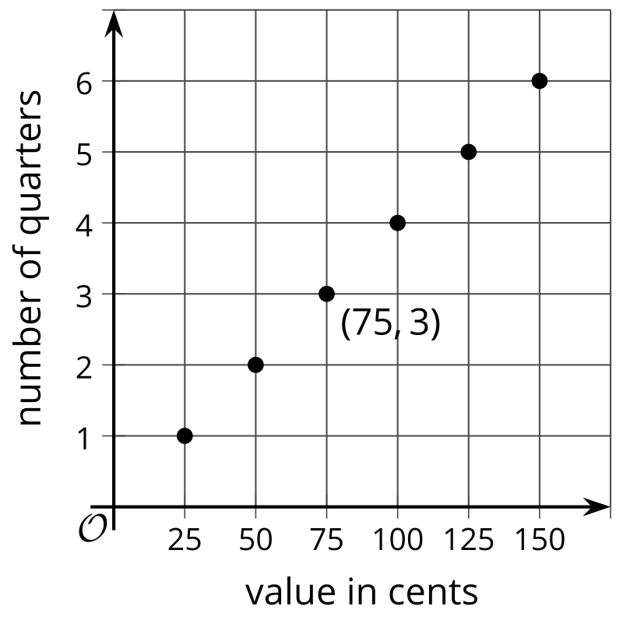
In the first equation, the value in cents depends on the number of coins, so we say that $v$ is the dependent variable and $n$ is the independent variable. In the second equation, it's the other way around.
Here is a task to try with your student:
A shopper is buying paper gift bags. The cost of each gift bag is $0.75.
- Write an equation that shows the cost of the gift bags, $c$, in terms of the number of bags purchased, $n$.
- Create a graph that represents the relationship of $c$ and $n$.
- What are the coordinates of some points on your graph? What do they represent?
Solution:
- $c=0.75n$. Every gift bag costs $0.75, and the shopper is buying $n$ of them, so the cost is $0.75n$.
- Sample response:
- 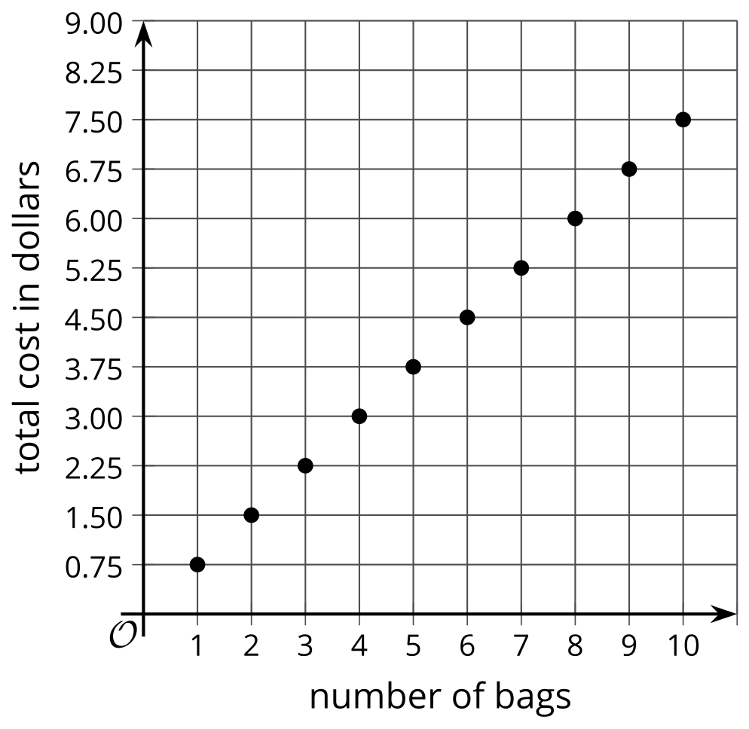
- Sample response: $\left(2,1.50\right)$ and $\left(10,7.50\right)$. The coordinates tell us that 2 gift bags cost $1.50, and 10 gift bags cost $7.50.

