Grade 6
Unit 5CC BY NC Illustrative Mathematics, based on IM 6–8 Math, CC BY Open Up Resources.

Unit 5 Family Support Materials

Arithmetic in Base Ten

Section A: Exploring, Adding, and Subtracting Decimals
This week, your student will add and subtract numbers using what they know about the meaning of the digits.
In earlier grades, your student learned that the 2 in 207.5 represents 2 hundreds, the 7 represents 7 ones, and the 5 represents 5 tenths. We add and subtract the digits that correspond to the same units, like hundreds or tenths. For example, to find $10.5+84.3$, we add the tens, the ones, and the tenths separately, so:
$10+80=90$
$0+4=4$
$0.5+0.3=0.8$
Afterward, we combine the tens, ones, and tenths: $90+4+0.8=94.8$.
Any time we add digits and the sum is greater than 10, we can compose 10 of them into the next higher unit. For example, $0.9+0.3=1.2$.
To add whole numbers and decimal numbers, we can arrange $0.921+4.37$ vertically, aligning the decimal points, and find the sum. This is a convenient way to be sure we are adding digits that correspond to the same units. This also makes it easy to keep track when we compose 10 units into the next higher unit. (Some people call this “carrying.”)
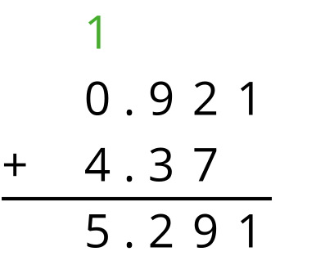
Here is a task to try with your student:
Find the value of $6.54+0.768$.
Solution: 7.308. Sample explanation: There are 8 thousandths in 0.768. Next, the 4 hundredths in 6.54 and the 6 hundredths in 0.768 combine make 1 tenth. Together with the 5 tenths in 6.54 and the 7 tenths in 0.768, there are 13 tenths, or 1 one and 3 tenths. In total, there are 7 ones, 3 tenths, no hundredths, and 8 thousandths.

Section B: Multiplying Decimals
This week, your student will multiply decimals. There are a few ways we can multiply two decimals such as $\left(2.4\right)⋅\left(1.3\right)$. One way is to represent the product as the area of a rectangle. If 2.4 and 1.3 are the side lengths of a rectangle, the product of $\left(2.4\right)⋅\left(1.3\right)$ is its area.
To find the area, it helps to decompose the rectangle into smaller rectangles by breaking the side lengths apart by place value. In this case, 2.4 can be decomposed into 2 and 0.4, and 1.3 can be decomposed into 1 and 0.3.
Then, we can find the area of each smaller rectangle. The sum of the areas of all of the smaller rectangles, 3.12, is the total area.
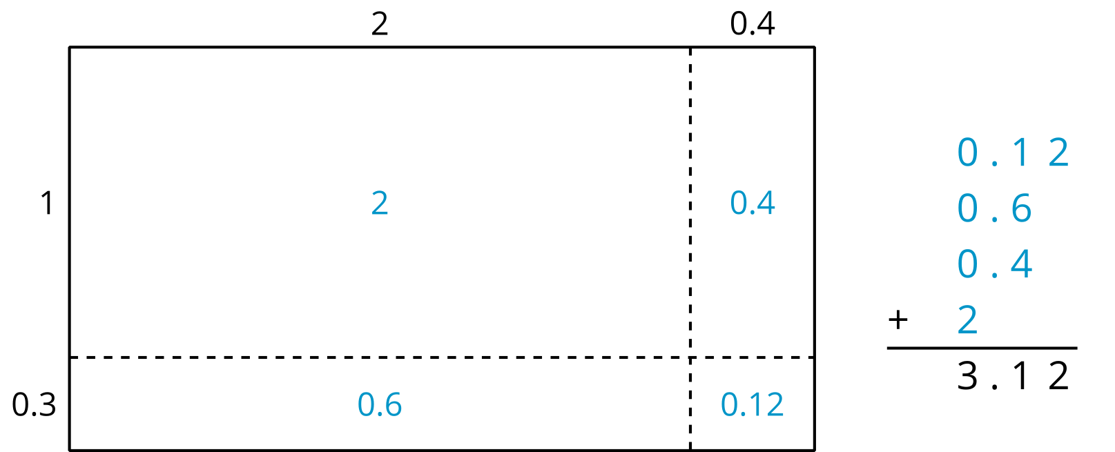
Here is a task to try with your student:
Find $\left(2.9\right)⋅\left(1.6\right)$ using an area model and partial products.
Solution: 4.64. The area of the rectangle (or the sum of the partial products) is $2+0.9+1.2+0.54=4.64$
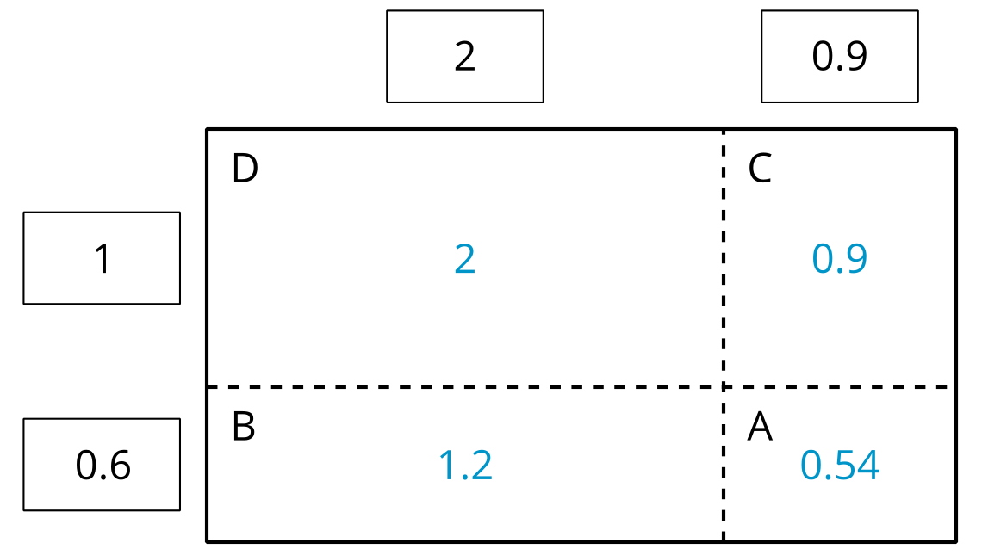

Section C: Dividing Decimals
This week, your student will divide whole numbers and decimals. We can think about division as breaking apart a number into equal-size groups.
Let's take $65÷4$ for example. We can imagine that we are sharing 65 dollars equally among 4 people. Here is one way to think about this:
- First, give each person 10 dollars. This means 40 dollars are shared out, and 25 dollars are left over.
- Next, give each person 6 more dollars. This means 24 more dollars are shared out, and 1 dollar is left.
- Then, give each person another 0.2 of a dollar. This means 0.8 of a dollar is shared out and 0.2 of a dollar is left.
- Finally, give each person 0.05 of a dollar. There is no money left.
The 65 dollars are divided into 4 equal groups. Everyone gets $10+6+0.2+0.05$, or 16.25, dollars.
The calculation on the left shows one way to record these steps for dividing.
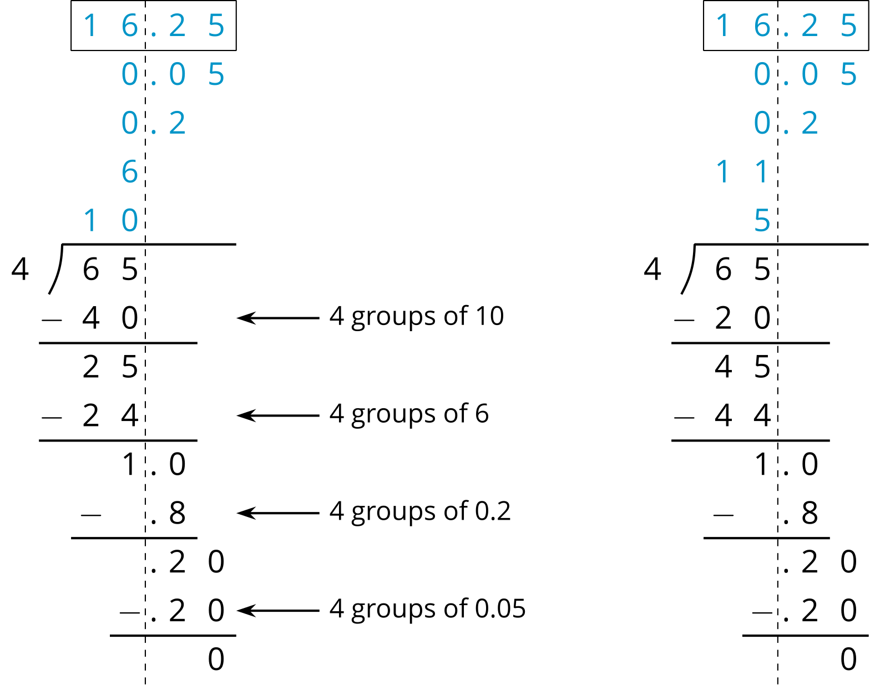
The calculation on the right shows different intermediate steps, but the quotient is the same. We say that this method of dividing uses partial quotients.
Here is a task to try with your student:
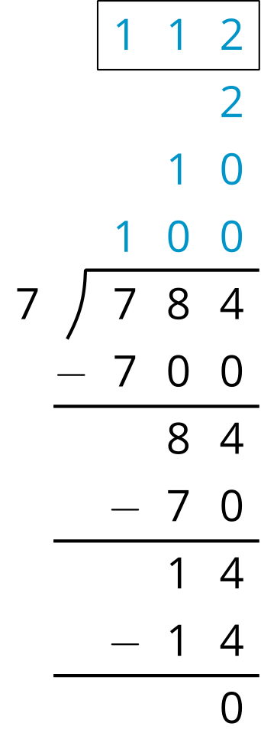
Here is how Jada found $784÷7$ using partial quotients.​​
- In the calculation, what does the subtraction of 700 represent?
- Above the dividend 784, we see the numbers 100, 10, and 2. What do they represent?
- How can we check if 112 if the correct quotient for $784÷7$?
Solution
- It represents the subtraction of 7 groups of 100 from 784.
- 100, 10, and 2 are the amounts distributed into each group over 3 rounds of dividing. There are 7 groups of 100 in 700, 7 groups of 10 in 70, and 7 groups of 2 in 14.
- We can multiply $7⋅112$ and see if it produces 784.

