Lesson 8 Practice Problems
- Match each quadratic expression given in factored form with an equivalent expression in standard form. One expression in standard form has no match.
  - $\left(y+x\right)\left(y−x\right)$
  - $\left(11+x\right)\left(11−x\right)$
  - $\left(x−11\right)\left(x+11\right)$
  - $\left(x−y\right)\left(x−y\right)$
  - $121−x^{2}$
  - $x^{2}+2xy−y^{2}$
  - $y^{2}−x^{2}$
  - $x^{2}−2xy+y^{2}$
  - $x^{2}−121$
- Both $\left(x−3\right)\left(x+3\right)$ and $\left(3−x\right)\left(3+x\right)$ contain a sum and a difference and have only 3 and $x$ in each factor.
- If each expression is rewritten in standard form, will the two expressions be the same? Explain or show your reasoning.

  - Show that the expressions $\left(5+1\right)\left(5−1\right)$ and $5^{2}−1^{2}$ are equivalent.
  - The expressions $\left(30−2\right)\left(30+2\right)$ and ${30}^{2}−2^{2}$ are equivalent and can help us find the product of two numbers. Which two numbers are they?
  - Write $94⋅106$ as a product of a sum and a difference, and then as a difference of two squares. What is the value of $94⋅106$?
- Write each expression in factored form. If not possible, write “not possible.”
  - $x^{2}−144$
  - $x^{2}+16$
  - $25−x^{2}$
  - $b^{2}−a^{2}$
  - $100+y^{2}$
- What are the solutions to the equation $\left(x−a\right)\left(x+b\right)=0$?
  - $a$ and $b$
  - $\text{-}a$ and $\text{-}b$
  - $a$ and $\text{-}b$
  - $\text{-}a$ and $b$
- (From Unit 7, Lesson 4.)
- Create a diagram to show that $\left(x−3\right)\left(x−7\right)$ is equivalent to $x^{2}−10x+21$.
- (From Unit 7, Lesson 6.)
- Select all the expressions that are equivalent to $8−x$.
  - $x−8$
  - $8+\left(\text{-}x\right)$
  - $\text{-}x−\left(\text{-}8\right)$
  - $\text{-}8+x$
  - $x−\left(\text{-}8\right)$
  - $x+\left(\text{-}8\right)$
  - $\text{-}x+8$
- (From Unit 7, Lesson 6.)
- Mai fills a tall cup with hot cocoa, 12 centimeters in height. She waits 5 minutes for it to cool. Then, she starts drinking in sips, at an average rate of 2 centimeters of height every 2 minutes, until the cup is empty.
- The function $C$ gives the height of hot cocoa in Mai’s cup, in centimeters, as a function of time, in minutes.
  - Sketch a possible graph of $C$. Be sure to include a label and a scale for each axis.
  - What quantities do the domain and range represent in this situation?
  - Describe the domain and range of $C$.
- 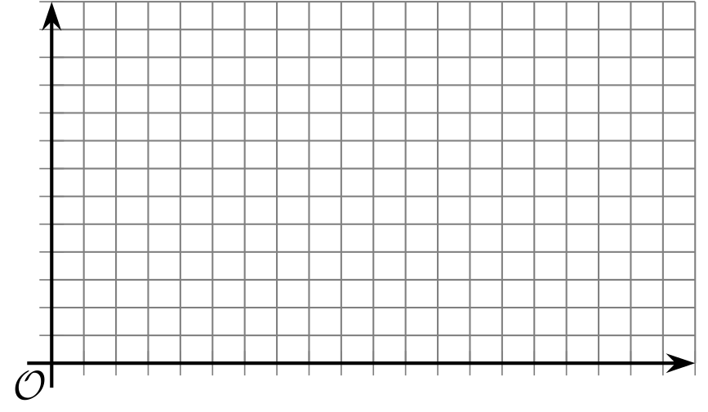
- (From Unit 4, Lesson 11.)
- Two bacteria populations are measured at the same time. One bacteria population, $p$, is modeled by the equation $p=250,​000⋅{\left(\frac{1}{2}\right)}^{d}$, where $d$ is the number of days since it was first measured. The second bacteria population, $q$, is modeled by the equation $q=500,​000⋅{\left(\frac{1}{3}\right)}^{d}$.
- Which statement is true about the two populations?
  - The second population will always be larger than the first.
  - Both populations are increasing.
  - The second bacteria population decreases more rapidly than the first.
  - When initially measured, the first population is larger than the second.
- (From Unit 5, Lesson 7.)
© CC BY 2019 by Illustrative Mathematics®

