Unit 5 Lesson 9: Interpreting Exponential Functions

1 Equivalent or Not? (Warm up)

Student Task Statement
Lin and Diego are discussing two expressions: $x^{2}$ and $2^{x}$.
- Lin says, “I think the two expressions are equivalent.”
- Diego says, “I think the two expressions are only equal for some values of $x$.”
Do you agree with either of them? Explain or show your reasoning.

2 Cost of Solar Cells

Student Task Statement
The cost, in dollars, to produce 1 watt of solar energy is a function of the number of years since 1977, $t$.
From 1977 to 1987, the cost could be modeled by an exponential function $f$. Here is the graph of the function.

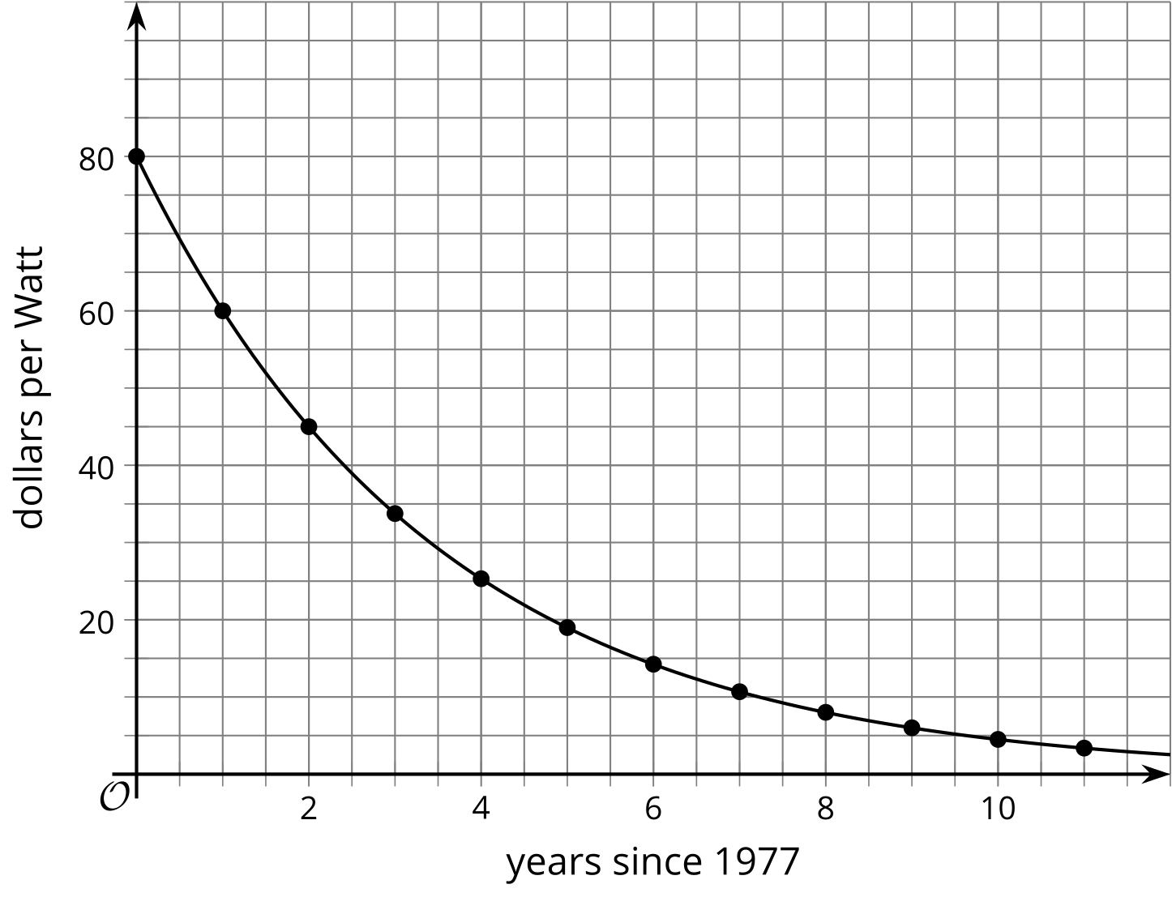
- What is the statement $f\left(9\right)≈6$ saying about this situation?
- What is $f\left(4\right)$? What about $f\left(3.5\right)$? What do these values represent in this context?
- When $f\left(t\right)=45$, what is $t$? What does that value of $t$ represent in this context?
- By what factor did the cost of solar cells change each year? (If you get stuck, consider creating a table.)

3 Paper Folding

Student Task Statement
- The thickness $t$ in millimeters of a folded sheet of paper after it is folded $n$ times is given by the equation $t=\left(0.05\right)⋅2^{n}$.
  - What does the number $0.05$ represent in the equation?
  - Use graphing technology to graph the equation $t=\left(0.05\right)⋅2^{n}$.
  - How many folds does it take before the folded sheet of paper is more than 1 mm thick? How many folds before it is more than 1 cm thick? Explain how you know.
- The area of a sheet of paper is 93.5 square inches.
  - Find the remaining, visible area of the sheet of paper after it is folded in half once, twice, and three times.
  - Write an equation expressing the visible area $a$ of the sheet of paper in terms of the number of times it has been folded $n$.
  - Use graphing technology to graph the equation.
  - In this context, can $n$ take negative values? Explain your reasoning.
  - Can $a$ take negative values? Explain your reasoning.

Activity Synthesis
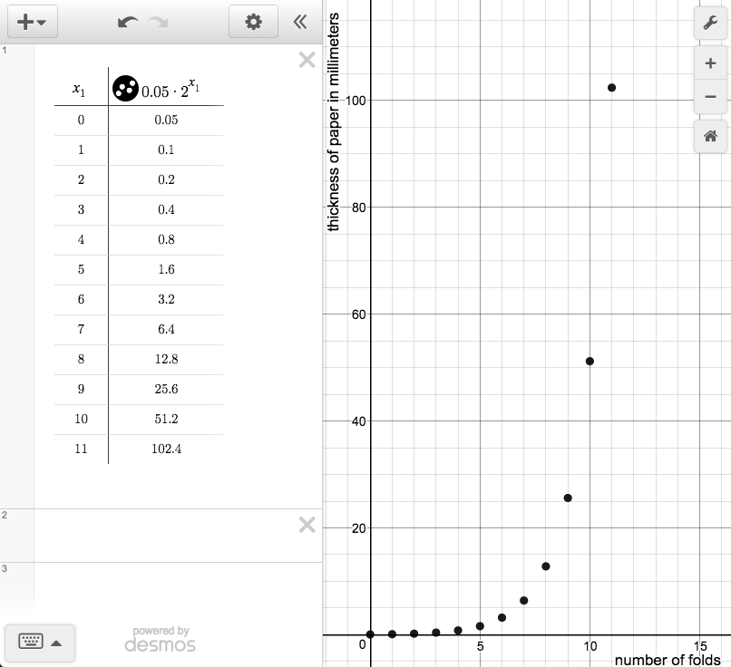

4 Info Gap: Smartphone Sales (Optional)

Student Task Statement
Your teacher will give you either a problem card or a data card. Do not show or read your card to your partner.
If your teacher gives you the data card:
- Silently read the information on your card.
- Ask your partner “What specific information do you need?” and wait for your partner to ask for information. Only give information that is on your card. (Do not figure out anything for your partner!)
- Before telling your partner the information, ask “Why do you need to know (that piece of information)?”
- Read the problem card, and solve the problem independently.
- Share the data card, and discuss your reasoning.
If your teacher gives you the problem card:
- Silently read your card and think about what information you need to answer the question.
- Ask your partner for the specific information that you need.
- Explain to your partner how you are using the information to solve the problem.
- When you have enough information, share the problem card with your partner, and solve the problem independently.
- Read the data card, and discuss your reasoning.
Pause here so your teacher can review your work. Ask your teacher for a new set of cards and repeat the activity, trading roles with your partner.

Activity Synthesis
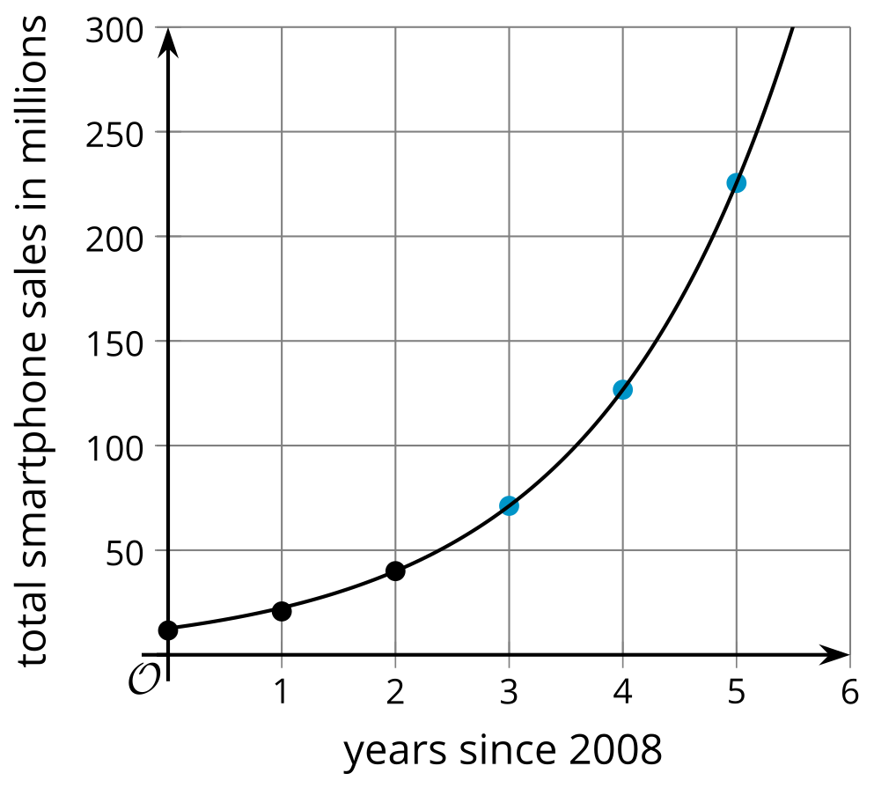
© CC BY 2019 by Illustrative Mathematics®

