Grade 2
Unit 2Lesson 10CC BY NC 2024 Illustrative Mathematics®
Unit 2, Lesson 10

Center Day 2
- Let’s play games to practice adding and subtracting.
Grade 2
Unit 2Lesson 10CC BY NC 2024 Illustrative Mathematics®

Warm-upNotice and Wonder: Compare the Representations
What do you notice? What do you wonder?

- 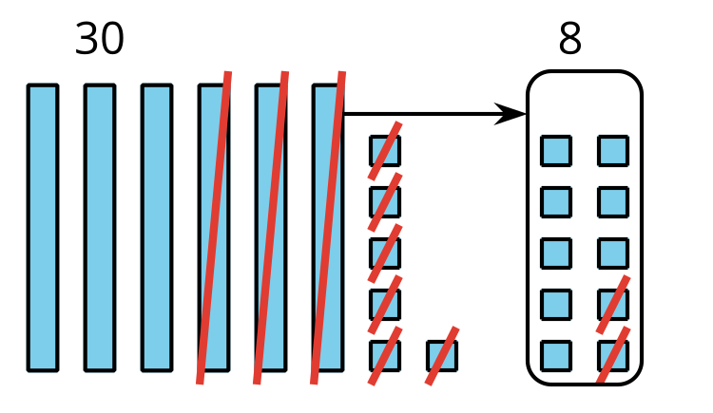

- $66−28$
$66=50+16$
$16−8=8$
$50−20=30$
$30+8=38$
$66−28=38$
Grade 2
Unit 2Lesson 10CC BY NC 2024 Illustrative Mathematics®

Activity 2Centers: Choice Time
Choose a center.
Target Numbers

Capture Squares
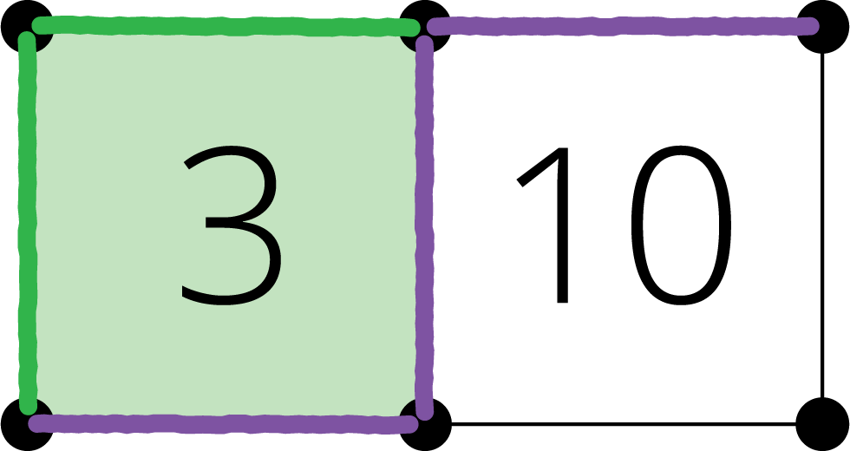
Five in a Row
