Grade 2
Unit 5Lesson 12CC BY NC 2024 Illustrative Mathematics®
Unit 5, Lesson 12

Order Numbers
- Let’s put numbers in order.
Grade 2
Unit 5Lesson 12CC BY NC 2024 Illustrative Mathematics®

Warm-up Number Talk: Subtract Tens
Find the value of each expression mentally.
- $80−50$
- $87−50$
- $76−40$
- $66−30$
Grade 2
Unit 5Lesson 12CC BY NC 2024 Illustrative Mathematics®

Activity 1 Who is Out of Order?
Kiran and Andre put a list of numbers in order from least to greatest.
Kiran
207, 217, 272, 269, 290
Andre
207, 217, 269, 272, 290
Andre disagreed with Kiran. He used a number line to justify his answer.
Unable to process <img src="/tikz_files/238908.svg">Failed: rsvg-convert --format png --dpi-x 300 --dpi-y 300 /app/tmp/svgtopng-1786381054.3715694.svg --output /app/tmp/svgtopng-1786381054.3715694.png Backtrace: /app/app/services/script/runner.rb:34:in `block in run_cmd' <internal:kernel>:90:in `tap' /app/app/services/script/runner.rb:32:in `run_cmd' /app/app/services/script/svg_to_png.rb:27:in `convert_svg_to_png' /app/app/services/script/svg_to_png.rb:17:in `to_png' /app/vendor/bundle/ruby/3.3.0/gems/embeddable_content-1.1.0/app/services/embeddable_content/images/image_downloader.rb:37:in `png_rendered_from_svg' /app/vendor/bundle/ruby/3.3.0/gems/embeddable_content-1.1.0/app/services/embeddable_content/images/image_downloader.rb:33:in `raw_image_data' /app/vendor/bundle/ruby/3.3.0/gems/embeddable_content-1.1.0/app/services/embeddable_content/images/image_downloader.rb:13:in `block in save' <internal:kernel>:90:in `tap' /app/vendor/bundle/ruby/3.3.0/gems/embeddable_content-1.1.0/app/services/embeddable_content/images/image_downloader.rb:13:in `save'
Who do you agree with? Explain your reasoning.
Grade 2
Unit 5Lesson 12CC BY NC 2024 Illustrative Mathematics®

Activity 2 Order Numbers
- Estimate the locations of 839, 765, 788, 815, and 719. Mark each number with a point. Label each point with the number it represents.
- Unable to process <img src="/tikz_files/238909.svg">Failed: rsvg-convert --format png --dpi-x 300 --dpi-y 300 /app/tmp/svgtopng-1786381054.43861.svg --output /app/tmp/svgtopng-1786381054.43861.png Backtrace: /app/app/services/script/runner.rb:34:in `block in run_cmd' <internal:kernel>:90:in `tap' /app/app/services/script/runner.rb:32:in `run_cmd' /app/app/services/script/svg_to_png.rb:27:in `convert_svg_to_png' /app/app/services/script/svg_to_png.rb:17:in `to_png' /app/vendor/bundle/ruby/3.3.0/gems/embeddable_content-1.1.0/app/services/embeddable_content/images/image_downloader.rb:37:in `png_rendered_from_svg' /app/vendor/bundle/ruby/3.3.0/gems/embeddable_content-1.1.0/app/services/embeddable_content/images/image_downloader.rb:33:in `raw_image_data' /app/vendor/bundle/ruby/3.3.0/gems/embeddable_content-1.1.0/app/services/embeddable_content/images/image_downloader.rb:13:in `block in save' <internal:kernel>:90:in `tap' /app/vendor/bundle/ruby/3.3.0/gems/embeddable_content-1.1.0/app/services/embeddable_content/images/image_downloader.rb:13:in `save'
- Order the numbers from least to greatest.
- _______, _______, _______, _______, _______
- Estimate the locations of 199, 245, 173, 218, and 137. Mark each number with a point. Label each point with the number it represents.
- Unable to process <img src="/tikz_files/238910.svg">Failed: rsvg-convert --format png --dpi-x 300 --dpi-y 300 /app/tmp/svgtopng-1786381054.560274.svg --output /app/tmp/svgtopng-1786381054.560274.png Backtrace: /app/app/services/script/runner.rb:34:in `block in run_cmd' <internal:kernel>:90:in `tap' /app/app/services/script/runner.rb:32:in `run_cmd' /app/app/services/script/svg_to_png.rb:27:in `convert_svg_to_png' /app/app/services/script/svg_to_png.rb:17:in `to_png' /app/vendor/bundle/ruby/3.3.0/gems/embeddable_content-1.1.0/app/services/embeddable_content/images/image_downloader.rb:37:in `png_rendered_from_svg' /app/vendor/bundle/ruby/3.3.0/gems/embeddable_content-1.1.0/app/services/embeddable_content/images/image_downloader.rb:33:in `raw_image_data' /app/vendor/bundle/ruby/3.3.0/gems/embeddable_content-1.1.0/app/services/embeddable_content/images/image_downloader.rb:13:in `block in save' <internal:kernel>:90:in `tap' /app/vendor/bundle/ruby/3.3.0/gems/embeddable_content-1.1.0/app/services/embeddable_content/images/image_downloader.rb:13:in `save'
- Order the numbers from greatest to least.
- _______, _______, _______, _______, _______
- Order the numbers from least to greatest.
- 545, 454, 405, 504, and 445
- _______, _______, _______, _______, _______
- Show your thinking using the number line.
- Unable to process <img src="/tikz_files/238911.svg">Failed: rsvg-convert --format png --dpi-x 300 --dpi-y 300 /app/tmp/svgtopng-1786381054.6309094.svg --output /app/tmp/svgtopng-1786381054.6309094.png Backtrace: /app/app/services/script/runner.rb:34:in `block in run_cmd' <internal:kernel>:90:in `tap' /app/app/services/script/runner.rb:32:in `run_cmd' /app/app/services/script/svg_to_png.rb:27:in `convert_svg_to_png' /app/app/services/script/svg_to_png.rb:17:in `to_png' /app/vendor/bundle/ruby/3.3.0/gems/embeddable_content-1.1.0/app/services/embeddable_content/images/image_downloader.rb:37:in `png_rendered_from_svg' /app/vendor/bundle/ruby/3.3.0/gems/embeddable_content-1.1.0/app/services/embeddable_content/images/image_downloader.rb:33:in `raw_image_data' /app/vendor/bundle/ruby/3.3.0/gems/embeddable_content-1.1.0/app/services/embeddable_content/images/image_downloader.rb:13:in `block in save' <internal:kernel>:90:in `tap' /app/vendor/bundle/ruby/3.3.0/gems/embeddable_content-1.1.0/app/services/embeddable_content/images/image_downloader.rb:13:in `save'
- Was it more helpful for you to put the numbers in order first or put them on the number line first?
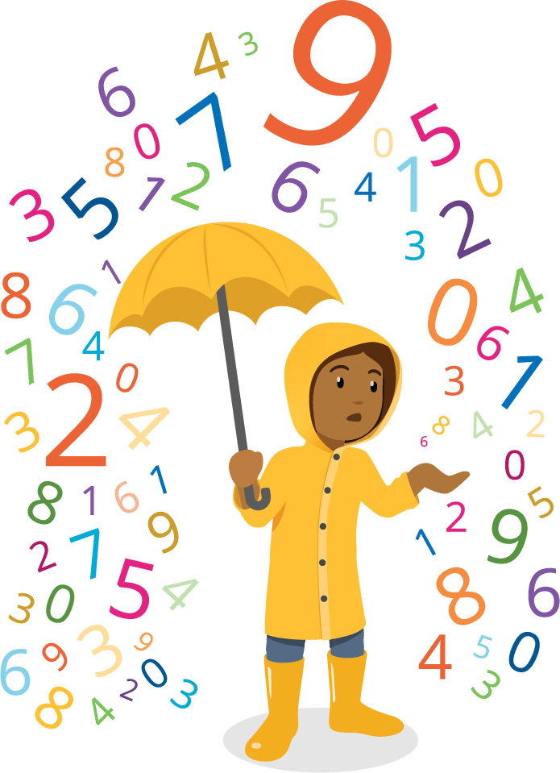

Section B Summary
We compared 3-digit numbers. We used number lines and base-ten diagrams. We used the value of the digits in base-ten numerals to compare numbers. We explained our thinking.
We learned that diagrams help when comparing numbers. We compared hundreds to hundreds, tens to tens, and ones to ones. We learned that diagrams help with digits too.
Unable to process <img src="/tikz_files/237297.svg">Failed: rsvg-convert --format png --dpi-x 300 --dpi-y 300 /app/tmp/svgtopng-1786381054.7442145.svg --output /app/tmp/svgtopng-1786381054.7442145.png Backtrace: /app/app/services/script/runner.rb:34:in `block in run_cmd' <internal:kernel>:90:in `tap' /app/app/services/script/runner.rb:32:in `run_cmd' /app/app/services/script/svg_to_png.rb:27:in `convert_svg_to_png' /app/app/services/script/svg_to_png.rb:17:in `to_png' /app/vendor/bundle/ruby/3.3.0/gems/embeddable_content-1.1.0/app/services/embeddable_content/images/image_downloader.rb:37:in `png_rendered_from_svg' /app/vendor/bundle/ruby/3.3.0/gems/embeddable_content-1.1.0/app/services/embeddable_content/images/image_downloader.rb:33:in `raw_image_data' /app/vendor/bundle/ruby/3.3.0/gems/embeddable_content-1.1.0/app/services/embeddable_content/images/image_downloader.rb:13:in `block in save' <internal:kernel>:90:in `tap' /app/vendor/bundle/ruby/3.3.0/gems/embeddable_content-1.1.0/app/services/embeddable_content/images/image_downloader.rb:13:in `save' Unable to process <img src="/tikz_files/237298.svg">Failed: rsvg-convert --format png --dpi-x 300 --dpi-y 300 /app/tmp/svgtopng-1786381054.836137.svg --output /app/tmp/svgtopng-1786381054.836137.png Backtrace: /app/app/services/script/runner.rb:34:in `block in run_cmd' <internal:kernel>:90:in `tap' /app/app/services/script/runner.rb:32:in `run_cmd' /app/app/services/script/svg_to_png.rb:27:in `convert_svg_to_png' /app/app/services/script/svg_to_png.rb:17:in `to_png' /app/vendor/bundle/ruby/3.3.0/gems/embeddable_content-1.1.0/app/services/embeddable_content/images/image_downloader.rb:37:in `png_rendered_from_svg' /app/vendor/bundle/ruby/3.3.0/gems/embeddable_content-1.1.0/app/services/embeddable_content/images/image_downloader.rb:33:in `raw_image_data' /app/vendor/bundle/ruby/3.3.0/gems/embeddable_content-1.1.0/app/services/embeddable_content/images/image_downloader.rb:13:in `block in save' <internal:kernel>:90:in `tap' /app/vendor/bundle/ruby/3.3.0/gems/embeddable_content-1.1.0/app/services/embeddable_content/images/image_downloader.rb:13:in `save'
The number line shows the numbers in order. We can tell which number is greater using its location on the number line.
Unable to process <img src="/tikz_files/237299.svg">Failed: rsvg-convert --format png --dpi-x 300 --dpi-y 300 /app/tmp/svgtopng-1786381054.8996012.svg --output /app/tmp/svgtopng-1786381054.8996012.png Backtrace: /app/app/services/script/runner.rb:34:in `block in run_cmd' <internal:kernel>:90:in `tap' /app/app/services/script/runner.rb:32:in `run_cmd' /app/app/services/script/svg_to_png.rb:27:in `convert_svg_to_png' /app/app/services/script/svg_to_png.rb:17:in `to_png' /app/vendor/bundle/ruby/3.3.0/gems/embeddable_content-1.1.0/app/services/embeddable_content/images/image_downloader.rb:37:in `png_rendered_from_svg' /app/vendor/bundle/ruby/3.3.0/gems/embeddable_content-1.1.0/app/services/embeddable_content/images/image_downloader.rb:33:in `raw_image_data' /app/vendor/bundle/ruby/3.3.0/gems/embeddable_content-1.1.0/app/services/embeddable_content/images/image_downloader.rb:13:in `block in save' <internal:kernel>:90:in `tap' /app/vendor/bundle/ruby/3.3.0/gems/embeddable_content-1.1.0/app/services/embeddable_content/images/image_downloader.rb:13:in `save'
We wrote expressions using the $<$, $>$, and $=$ symbols.
$432>423$
432 is greater than 423
$423<432$
423 is less than 432

