Unit 6 Lesson 10: Graphs of Functions in Standard and Factored Forms

1 A Linear Equation and Its Graph (Warm up)

Student Task Statement
Here is a graph of the equation $y=8−2x$.
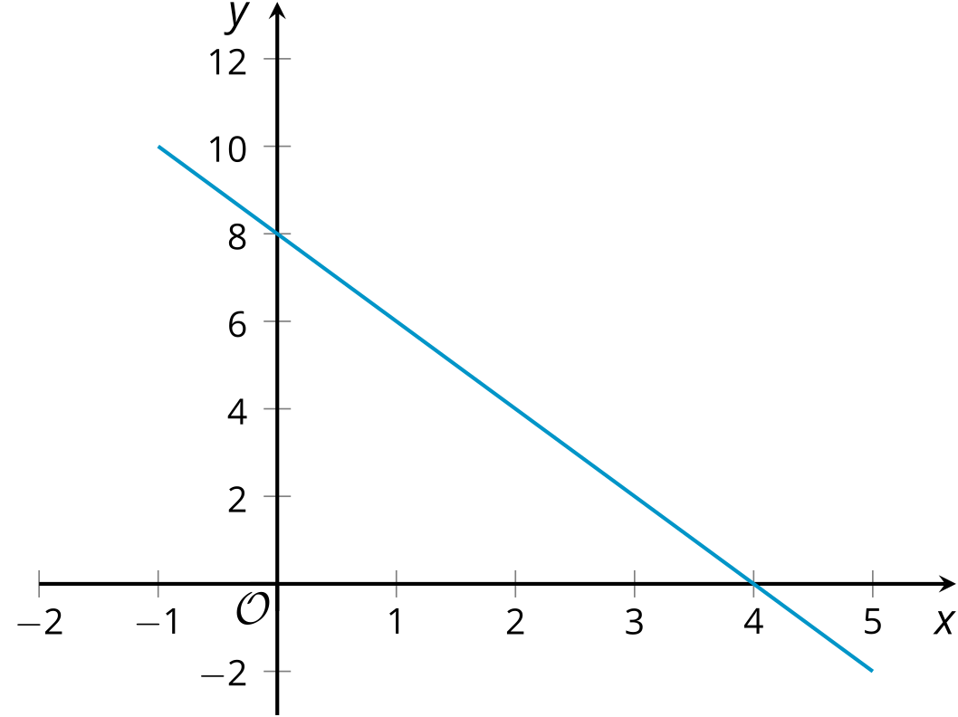
- Where do you see the 8 from the equation in the graph?
- Where do you see the -2 from the equation in the graph?
- What is the $x$-intercept of the graph? How does this relate to the equation?

2 Revisiting Projectile Motion

Student Task Statement
In an earlier lesson, we saw that an equation such as $h\left(t\right)=10+78t−16t^{2}$ can model the height of an object thrown upward from a height of 10 feet with a vertical velocity of 78 feet per second.

- Is the expression $10+78t−16t^{2}$ written in standard form? Explain how you know.
- Jada said that the equation $g\left(t\right)=\left(\text{-}16t−2\right)\left(t−5\right)$ also defines the same function, written in factored form. Show that Jada is correct.
- Here is a graph representing both $g\left(t\right)=\left(\text{-}16t−2\right)\left(t−5\right)$ and $h\left(t\right)=10+78t−16t^{2}$.
- 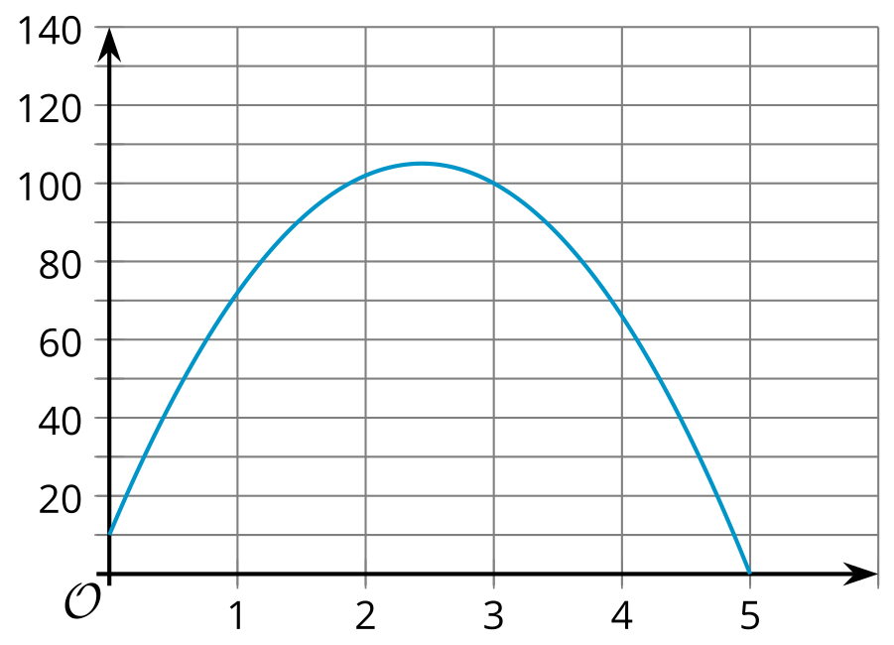
  - Identify or approximate the vertical and horizontal intercepts.
  - What do each of these points mean in this situation?

3 Relating Expressions and Their Graphs

Student Task Statement
Here are pairs of expressions in standard and factored forms. Each pair of expressions define the same quadratic function, which can be represented with the given graph.
- Identify the $x$-intercepts and the $y$-intercept of each graph.
- Function $f$
- $x^{2}+4x+3$
- $\left(x+3\right)\left(x+1\right)$
- 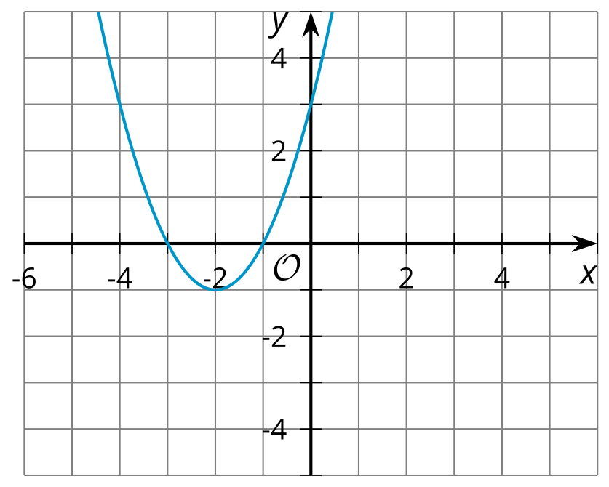
- $x$-intercepts:
- $y$-intercept:
- Function $g$
- $x^{2}−5x+4$
- $\left(x−4\right)\left(x−1\right)$
- 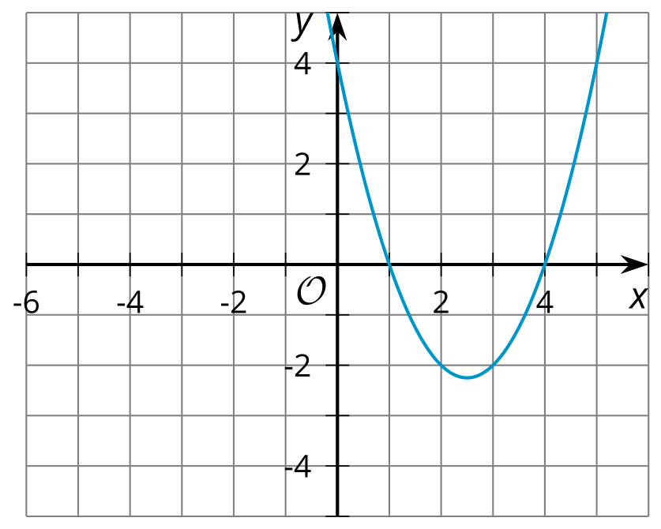
- $x$-intercepts:
- $y$-intercept:
- Function $h$
- $x^{2}−9$
- $\left(x−3\right)\left(x+3\right)$
- 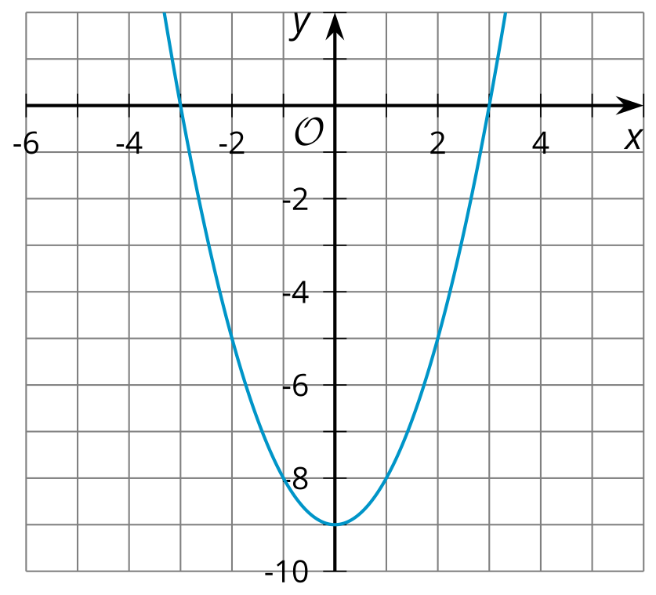
- $x$-intercepts:
- $y$-intercept:
- Function $i$
- $x^{2}−5x$
- $x\left(x−5\right)$
- 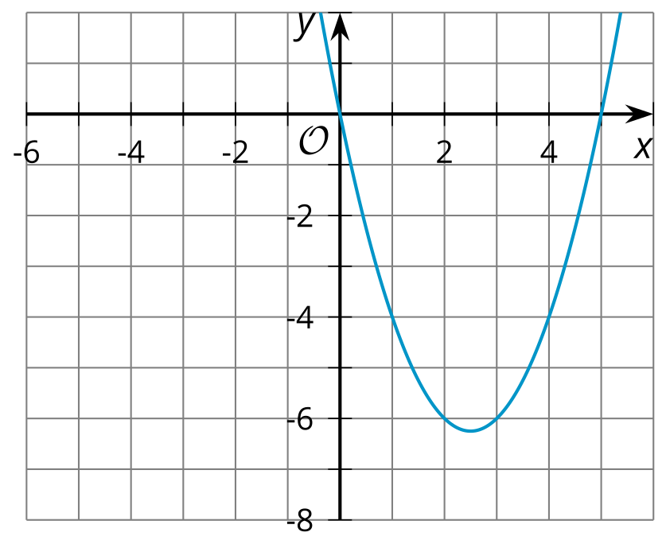
- $x$-intercepts:
- $y$-intercept:
- Function $j$
- $5x−x^{2}$
- $x\left(5−x\right)$
- 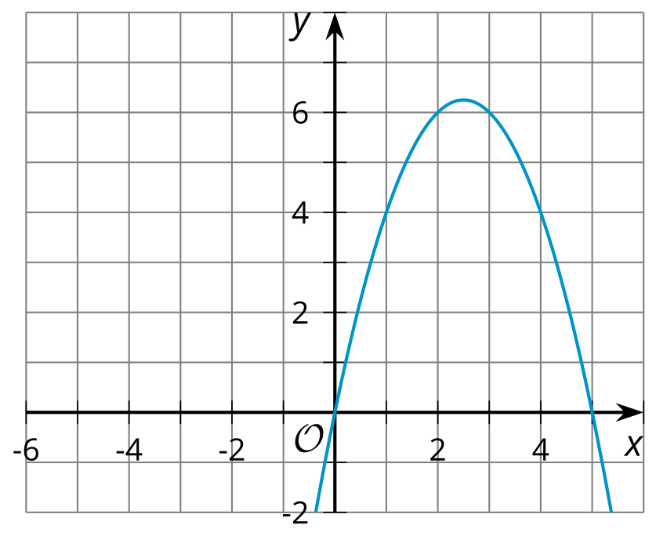
- $x$-intercepts:
- $y$-intercept:
- Function $k$
- $x^{2}+4x+4$
- $\left(x+2\right)\left(x+2\right)$
- 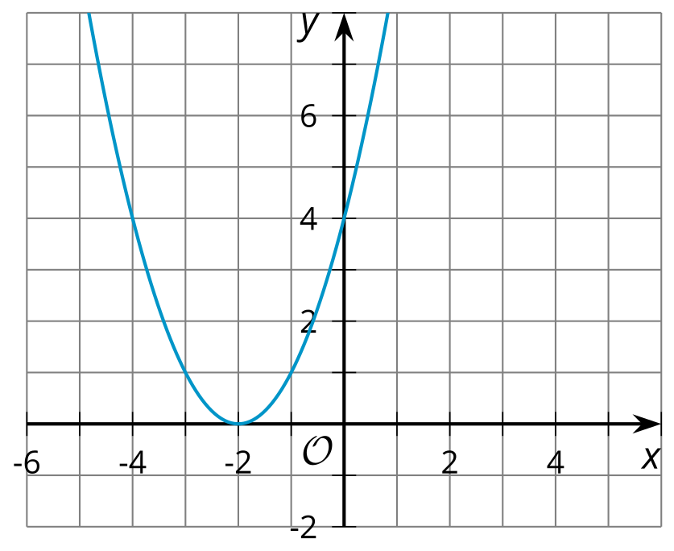
- $x$-intercepts:
- $y$-intercept:
- What do you notice about the $x$-intercepts, the $y$-intercept, and the numbers in the expressions defining each function? Make a couple of observations.
- Here is an expression that models function $p$, another quadratic function: $\left(x−9\right)\left(x−1\right)$. Predict the $x$-intercepts and the $y$-intercept of the graph that represent this function.
© CC BY 2019 by Illustrative Mathematics®

