Unit 3 Lesson 14: Using Diagrams to Represent Addition and Subtraction

1 Do the Zeros Matter? (Warm up)

Student Task Statement
- Evaluate mentally: $1.009+0.391$
- Decide if each equation is true or false. Be prepared to explain your reasoning.
  - $34.56000=34.56$
  - $25=25.0$
  - $2.405=2.45$

2 Finding Sums in Different Ways (Optional)

Images for Launch


Student Task Statement
- Here are two ways to calculate the value of $0.26+0.07$. In the diagram, each rectangle represents 0.1 and each square represents 0.01.
- 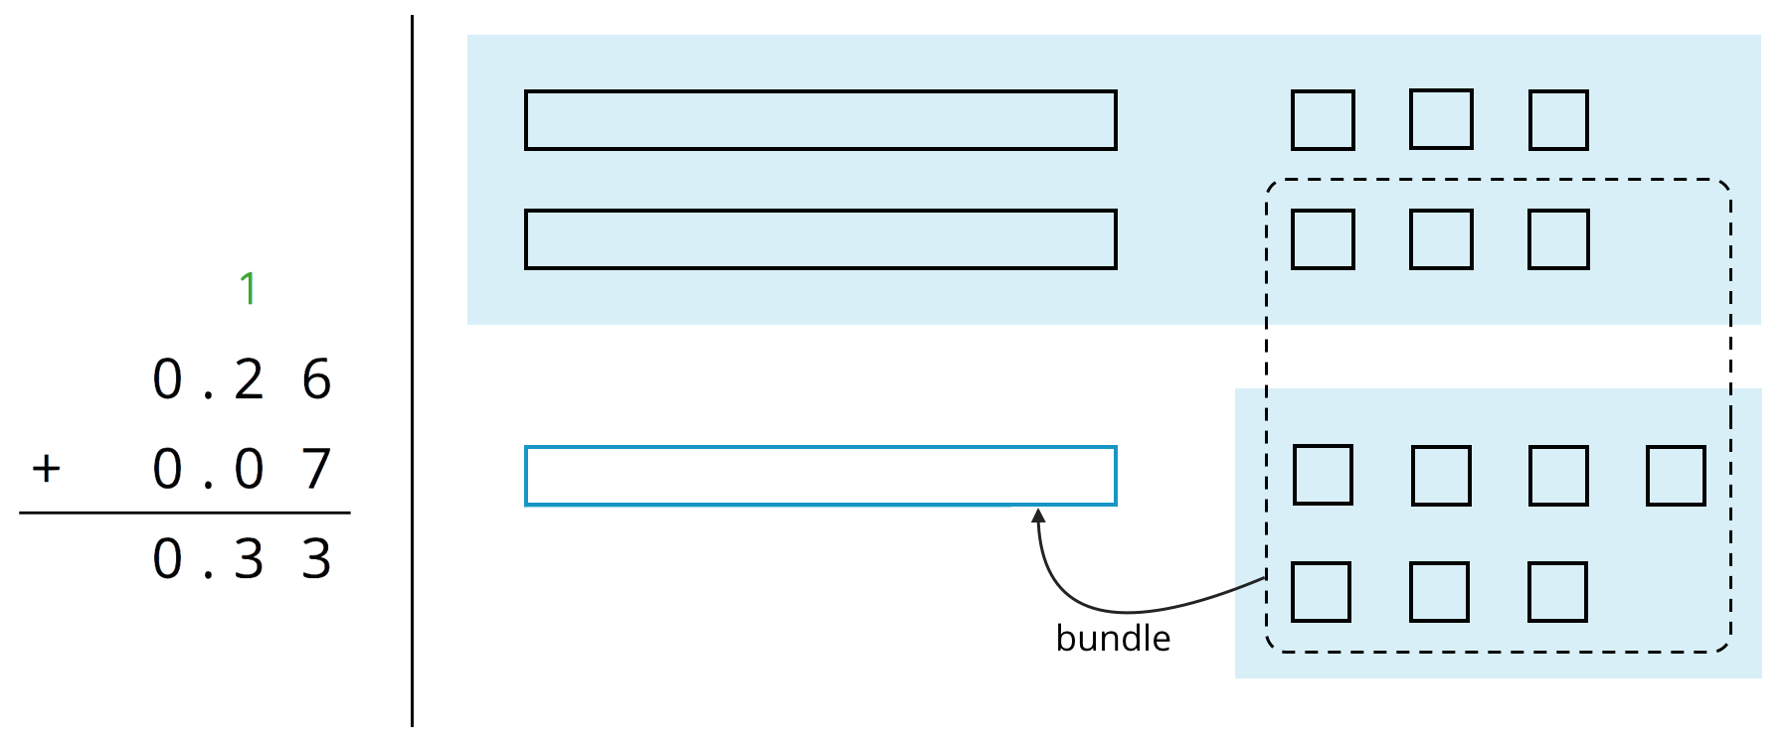
- Use what you know about base-ten units and addition to explain:
  - Why ten squares can be “bundled” into a rectangle.
  - How this “bundling” is represented in the vertical calculation.
- Find the value of $0.38+0.69$ by drawing a diagram. Can you find the sum without bundling? Would it be useful to bundle some pieces? Explain your reasoning.
- Calculate $0.38+0.69$. Check your calculation against your diagram in the previous question.
- Find each sum. The larger square represents 1.

  - 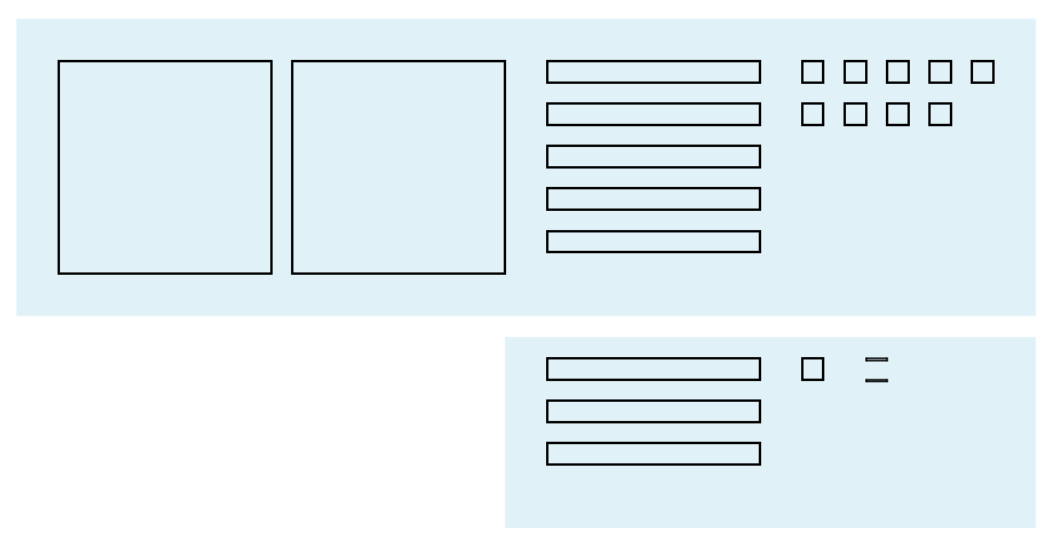

  - 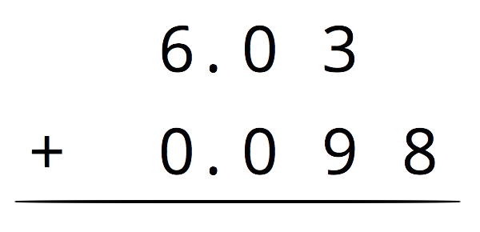

3 Subtracting Decimals of Different Lengths

Images for Launch


Student Task Statement
Diego and Noah drew different diagrams to represent $0.4−0.03$. Each rectangle represents 0.1. Each square represents 0.01.
- Diego started by drawing 4 rectangles to represent 0.4. He then replaced 1 rectangle with 10 squares and crossed out 3 squares to represent subtraction of 0.03, leaving 3 rectangles and 7 squares in his diagram.
- 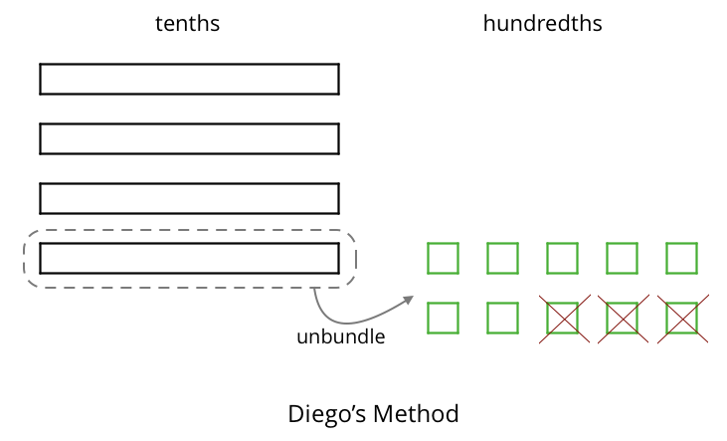
- Noah started by drawing 4 rectangles to represent 0.4. He then crossed out 3 rectangles to represent the subtraction, leaving 1 rectangle in his diagram.
- 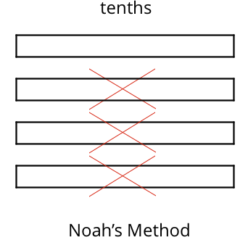
- Do you agree that either diagram correctly represents $0.4−0.03$? Discuss your reasoning with a partner.
- Elena also drew a diagram to represent $0.4−0.03$. She started by drawing 4 rectangles. She then replaced all 4 rectangles with 40 squares and crossed out 3 squares to represent subtraction of 0.03, leaving 37 squares in her diagram. Is her diagram correct? Discuss your reasoning with a partner.
- 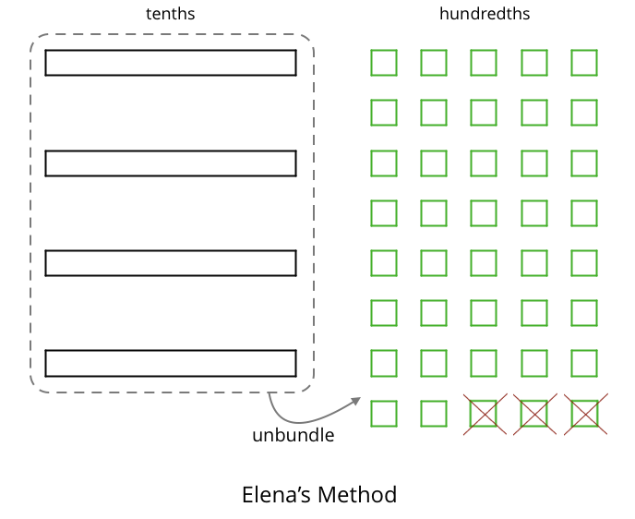
- Find each difference. Explain or show your reasoning.
  - $0.3−0.05$
  - $2.1−0.4$
  - $1.03−0.06$
  - $0.02−0.007$

Activity Synthesis
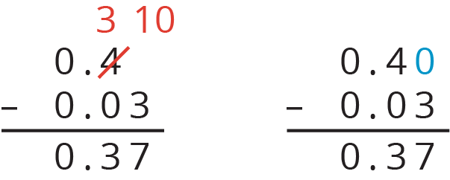
© CC BY Open Up Resources. Adaptations CC BY IM.

