Grade 2
Unit 7Lesson 10CC BY NC 2024 Illustrative Mathematics®
Unit 7, Lesson 10

Add within 1,000
- Let’s find sums within 1,000 and explain our strategies.
Grade 2
Unit 7Lesson 10CC BY NC 2024 Illustrative Mathematics®

Warm-up Number Talk: Use Sums to Find Sums
Find the value of each expression mentally.
- $199+23$
- $198+24$
- $297+25$
- $395+27$
Grade 2
Unit 7Lesson 10CC BY NC 2024 Illustrative Mathematics®

Activity 1Sort 3-digit Sums
- Sort the cards into 2 groups with your partner.
  - Make a group of expressions that you agree is less challenging to find.
  - Make another group of expressions that you agree is more challenging to find.
  - Keep any expressions together that you and your partner disagree on.
- Choose an expression that you feel is less challenging.
- Find the value of the sum. Show your thinking, using drawings, numbers, or words.
- Choose an expression that you feel is more challenging.
- Find the value of the sum. Show your thinking, using drawings, numbers, or words.
- Discuss 1 card you and your partner disagree on. Do you feel the expression is more challenging or less challenging? Explain your reasoning.

Grade 2
Unit 7Lesson 10CC BY NC 2024 Illustrative Mathematics®

Activity 2 Find the Unknown Value
Oh no! Diego spilled paint on his paper. He can’t see all the digits in each of his equations.
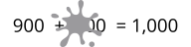
- Find the 3-digit number that makes the equation true. Show your thinking, using drawings, numbers, or words.
- 
- Find the 3-digit number that makes the equation true. Show your thinking, using drawings, numbers, or words.
- 

Section B Summary
We used place value to add 3-digit numbers. We added hundreds to hundreds, tens to tens, and ones to ones, with base-ten blocks, diagrams, and equations. We learned that we may need to compose a ten, a hundred, or both when adding by place value.
Base-Ten Diagram
$358+67$
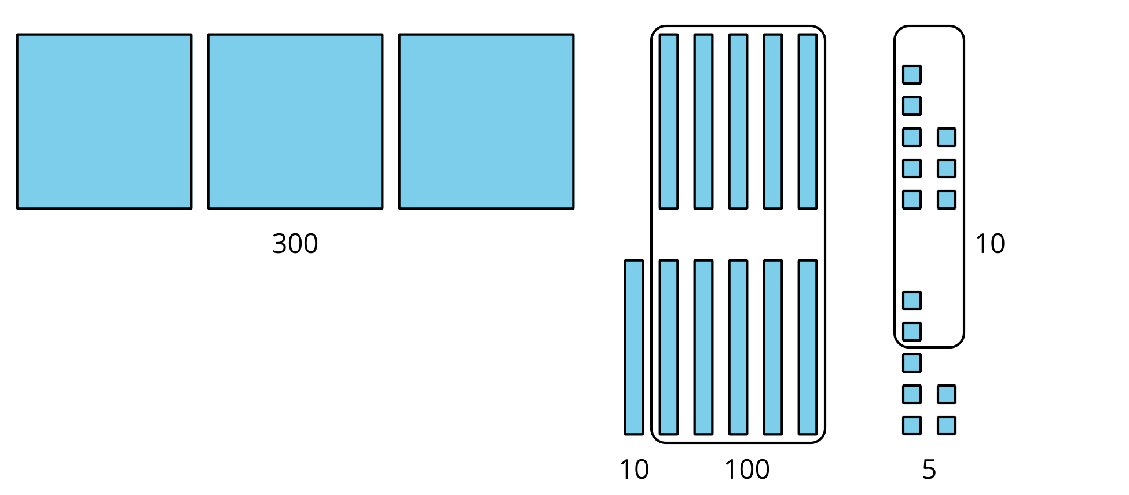
Unit Form and Equations
$358+67$
3 hundreds + 5 tens + 8 ones
6 tens + 7 ones
3 hundreds + 11 tens + 15 ones
11 tens = 110
15 ones = 15
$300+110+15=425$
Adding by Place
$267+338$
$200+300=500$
$60+30=90$
$7+8=15$
$500+90+15$
$500+90+10+5$
$500+100+5=605$

