Grade 6
Unit 9Lesson 6CC BY NC Illustrative Mathematics, based on IM 6–8 Math, CC BY Open Up Resources.
Unit 9, Lesson 6

More than Two Choices
Let's explore different ways to determine a winner.
Grade 6
Unit 9Lesson 6CC BY NC Illustrative Mathematics, based on IM 6–8 Math, CC BY Open Up Resources.

6.1Field Day
Students in a sixth-grade class were asked, “What activity would you most like to do for field day?” The results are shown in the table.
activity | number of votes
softball game | 16
scavenger hunt | 10
dancing talent show | 8
marshmallow throw | 4
no preference | 2
- What percentage of the class voted for softball?
- What percentage did not vote for softball as their first choice?
Grade 6
Unit 9Lesson 6CC BY NC Illustrative Mathematics, based on IM 6–8 Math, CC BY Open Up Resources.

6.2Field Trip (Part 1)
Suppose students at our school are voting for the sixth-grade field trip. The following is a list of options for your class to vote on.
Option 1: Baseball Game
- During school hours
- Buy lunch at the game
- Free souvenir
Option 2: Amusement Park
- During and after school
- Lunch included
- Unlimited rides
Option 3: Museum
- During school hours
- Lunch included
- Free souvenir
Option 4: Dance at School
- After school hours
- Snacks included
- DJ games and prizes
options | vote 1
baseball game
amusement park
museum
dance
- After the second round of voting, did any choice get a majority? If so, is it the same choice that got a plurality in Voting System #1?
- Which choice won?
- What percentage of voters are satisfied with these results (voted for the winning option)? What percentage were not satisfied?
- Compare the satisfaction results for the plurality voting rule and the runoff rule. Did one produce satisfactory results for more people than the other?
Grade 6
Unit 9Lesson 6CC BY NC Illustrative Mathematics, based on IM 6–8 Math, CC BY Open Up Resources.

6.3Field Trip (Part 2)
Let’s analyze a different election.
In another class, there are four clubs. They plan to use the ranked-voting system. Everyone in each club agrees to make the same choice for the field trip for each round of voting. That means that everyone’s choices are set by their first vote. The table shows their choices.
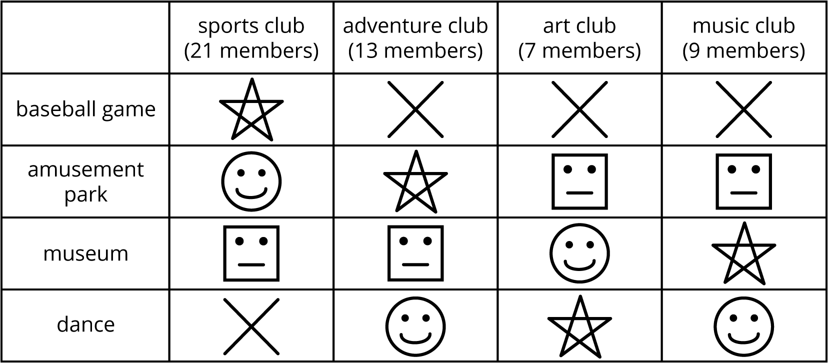
Figure out which option won the election by answering these questions.
- If this were a vote by plurality, where everyone votes for their first choice, how many votes would each option get? Did any choice get a majority?
- If they continued voting by removing the least voted option, which option would be removed after the first vote?
- On the second vote, how many votes did each of the remaining three options get? Did any option get a majority?
- Which option is removed from the next vote?
- On the third vote, how many votes did each of the remaining two options get? Which option won?

