Unit 2 Lesson 8: Equivalent Fractions on the Number Line

WU Estimation Exploration: A Shaded Portion (Warm up)

Student Task Statement
If the entire diagram represents 1 whole, about what fraction is shaded?

Make an estimate that is:
too low | about right | too high

1 Handy Number Lines

Student Task Statement
Andre used number lines to find fractions that are equivalent to $\frac{1}{5}$. He drew this number line:
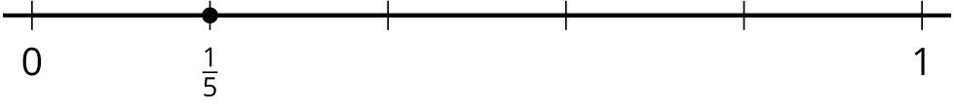
Then, he drew three more lines and wrote a fraction for the point on each line:
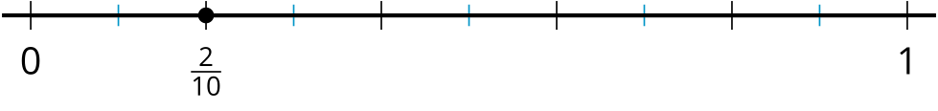
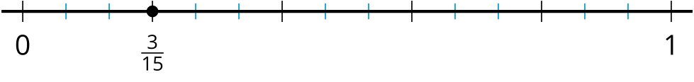
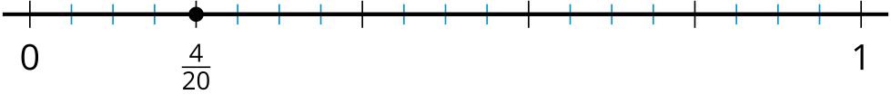
- How did Andre use the number lines to find fractions equivalent to $\frac{1}{5}$? Explain your thinking to a partner.
- How can number lines be used to show whether the following fractions are equivalent?
  - $\frac{8}{10}$ and $\frac{4}{5}$
  - $\frac{14}{20}$ and $\frac{4}{5}$
- Find three fractions that are equivalent to $\frac{6}{5}$. Explain or show how Andre’s number lines can help.

2 Can It Be Done?

Student Task Statement
- Priya wants to find fractions that are equivalent to $\frac{2}{3}$, other than $\frac{4}{6}$. She wonders if she can find equivalent fractions with denominator 9, 10, and 12.
- 0009 00010 00012
- Can it be done? Use number lines to show your reasoning.
- 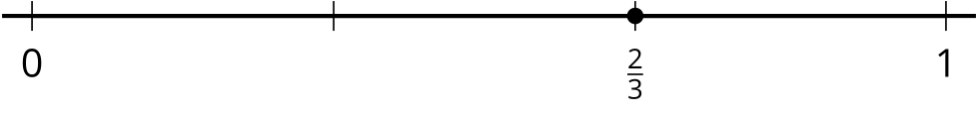
- Represent $\frac{1}{10}$ on a number line. Then, find two fractions that are equivalent to $\frac{1}{10}$. How would you use the number line to show that they are equivalent to $\frac{1}{10}$?
- Can you find an equivalent fraction for $\frac{1}{10}$ with 100 for the denominator? Explain or show your reasoning.
© CC BY 2021 Illustrative Mathematics®

