Grade 2
Unit 1Lesson 16CC BY NC 2024 Illustrative Mathematics®
Unit 1, Lesson 16

Solve All Kinds of Compare Problems
- Let’s solve Compare problems.
Grade 2
Unit 1Lesson 16CC BY NC 2024 Illustrative Mathematics®

Warm-upTrue or False: Multiples of 10
Decide if each statement is true or false. Be prepared to explain your reasoning.
- $18+5=18+2+3$
- $28+5=30+3$
- $38+4=40+3$
Grade 2
Unit 1Lesson 16CC BY NC 2024 Illustrative Mathematics®

Activity 1A Trip to the Library
- Priya returns 29 books to the library. Andre returns 8 more than Priya.
  - Who returns more books?
  - Use the story problem to fill out the tape diagram.
  - 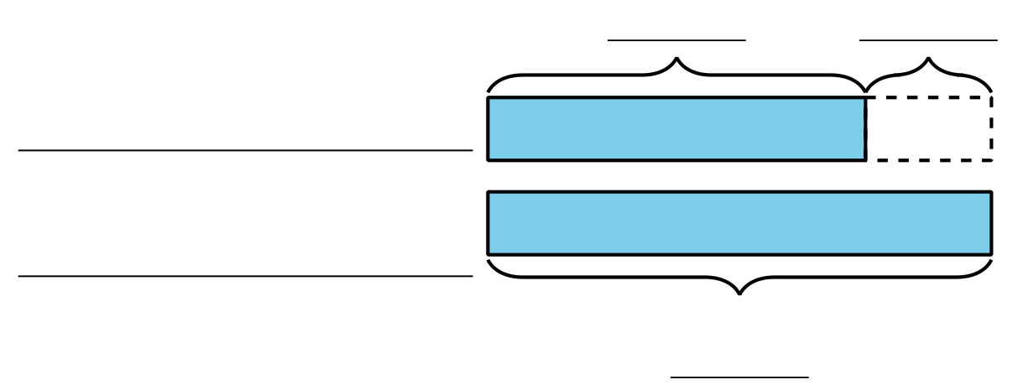
  - How many books does Andre return?
- Andre reads 45 pages of his book. Priya reads 20 fewer.
  - Who reads more pages?
  - Use the story problem to fill out the tape diagram.
  - 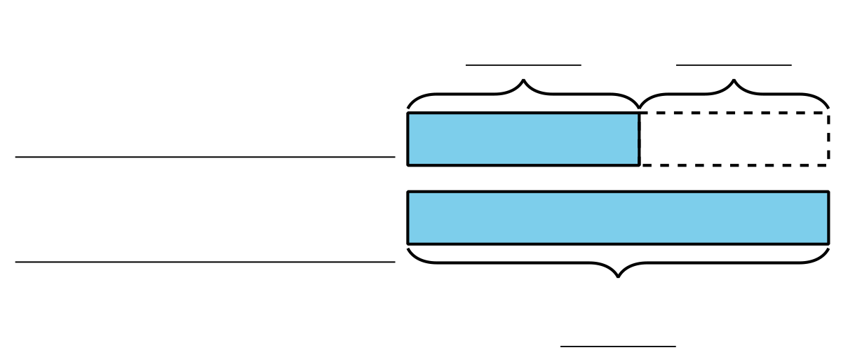
  - How many pages does Priya read?

Grade 2
Unit 1Lesson 16CC BY NC 2024 Illustrative Mathematics®

Activity 2Solve Compare Problems
- Jada reads 10 fewer pages than Noah. Noah reads 27 pages. How many pages does Jada read?
- Noah reads for 25 minutes. Jada reads for 30 more minutes than Noah. How long does Jada read?
- Jada reads 47 pages. Noah reads 20 pages. How many fewer pages does Noah read?
- Noah stacks 14 more books than Jada. Jada stacks 28. How many books does Noah stack?

Section C Summary
We represented and solved Compare problems. We used bar graphs to find the difference between 2 categories.
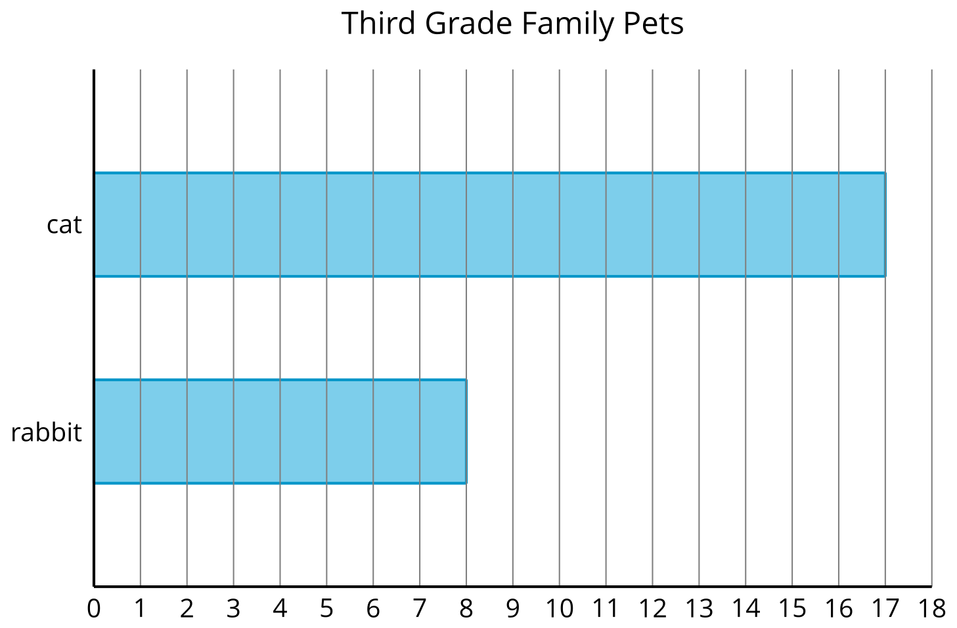
How many more students have cats than rabbits? Show 2 ways to find the difference.
We used diagrams to make sense of story problems. We used the diagrams to show which part of a comparison we need to find.
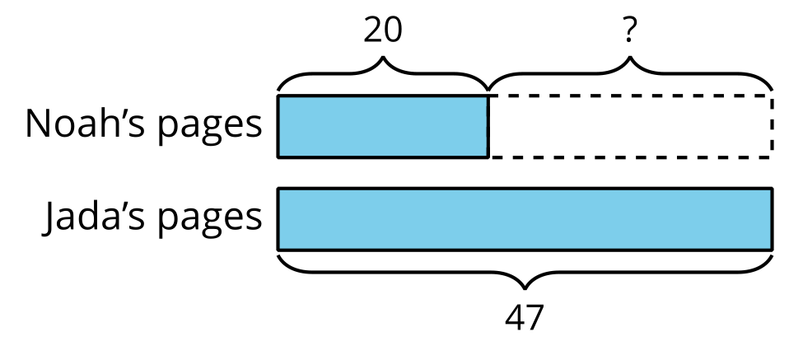
Jada reads 47 pages. Noah reads 20 pages. How many fewer pages does Noah read?
In this problem, we find the difference. We know how many pages Noah and Jada read. The ? represents the difference.

