Grade 2
Unit 8Lesson 2CC BY NC 2024 Illustrative Mathematics®
Unit 8, Lesson 2

Partners Make Pairs
- Let’s make pairs with groups of objects.
Grade 2
Unit 8Lesson 2CC BY NC 2024 Illustrative Mathematics®

Warm-upWhich Three Go Together: Laundry Day
Which 3 go together?
A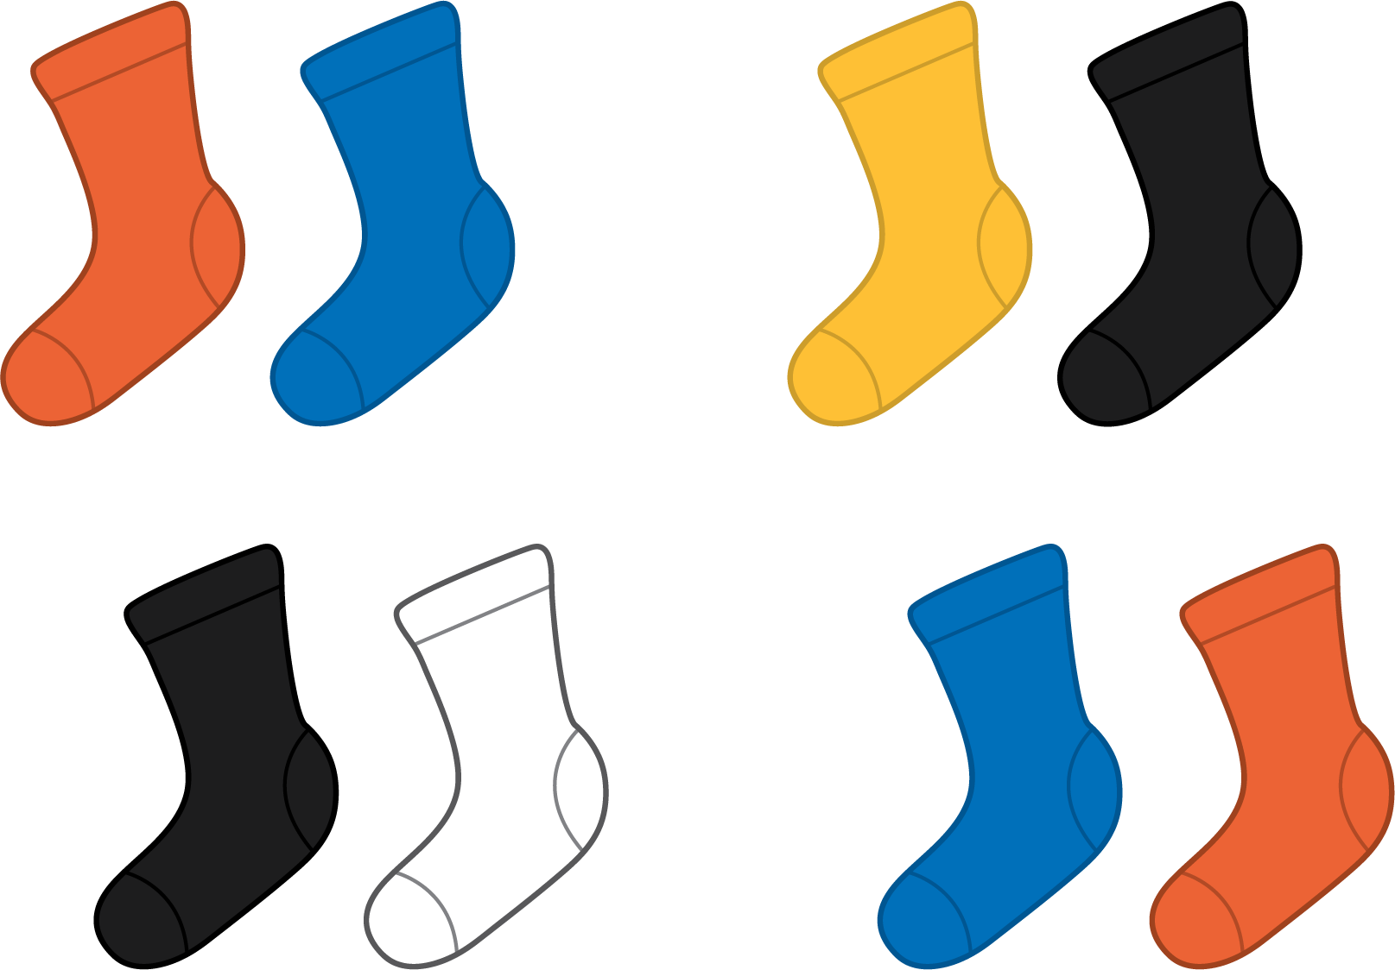
B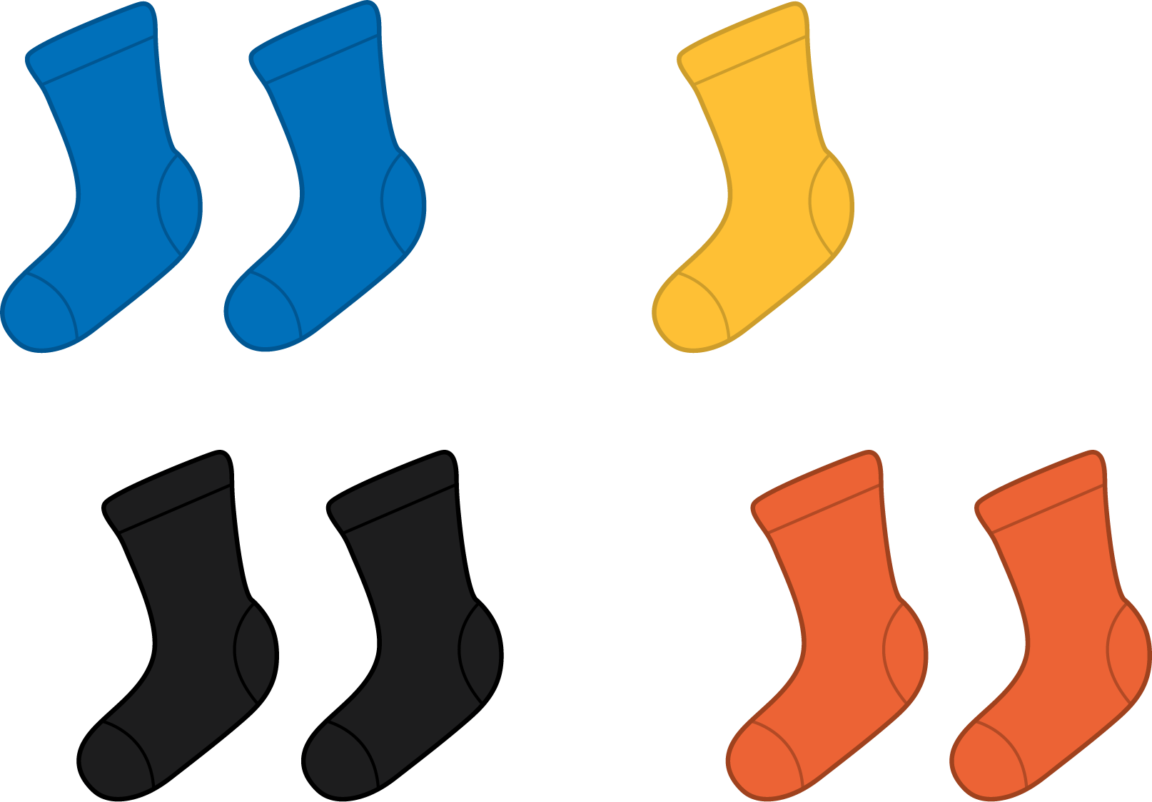
C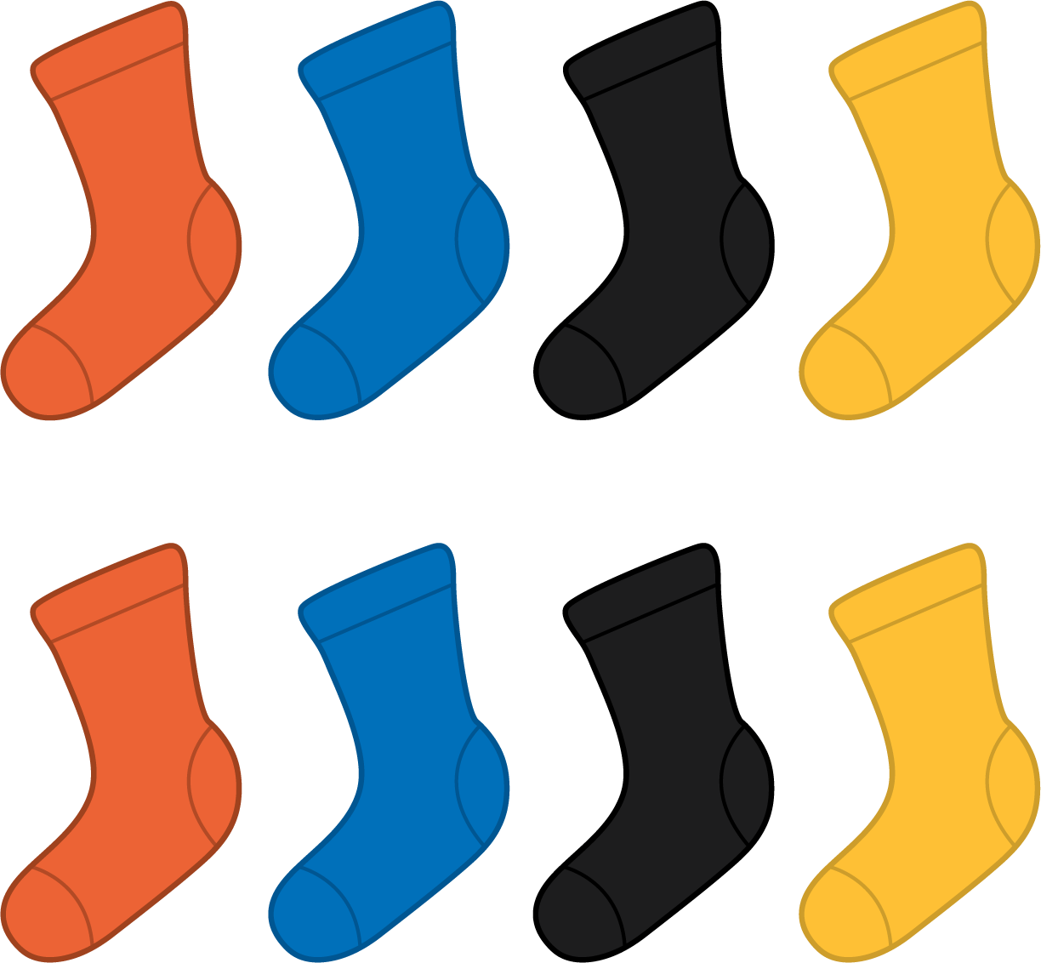
D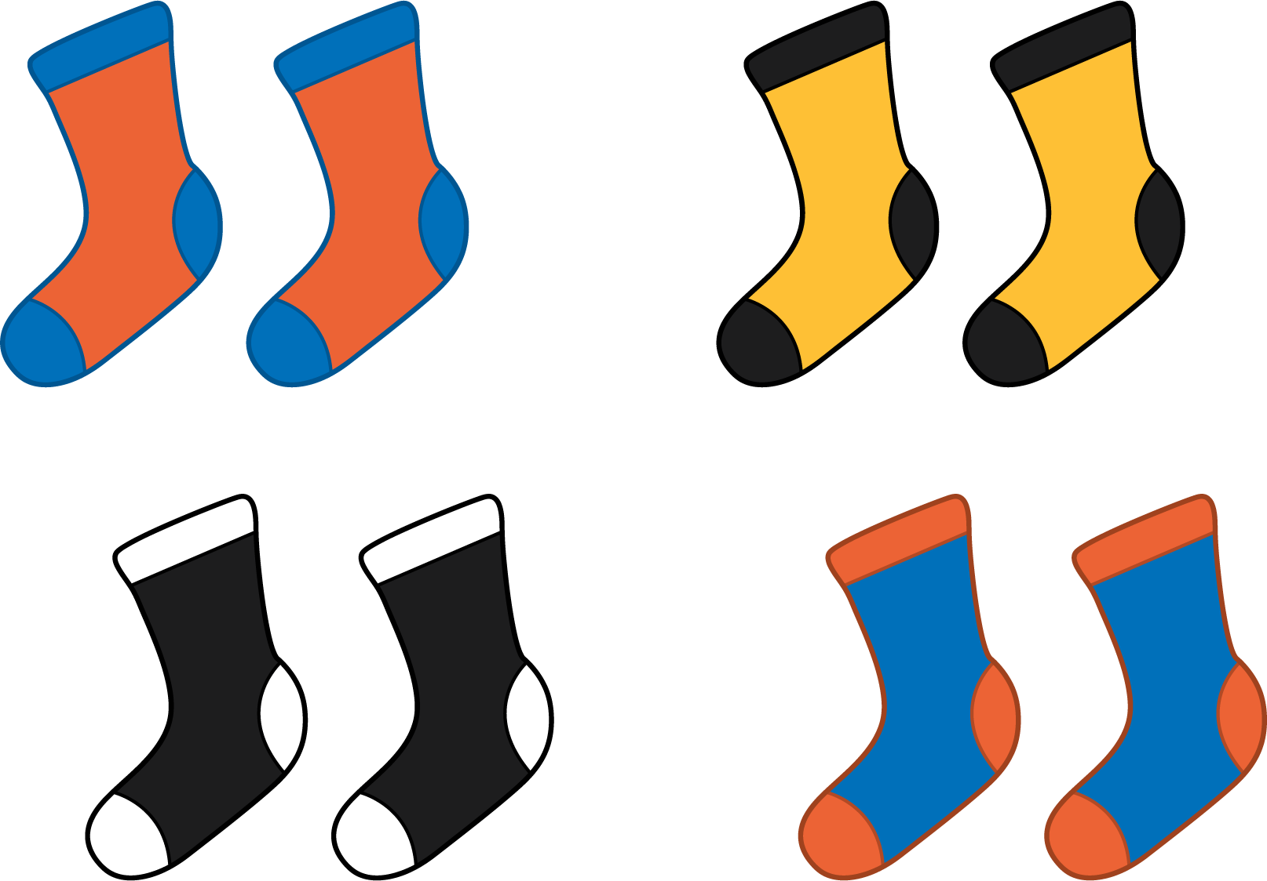
Grade 2
Unit 8Lesson 2CC BY NC 2024 Illustrative Mathematics®

Activity 1 Pair Up
Make pairs with 1 yellow counter and 1 red counter.
my counters
total counters
leftover counters
Grade 2
Unit 8Lesson 2CC BY NC 2024 Illustrative Mathematics®

Activity 2 Are You Feeling Left Out?
Show your thinking using objects, drawings, numbers, or words.
- There are 18 students in Clare’s class. Can everyone be in a group of 2?
- There are 20 students in Priya’s class. Can everyone be in a group of 2?
- There are 19 students in Noah’s class. Can everyone be in a group of 2?

