Unit 2 Lesson 19: Story Problems and Equations

WU Choral Count: 0-100 and Back Again (Warm up)

Student Task Statement

1 Lotería

Student Task Statement
- 10 picture cards have been called.
7 of the pictures are on Mai’s board.
How many of the pictures are not on Mai’s board?
Show your thinking using drawings, numbers, or words.
- Equation: ________________________________
- Equation: ________________________________
- Lin has 10 beans to play with.
3 of her beans fall on the floor.
How many beans does Lin have to play with now?
Show your thinking using drawings, numbers, or words.
- Equation: ________________________________
- Equation: ________________________________
- 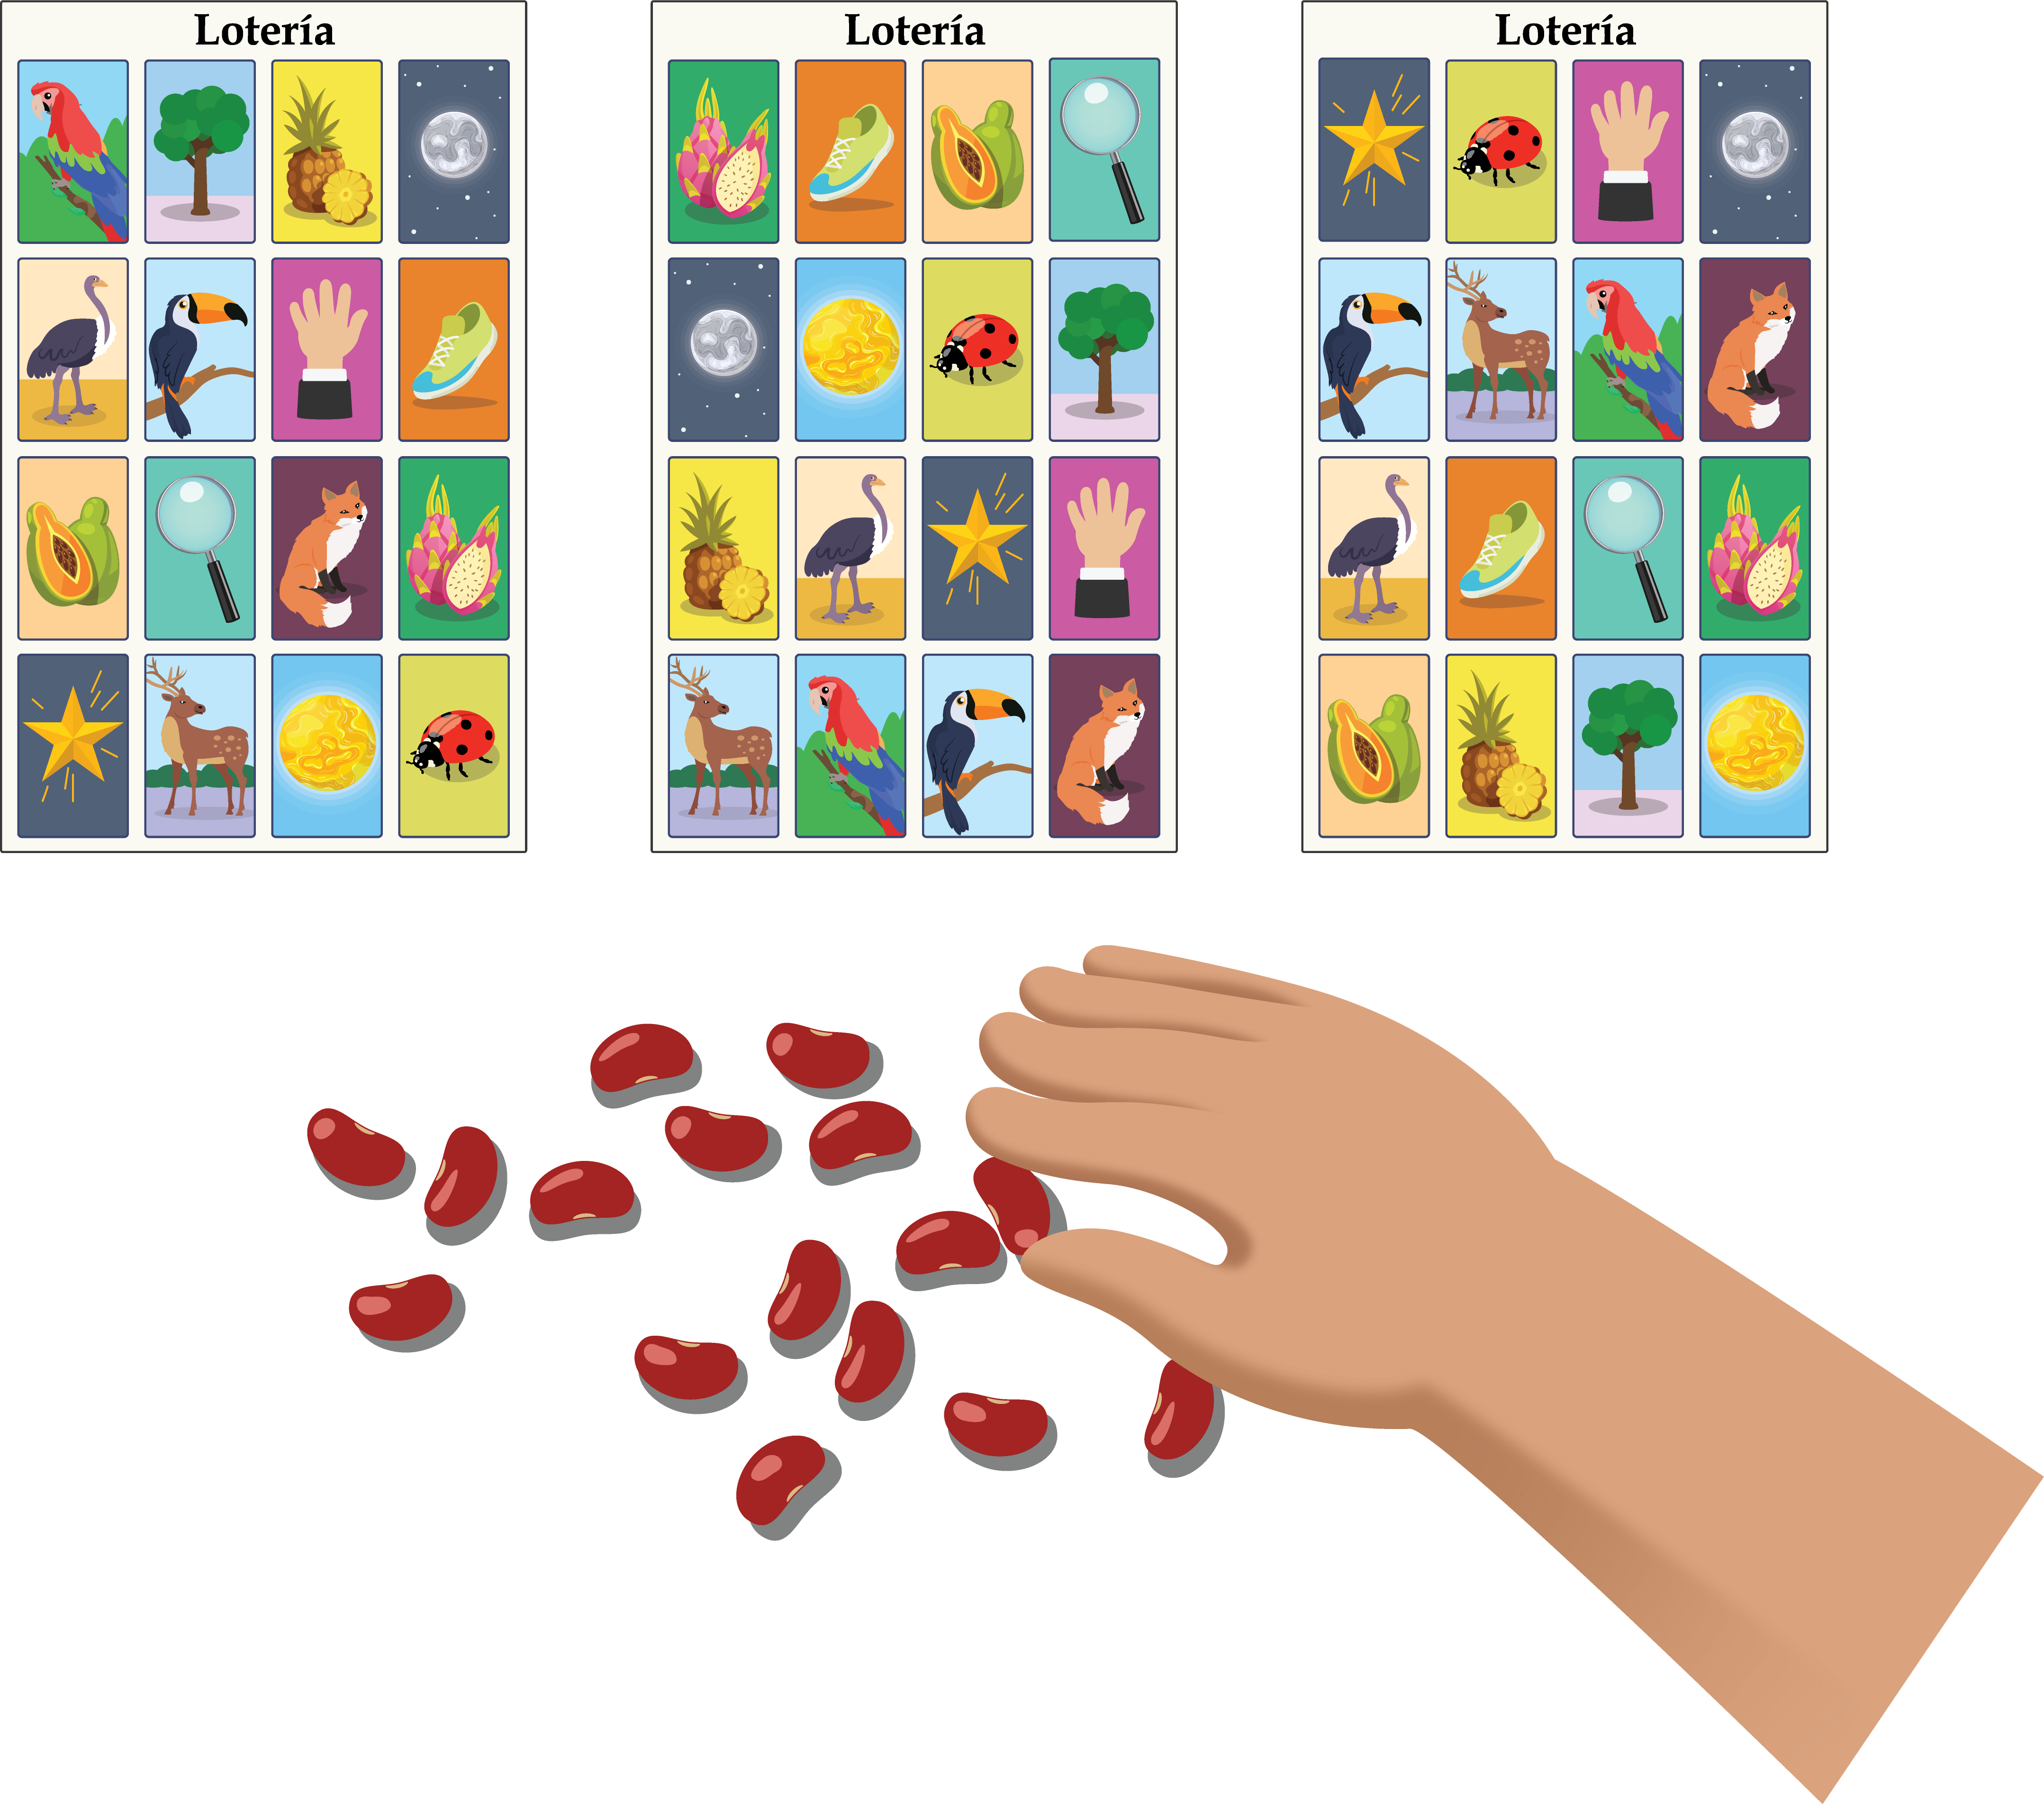
- 10 students are playing Lotería.
Some students are using beans on their boards.
Some students are using small rocks.
What are some ways to show how many students are using beans and how many are using small rocks?
Show your thinking using drawings, numbers, or words.
- Equation: ________________________________
- Equation: ________________________________
- Noah has 3 pictures covered on his board.
His brother has 10 pictures covered.
How many fewer pictures does Noah have covered than his brother?
Show your thinking using drawings, numbers, or words.
- Equation: ________________________________
- Equation: ________________________________
- 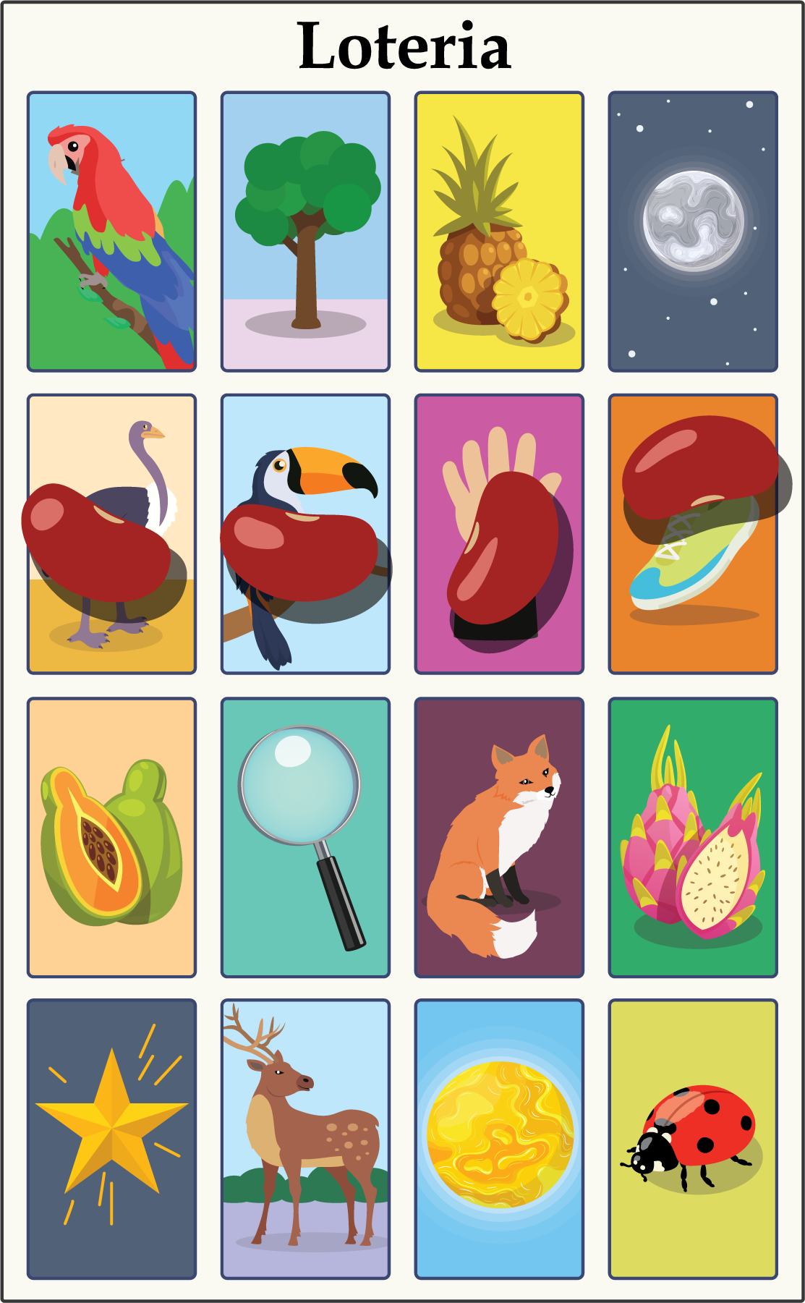

2 What's Your Question?

Student Task Statement
- Clare has 3 pictures covered on her board.
She covers some more.
Now she has 9 pictures covered.
- What is a question you can ask about the story?
- Show your thinking using drawings, numbers, or words.
- Which equation matches how you solved the story problem?
- 3+6=9
- 9−3=6
- Diego has 2 beans on his board.
Noah has 9 beans on his board.
- What is a question you can ask about the story?
- Show your thinking using drawings, numbers, or words.
- Which equation matches how you solved the story problem?
- 2+7=9
- 9−2=7
© CC BY 2021 Illustrative Mathematics®

