Grade 2
Unit 2Lesson 10CC BY NC 2024 Illustrative Mathematics®
Unit 2, Lesson 10

Center Day 2
- Let’s play games to practice adding and subtracting.
Grade 2
Unit 2Lesson 10CC BY NC 2024 Illustrative Mathematics®

Warm-upNotice and Wonder: Compare the Representations
What do you notice? What do you wonder?
- Unable to process <img src="/tikz_files/237845.svg">Failed: rsvg-convert --format png --dpi-x 300 --dpi-y 300 /app/tmp/svgtopng-1786380761.4702451.svg --output /app/tmp/svgtopng-1786380761.4702451.png Backtrace: /app/app/services/script/runner.rb:34:in `block in run_cmd' <internal:kernel>:90:in `tap' /app/app/services/script/runner.rb:32:in `run_cmd' /app/app/services/script/svg_to_png.rb:27:in `convert_svg_to_png' /app/app/services/script/svg_to_png.rb:17:in `to_png' /app/vendor/bundle/ruby/3.3.0/gems/embeddable_content-1.1.0/app/services/embeddable_content/images/image_downloader.rb:37:in `png_rendered_from_svg' /app/vendor/bundle/ruby/3.3.0/gems/embeddable_content-1.1.0/app/services/embeddable_content/images/image_downloader.rb:33:in `raw_image_data' /app/vendor/bundle/ruby/3.3.0/gems/embeddable_content-1.1.0/app/services/embeddable_content/images/image_downloader.rb:13:in `block in save' <internal:kernel>:90:in `tap' /app/vendor/bundle/ruby/3.3.0/gems/embeddable_content-1.1.0/app/services/embeddable_content/images/image_downloader.rb:13:in `save'

- $66−28$
$66=50+16$
$16−8=8$
$50−20=30$
$30+8=38$
$66−28=38$
Grade 2
Unit 2Lesson 10CC BY NC 2024 Illustrative Mathematics®

Activity 2Centers: Choice Time
Choose a center.
Target Numbers
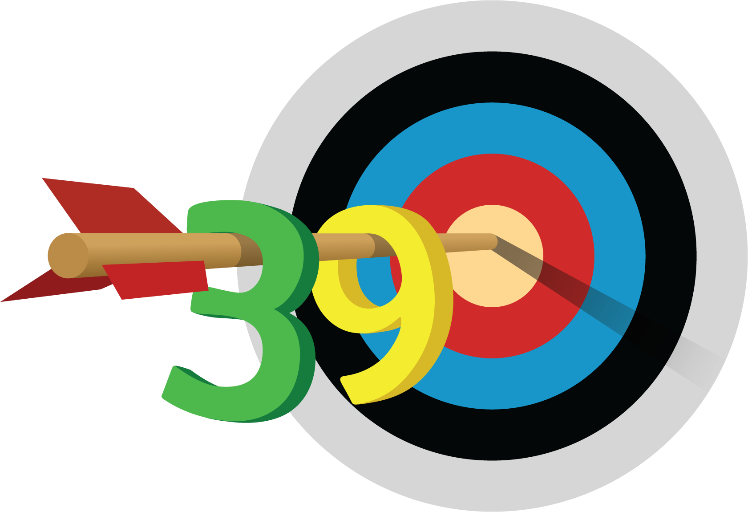
Capture Squares
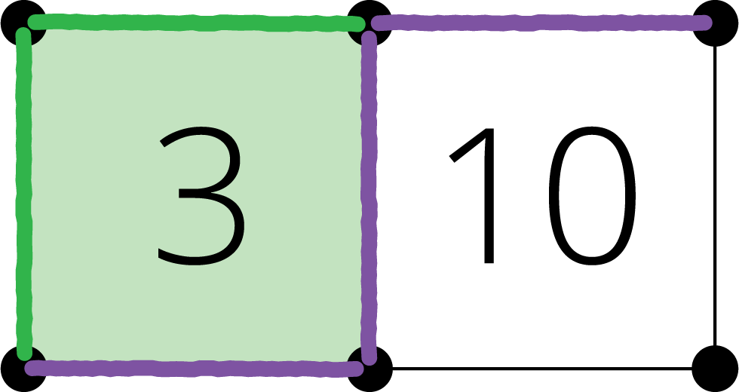
Five in a Row
