Lesson 16 Practice Problems
- Which equation can be represented by a graph with a vertex at $\left(1,3\right)$?
  - $y={\left(x−1\right)}^{2}+3$
  - $y={\left(x+1\right)}^{2}+3$
  - $y={\left(x−3\right)}^{2}+1$
  - $y={\left(x+3\right)}^{2}+1$

  - Where is the vertex of the graph that represents $y={\left(x−2\right)}^{2}−8$?
  - Where is the $y$-intercept? Explain how you know.
  - Identify one other point on the graph of the equation. Explain or show how you know.
  - Sketch a graph that represents the equation.
  - 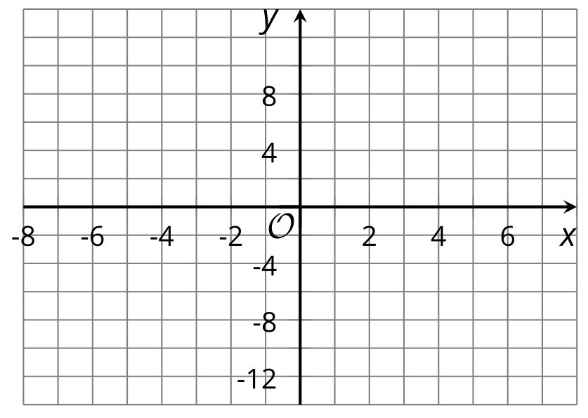

- The function $v$ is defined by $v\left(x\right)=\frac{1}{2}{\left(x+5\right)}^{2}−7$.
- Without graphing, determine if the vertex of the graph representing $v$ shows the minimum or maximum value of the function. Explain how you know.
- Match each graph to an equation that represents it.
- 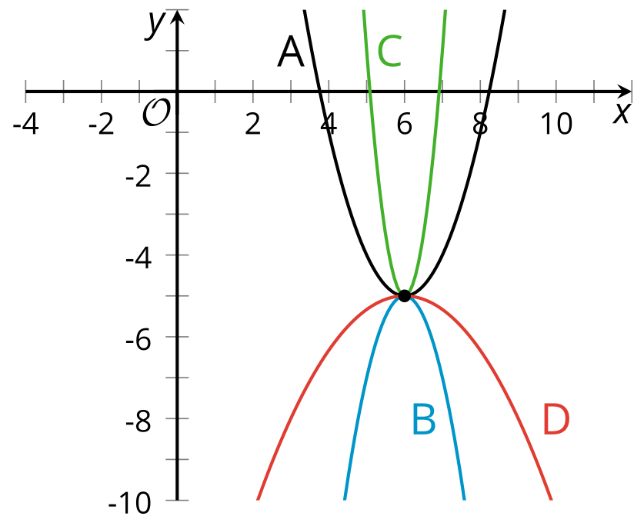
  - Graph A
  - Graph B
  - Graph C
  - Graph D
  - $y=\text{-}2{\left(x−6\right)}^{2}−5$
  - $y={\left(x−6\right)}^{2}−5$
  - $y=6{\left(x−6\right)}^{2}−5$
  - $y=\text{-}\frac{1}{3}{\left(x−6\right)}^{2}−5$
- Here is a graph that represents $y=x^{2}$.
  - Describe what would happen to the graph if the original equation was changed to:
    - $y=\frac{1}{2}x^{2}$
    - $y=x^{2}−8$
  - 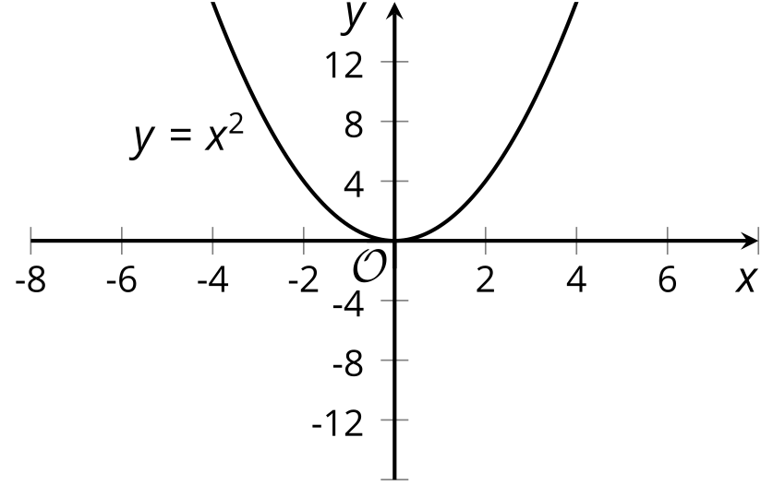
  - Graph the equation $y=\frac{1}{2}x^{2}−8$ on the same coordinate plane as $y=x^{2}$.
- (From Unit 6, Lesson 12.)
- Clare throws a rock into the lake. The graph shows the rock's height above the water, in feet, as a function of time in seconds.
- Select all the statements that describe this situation.
- 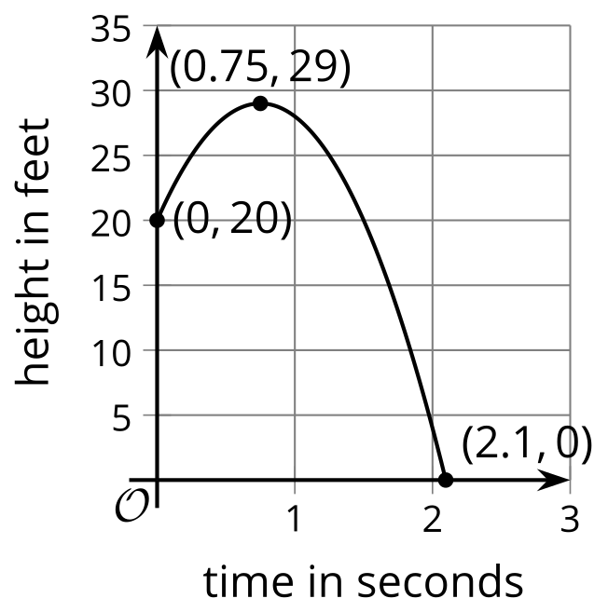
  - The vertex of the graph is $\left(0.75,29\right)$.
  - The $y$-intercept of the graph is $\left(2.1,0\right)$.
  - Clare just dropped the rock into the lake.
  - The maximum height of the rock is about 20 feet.
  - The rock hits the surface of the water after about 2.1 seconds.
  - Clare tossed the rock up into the air from a point 20 feet above the water.
- (From Unit 6, Lesson 14.)
- Technology required. Two objects are launched into the air.
  - The height, in feet, of Object A is given by the equation $f\left(t\right)=4+32t−16t^{2}$.
  - The height, in feet, of the Object B is given by the equation $g\left(t\right)=2.5+40t−16t^{2}$. In both functions, $t$ is seconds after launch.
- Use technology to graph each function in the same graphing window.
  - What is the maximum height of each object?
  - Which object hits the ground first? Explain how you know.
- (From Unit 6, Lesson 14.)
- Andre thinks the vertex of the graph of the equation $y={\left(x+2\right)}^{2}−3$ is $\left(2,\text{-}3\right)$. Lin thinks the vertex is $\left(\text{-}2,3\right)$. Do you agree with either of them?
- (From Unit 6, Lesson 15.)
- The expression $2,​000⋅{\left({1.015}^{12}\right)}^{5}$ represents the balance, in dollars, in a savings account.
  - Using the expression, describe the interest rate paid on the account.
  - How many years has the account been accruing interest?
  - How much money was invested?
  - How much money is in the account now?
  - Write an equivalent expression to represent the balance in the savings account.
- (From Unit 5, Lesson 17.)
© CC BY 2019 by Illustrative Mathematics®

