Grade 2
Unit 6Lesson 7CC BY NC 2024 Illustrative Mathematics®
Unit 6, Lesson 7

Make Halves, Thirds, and Fourths
- Let’s make halves, thirds, and fourths (or quarters).
Grade 2
Unit 6Lesson 7CC BY NC 2024 Illustrative Mathematics®

Warm-upWhich Three Go Together: Compare Equal-Size Pieces
Which 3 go together?
A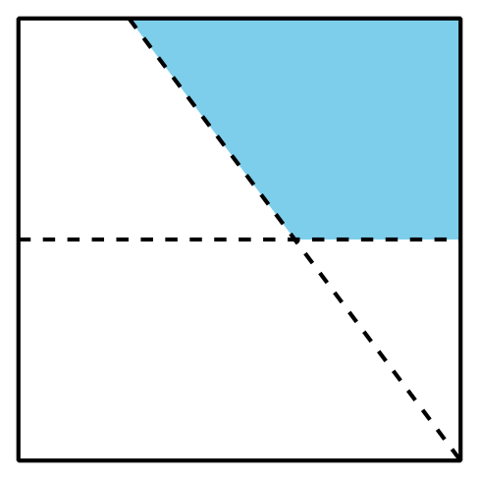

B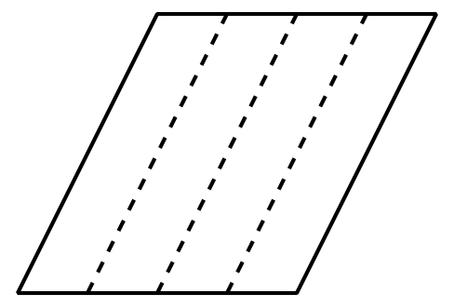
C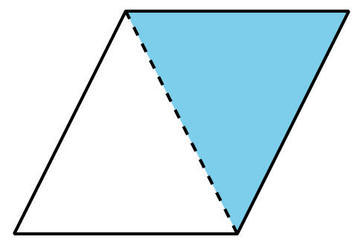
D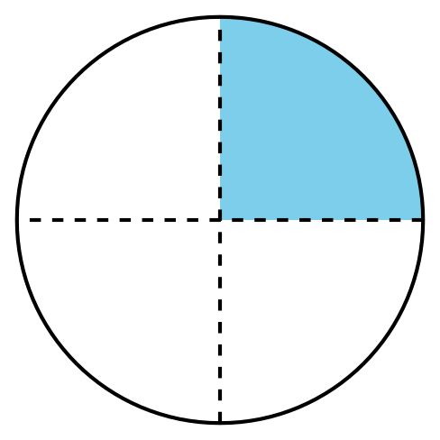
Grade 2
Unit 6Lesson 7CC BY NC 2024 Illustrative Mathematics®

Activity 1 Fold Equal-Size Pieces
- Fold the rectangle to make 2 equal-size pieces. Cut them out.
- Each piece is called a ____________________________.
- Compare with your partner. Tell them how you know the pieces are equal.
- Fold the rectangle to make 4 equal-size pieces. Cut them out.
- Each piece is called a ____________________________.
- Compare with your partner. Tell them how you know the pieces are equal.
- Fold the rectangle to make 3 equal-size pieces. Cut them out.
- Each piece is called a ____________________________.
- Compare with your partner. Tell them how you know the pieces are equal.
Grade 2
Unit 6Lesson 7CC BY NC 2024 Illustrative Mathematics®

Activity 2 That’s Not It
- Noah looks for examples of circles partitioned into halves, thirds, or fourths.
  - Put an X on the 2 circles in each row that are not examples.
  - halves
  - 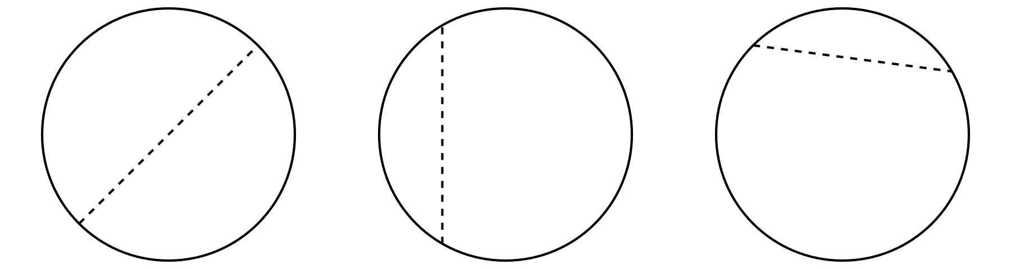
  - fourths
  - 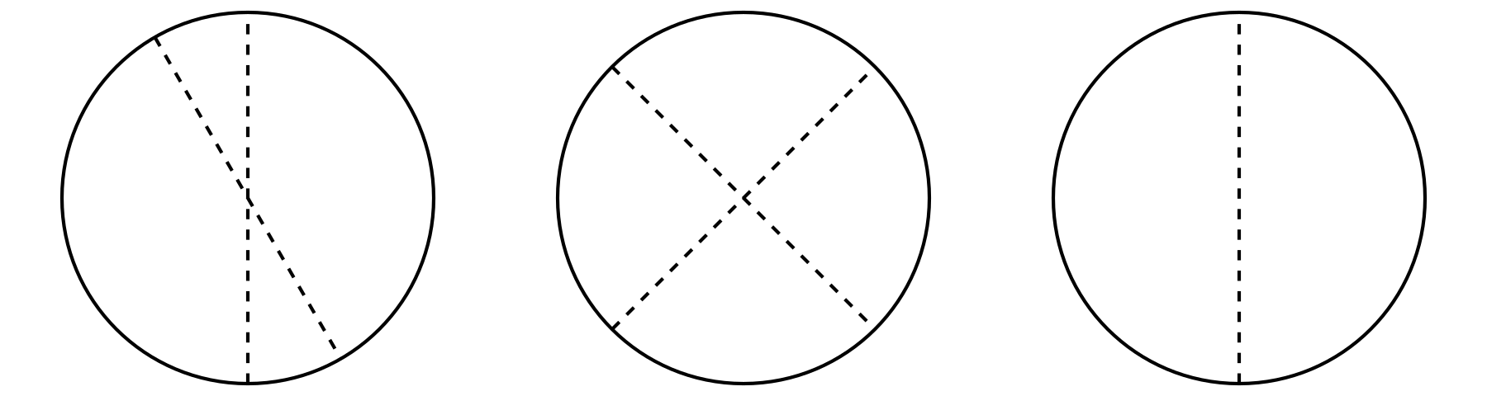
  - thirds
  - 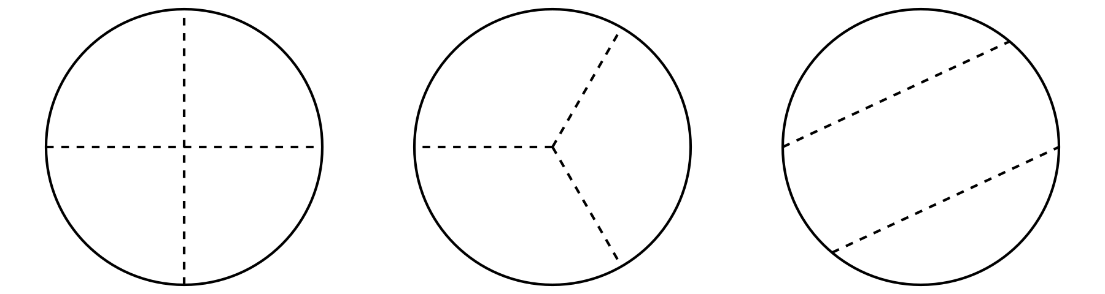
  - Why are the shapes you marked not examples of halves, fourth, or thirds? Explain your reasoning to your partner.
- Partition this circle into thirds.
- 