Lesson 7: Answer Questions about Scaled Bar Graphs
- Let’s solve problems based on data represented in bar graphs.

Warm-up: How Many Do You See: Groups of Dots
How many do you see? How do you see them?

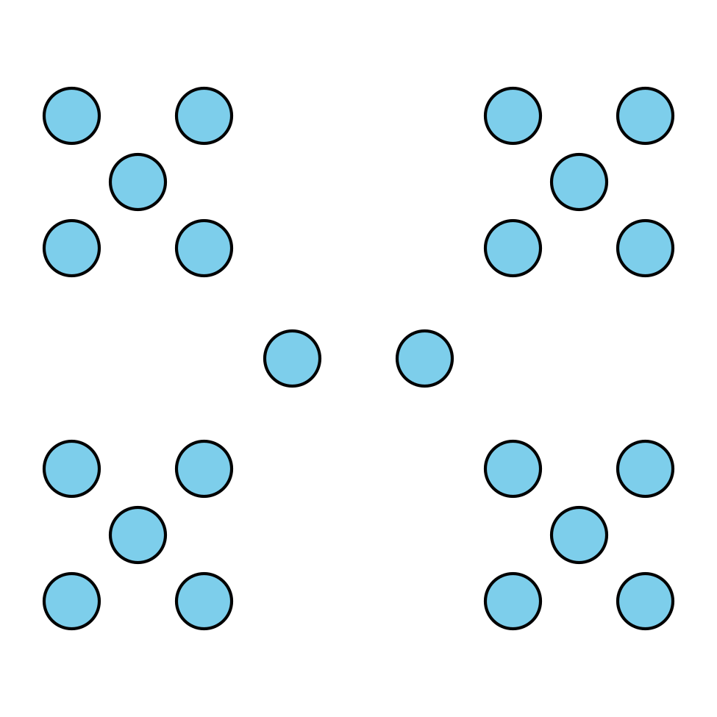

7.1: Questions about Favorite Time of the Year
Use your Favorite Time of the Year graph to answer the questions. Show your thinking using expressions or equations.
- How many students are represented in the graph?
- How many students chose spring or fall as their favorite season?
- How many more students chose summer than winter?
- How many fewer students chose spring than fall?

7.2: Questions About Bugs in the Garden
Data was collected to see how many of each type of bug were in a garden. The data is shown in this bar graph:
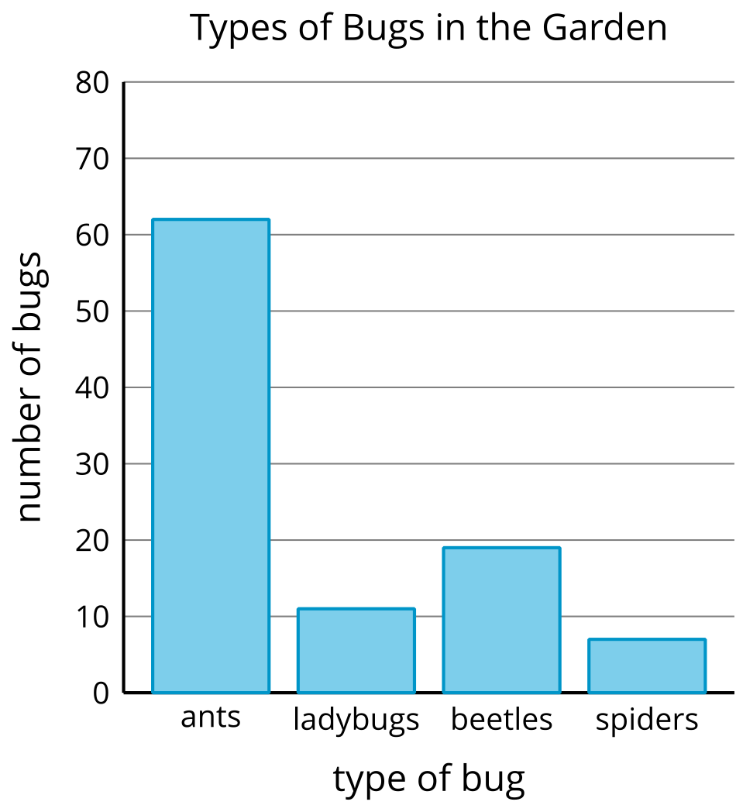
Use the bar graph to answer the questions. Show your thinking using expressions or equations.
- How many bugs were in the garden?
- How many more ants were in the garden than spiders?
- How many fewer ladybugs were there than ants?
- Work with your partner to write 2 questions that could be asked about the bugs in the garden.
- Trade with another group and answer each others’ questions.

© CC BY 2021 Illustrative Mathematics®

