Grade 6
Unit 4Lesson 17CC BY NC Illustrative Mathematics, based on IM 6–8 Math, CC BY Open Up Resources.
Unit 4, Lesson 17

Fitting Boxes into Boxes
Let’s use what we learned about fractions to find shipping costs.
Grade 6
Unit 4Lesson 17CC BY NC Illustrative Mathematics, based on IM 6–8 Math, CC BY Open Up Resources.

17.1What Do We Need to Know and Do?
An artist makes necklaces. She packs each necklace in a small gift box that is $1\frac{3}{4}$ inches by $2\frac{1}{4}$ inches by $\frac{3}{4}$ inch.
A department store ordered 270 necklaces. The artist plans to ship the necklaces to the store using flat-rate shipping boxes from the post office. She wants to know which boxes to use to minimize her shipping cost.
- What information would she need to find out?
- How would you use this information to find the most inexpensive way to ship the necklaces? With your group, make a plan and write down the main steps.
Grade 6
Unit 4Lesson 17CC BY NC Illustrative Mathematics, based on IM 6–8 Math, CC BY Open Up Resources.

17.2How Many Shipping Boxes?
Work with your group to find out how many shipping boxes are needed to ship 270 necklaces. Each group member should select a different type of flat-rate shipping box to investigate.
For each type of shipping box:
- Find how many gift boxes can be packed in it. Explain or show your reasoning. Draw a sketch, if needed.
- Find out how many shipping boxes are needed to fit 270 gift boxes.
Show your reasoning and organize it so that it can be followed by others.
Record the size, measurements, and cost of the shipping box that you are investigating.
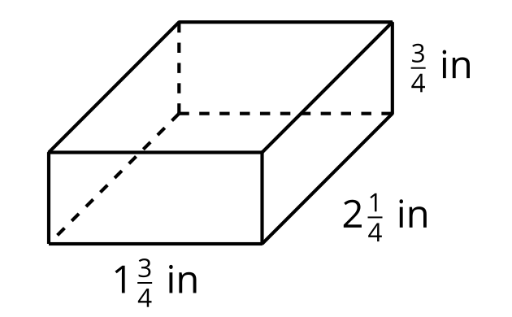
box size | measurements | cost
Grade 6
Unit 4Lesson 17CC BY NC Illustrative Mathematics, based on IM 6–8 Math, CC BY Open Up Resources.

17.3How Much Would It Cost to Ship?
Work with your group to find the best plan for shipping the boxes of necklaces.
- For each size of shipping box and based on your work earlier, record the number of boxes needed to ship all 270 necklaces. You can also include an option that involves using shipping boxes in two different sizes and record that information in the last row.
- Calculate the total cost of shipping for each box size or a combination of sizes. Show your reasoning.
- Decide which shipping boxes the artist should use. Be prepared to explain your reasoning.
box size | gift boxes that can fit | shipping boxes needed | cost per box | total cost

