Grade 6
Unit 1Lesson 19CC BY NC Illustrative Mathematics, based on IM 6–8 Math, CC BY Open Up Resources.
Unit 1, Lesson 19

All about Tents
Let’s find out how much material is needed to build some tents.
Grade 6
Unit 1Lesson 19CC BY NC Illustrative Mathematics, based on IM 6–8 Math, CC BY Open Up Resources.

19.1Notice and Wonder: Structures
What do you notice? What do you wonder?
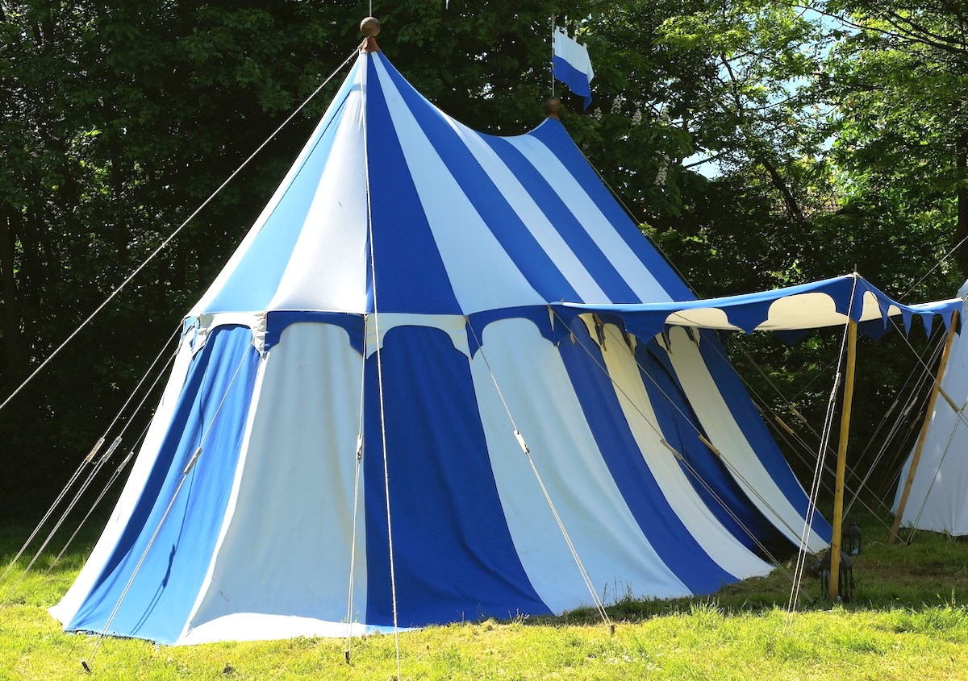
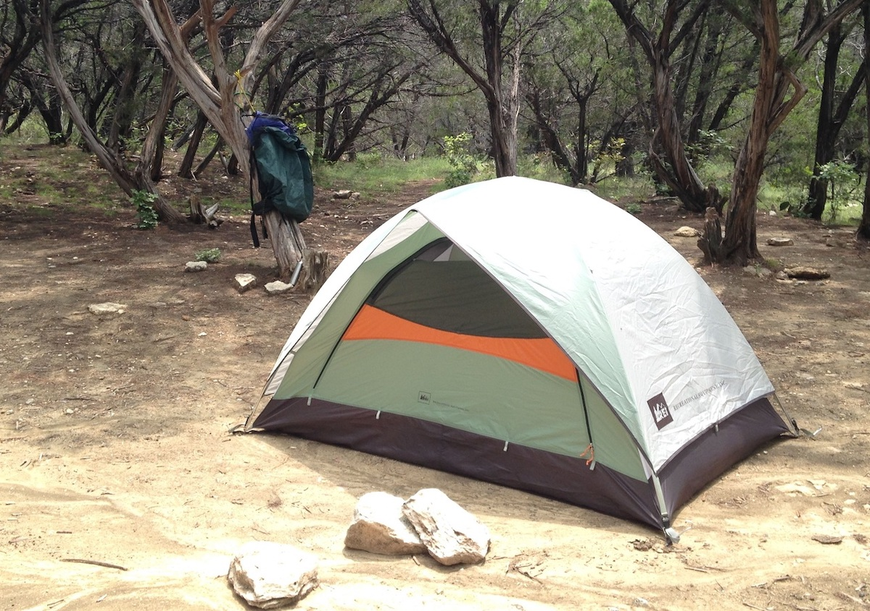
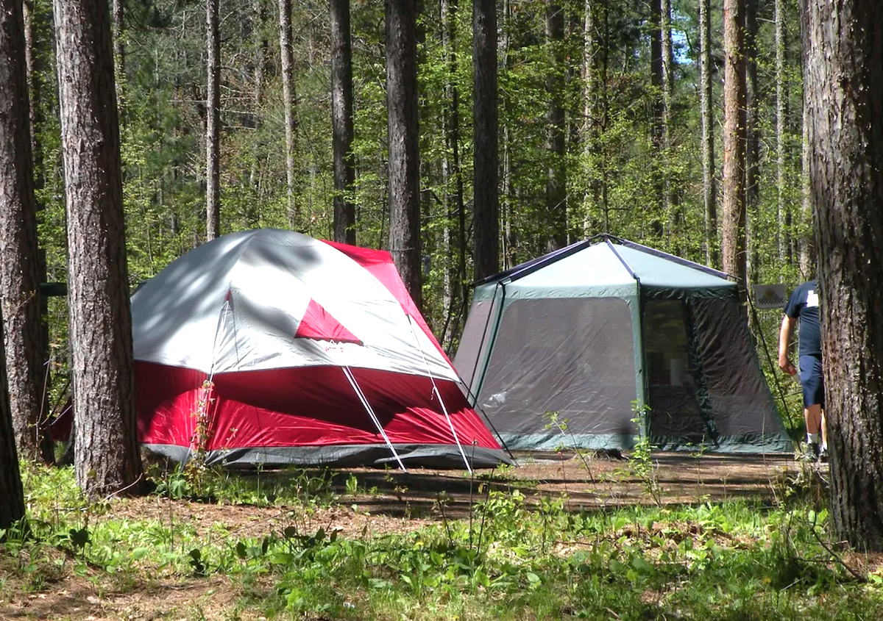
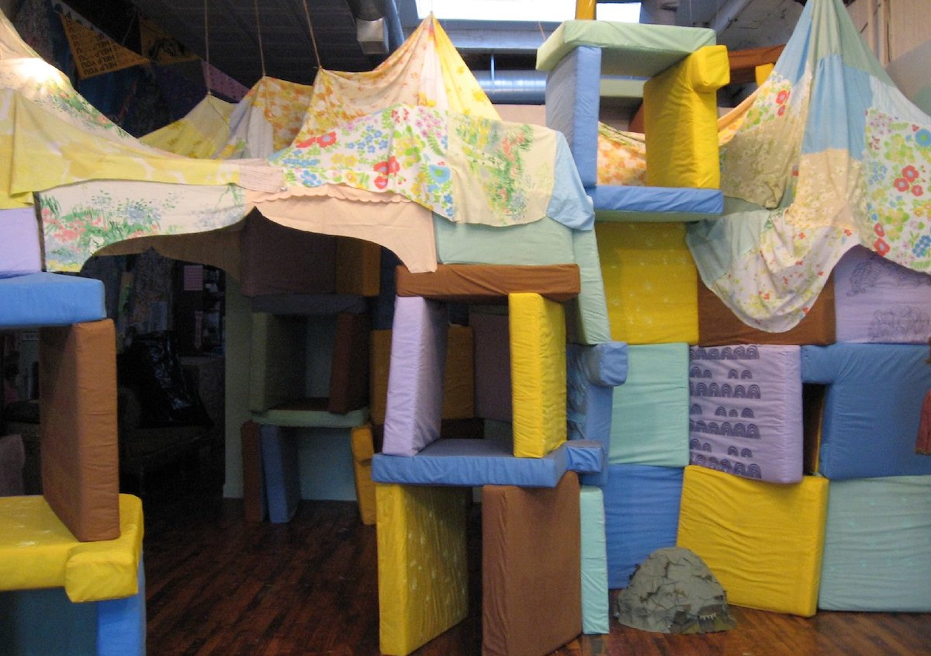
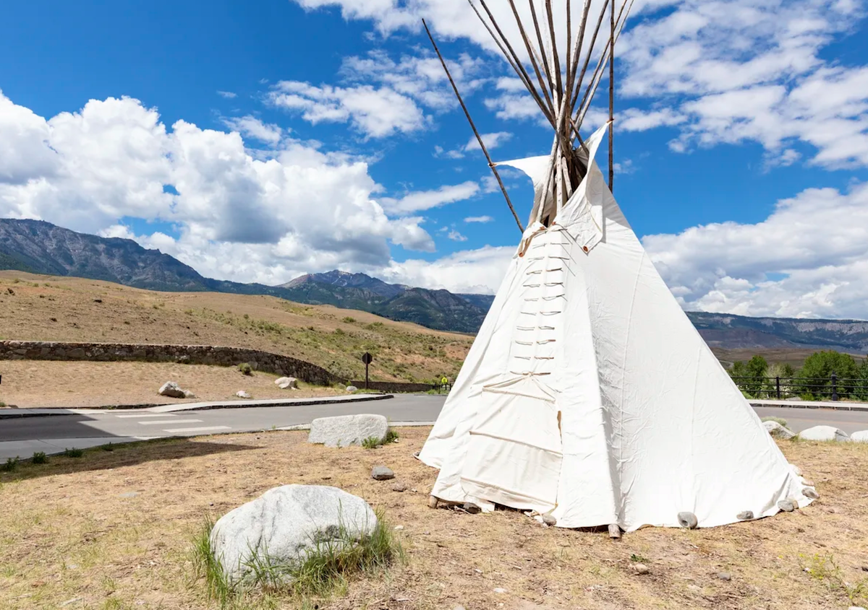
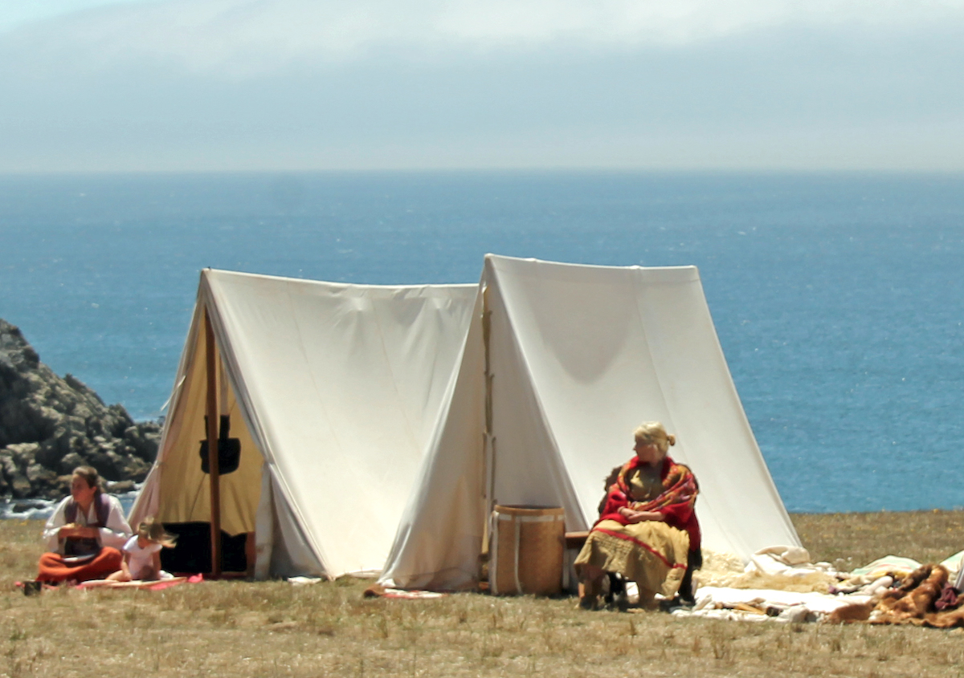
​​​​​​
Grade 6
Unit 1Lesson 19CC BY NC Illustrative Mathematics, based on IM 6–8 Math, CC BY Open Up Resources.

19.2Two Tents
Here is an image of two tents.
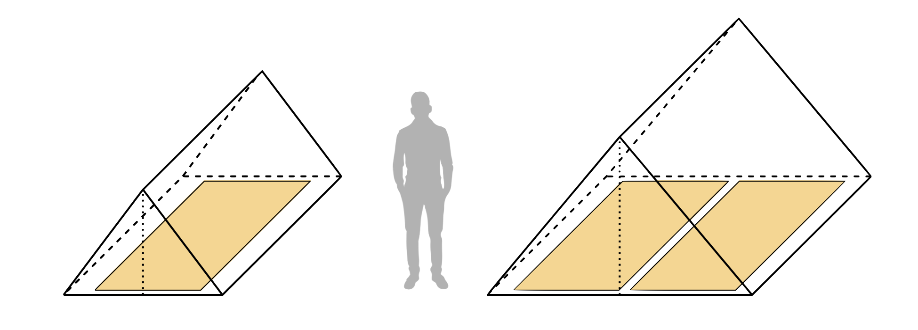
- Record the question that your class is answering.
- What do you need to know to be able to answer the question? List the information that you need.
- Use the information that you received to answer the question. Show your reasoning, including any assumptions that you make about the situation. Organize your work so that it can be followed by others.
Grade 6
Unit 1Lesson 19CC BY NC Illustrative Mathematics, based on IM 6–8 Math, CC BY Open Up Resources.

19.3Tent Design (Part 1)
You are going to design a tent for 4 people. Your design must:
- Include a floor panel.
- Show how the sleeping bags fit inside.
- Be tall enough that people can at least kneel inside the tent.
After creating a design, you will estimate the amount of material needed to build it and show your reasoning.
Sample Tent Styles
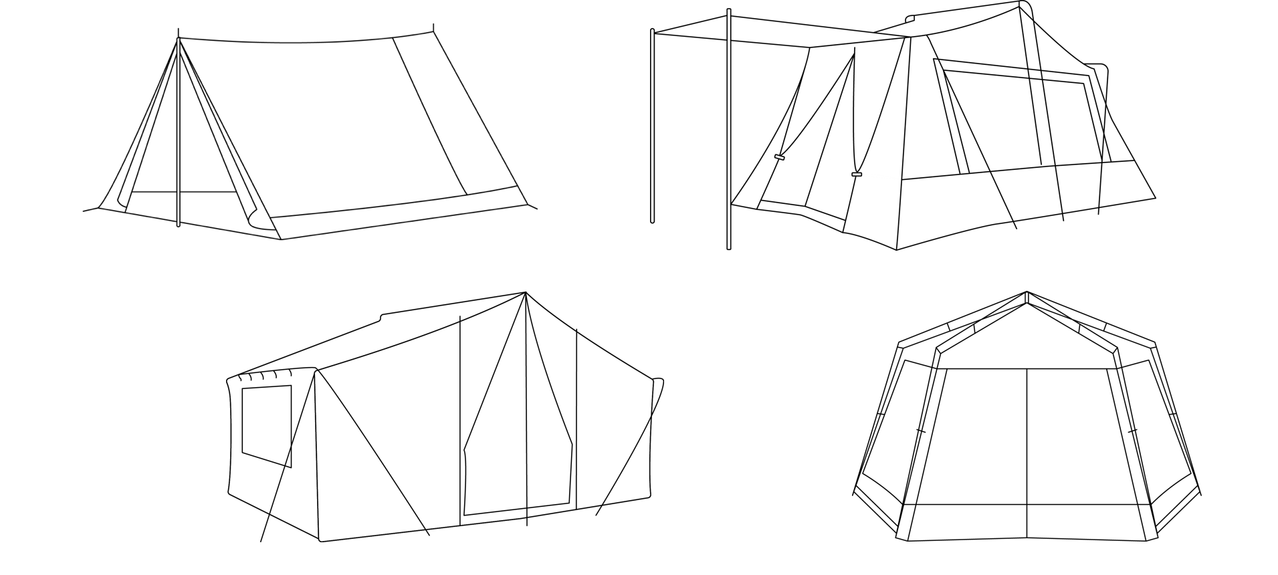
Tent Height Specifications
height  description | height  of tent | notes
sitting height | 3 feet | Campers are able to sit, lie, or crawl inside tent.
kneeling height | 4 feet | Campers are able to kneel inside tent. Found mainly in 3–4 person tents.
stooping height | 5 feet | Campers are able to move around on their feet inside tent, but most campers will not be able to stand upright.
standing height | 6 feet | Most adult campers are able to stand upright inside tent.
wheelchair seating height | 4.5 feet | Most campers in a wheelchair have enough head clearance.
roaming height | 7 feet | Adult campers are able to stand upright and walk around inside tent.
Sleeping Bag Measurements
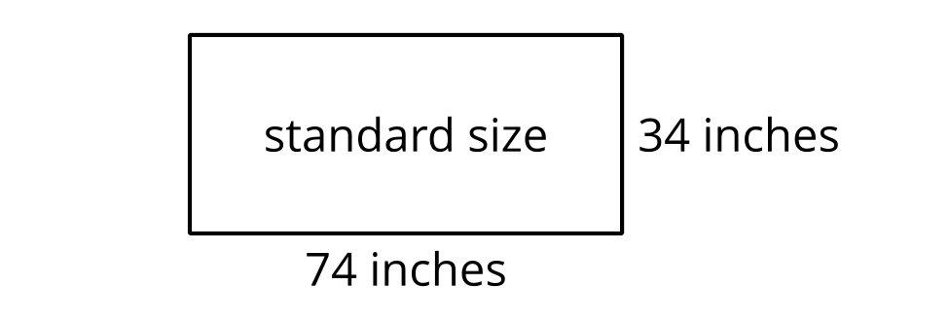
- Create your design.
  - Tent floor: Sketch the shape of the floor panel and the placements of sleeping bags. Think about approximate measurements. How large is this floor panel?
  - Relevant information: What decisions did you make for your tent? What assumptions did you make?
  - Overall design: Sketch what the tent would look like. Think about approximate measurements. How high is the tallest point of your tent?
- Estimate the amount of material needed to build your tent. Your estimate must:
  - Be based on measurements you researched or received.
  - Include sketches that show the parts of the tent and their measurements.
  - Be supported by calculations.
- Organize your work so it can be followed by others. You can use additional paper if you need more space.
Grade 6
Unit 1Lesson 19CC BY NC Illustrative Mathematics, based on IM 6–8 Math, CC BY Open Up Resources.

19.4Tent Design (Part 2)
- Explain your tent design and material estimate to your group. Be sure to explain why you chose this design and how you found your material estimate.
- Compare the estimated material necessary for each tent in your group. Discuss the following questions:
  - Which tent design used the least material? Why?
  - Which tent design used the most material? Why?

