Grade 2
Unit 3Lesson 14CC BY NC 2024 Illustrative Mathematics®
Unit 3, Lesson 14

What Is a Line Plot?
- Let’s learn a new way to represent data.
Grade 2
Unit 3Lesson 14CC BY NC 2024 Illustrative Mathematics®

Warm-upNotice and Wonder: “Handy” Graphs
What do you notice? What do you wonder?
Unable to process <img src="/tikz_files/238109.svg">Failed: rsvg-convert --format png --dpi-x 300 --dpi-y 300 /app/tmp/svgtopng-1786380856.2907927.svg --output /app/tmp/svgtopng-1786380856.2907927.png Backtrace: /app/app/services/script/runner.rb:34:in `block in run_cmd' <internal:kernel>:90:in `tap' /app/app/services/script/runner.rb:32:in `run_cmd' /app/app/services/script/svg_to_png.rb:27:in `convert_svg_to_png' /app/app/services/script/svg_to_png.rb:17:in `to_png' /app/vendor/bundle/ruby/3.3.0/gems/embeddable_content-1.1.0/app/services/embeddable_content/images/image_downloader.rb:37:in `png_rendered_from_svg' /app/vendor/bundle/ruby/3.3.0/gems/embeddable_content-1.1.0/app/services/embeddable_content/images/image_downloader.rb:33:in `raw_image_data' /app/vendor/bundle/ruby/3.3.0/gems/embeddable_content-1.1.0/app/services/embeddable_content/images/image_downloader.rb:13:in `block in save' <internal:kernel>:90:in `tap' /app/vendor/bundle/ruby/3.3.0/gems/embeddable_content-1.1.0/app/services/embeddable_content/images/image_downloader.rb:13:in `save'
Unable to process <img src="/tikz_files/254179.svg">Failed: rsvg-convert --format png --dpi-x 300 --dpi-y 300 /app/tmp/svgtopng-1786380856.3518202.svg --output /app/tmp/svgtopng-1786380856.3518202.png Backtrace: /app/app/services/script/runner.rb:34:in `block in run_cmd' <internal:kernel>:90:in `tap' /app/app/services/script/runner.rb:32:in `run_cmd' /app/app/services/script/svg_to_png.rb:27:in `convert_svg_to_png' /app/app/services/script/svg_to_png.rb:17:in `to_png' /app/vendor/bundle/ruby/3.3.0/gems/embeddable_content-1.1.0/app/services/embeddable_content/images/image_downloader.rb:37:in `png_rendered_from_svg' /app/vendor/bundle/ruby/3.3.0/gems/embeddable_content-1.1.0/app/services/embeddable_content/images/image_downloader.rb:33:in `raw_image_data' /app/vendor/bundle/ruby/3.3.0/gems/embeddable_content-1.1.0/app/services/embeddable_content/images/image_downloader.rb:13:in `block in save' <internal:kernel>:90:in `tap' /app/vendor/bundle/ruby/3.3.0/gems/embeddable_content-1.1.0/app/services/embeddable_content/images/image_downloader.rb:13:in `save'
Grade 2
Unit 3Lesson 14CC BY NC 2024 Illustrative Mathematics®

Activity 1Measure Our Hand Spans
- Trace your hand. (Spread your fingers wide.)
- Draw a line from your thumb to your pinky. This line represents your hand span. Measure the length of your hand span in inches.
- My hand span is ____________ inches.
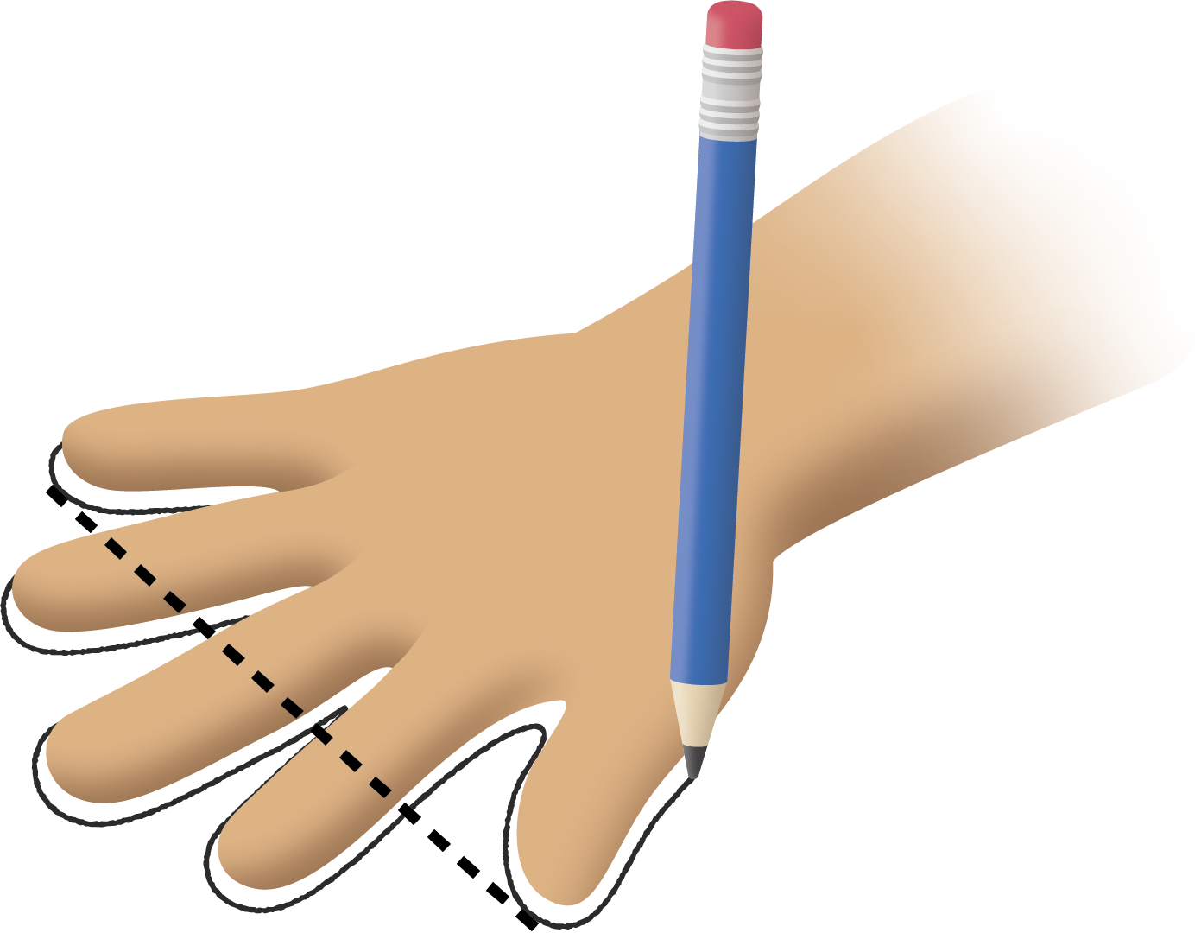
Grade 2
Unit 3Lesson 14CC BY NC 2024 Illustrative Mathematics®

Activity 2Interpret Our Numerical Data
- What is the longest hand span in your class?
- What is the shortest hand span?
- Write another statement about the hand spans using the line plot.

