Lesson 2: Relate Addition and Subtraction
- Let’s look at the relationship between addition and subtraction.

Warm-up: Number Talk: Connect Addition and Subtraction
Find the value of each expression mentally.
- $5+4$
- $4+5$
- $9−4$
- $9−5$

2.1: Cube Tower Addition and Subtraction
Write an addition and a subtraction equation to match the connecting cubes.

- 

- 

- 

- 

- 

2.2: Find the Unknown Number
Find the number that makes each equation true.
Explain to your partner how you found it.
- 4+aaaiaaai=9
- 9−5=aaaiaaai
- aaaiaaai+5=8
- 8−3=aaaiaaai
- 7−4=aaaiaaai
- 8=2+aaaiaaai
- 8−aaaiaaai=4

2.3: Differences I've Got
Color the differences you know the value of from memory.
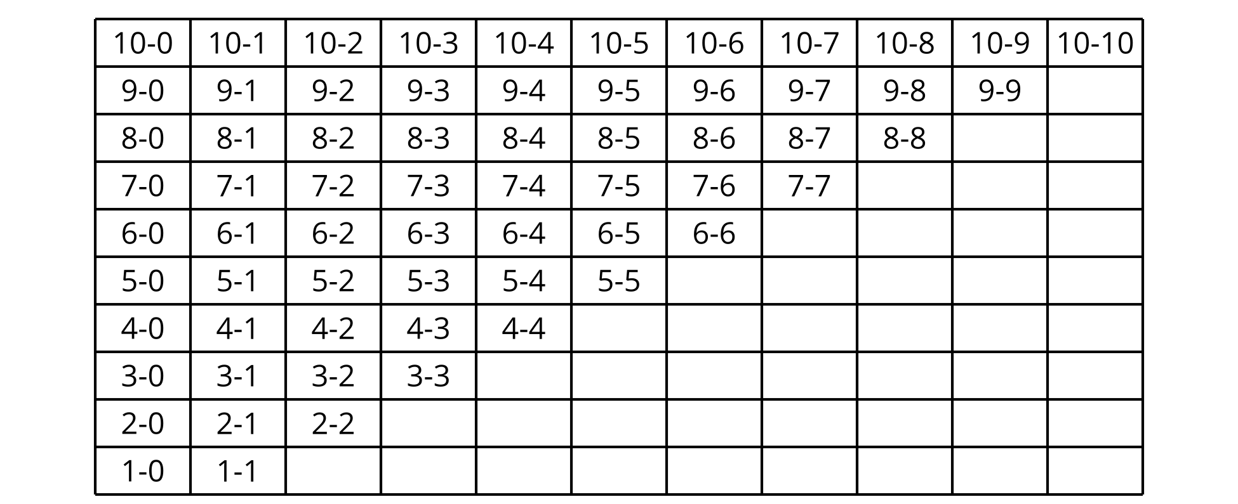
Write each difference that is not colored, on an index card.
Write an addition equation on the card that can help you find the value of the difference.
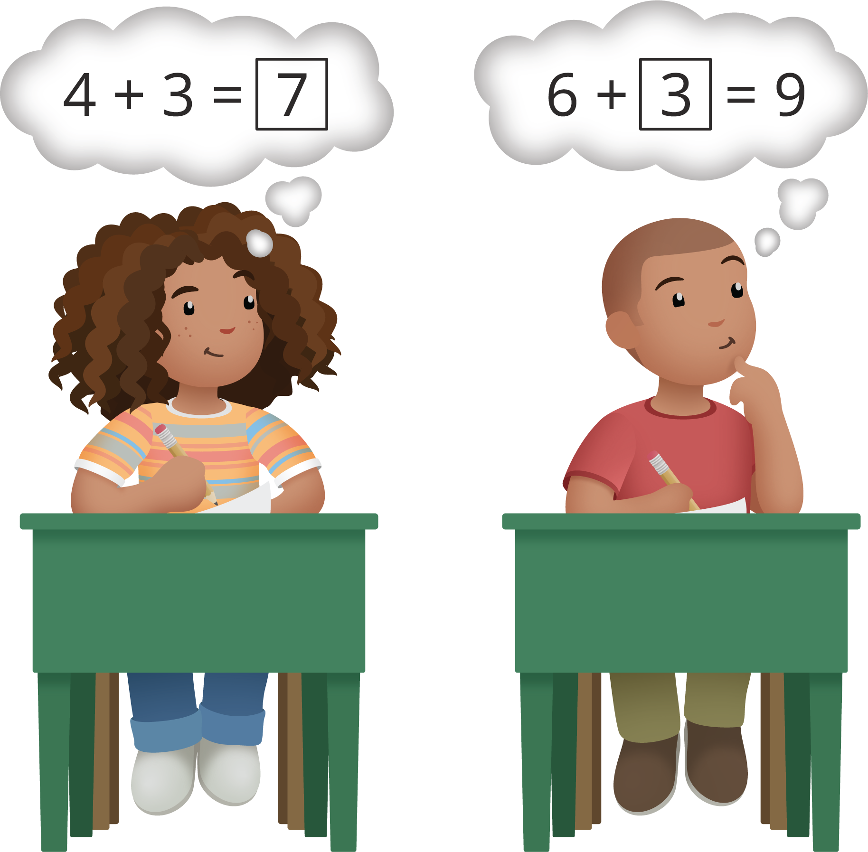
© CC BY 2021 Illustrative Mathematics®

