Lesson 16: Using Graphs and Logarithms to Solve Problems (Part 2)
- Let’s compare exponential functions by studying their graphs.

16.1: Two Bank Accounts
A business owner opened two different types of investment accounts at the start of the year. The functions $f$ and $g$ represent the values of the two accounts as a function of the number of months after the accounts were opened.
- Here are some true statements about the investment accounts. What does each statement mean?
  - $f\left(3\right)>g\left(3\right)$
  - $f\left(6\right)<g\left(6\right)$
  - $f\left(m\right)=g\left(m\right)$
- If the two functions were graphed on the same coordinate plane, what might it look like? Sketch the two functions.

16.2: Bacteria in Different Conditions
To study the growth of bacteria in different conditions, a scientist measures the area, in square millimeters, occupied by two populations.
The growth of Population A, in square millimeters, can be modeled by $f\left(h\right)=24⋅e^{\left(0.4h\right)}$ where $h$ is the number of hours since the experiment began. The growth of Population B can be modeled by $g\left(h\right)=9⋅e^{\left(0.6h\right)}$. Here are the graphs representing the two populations.
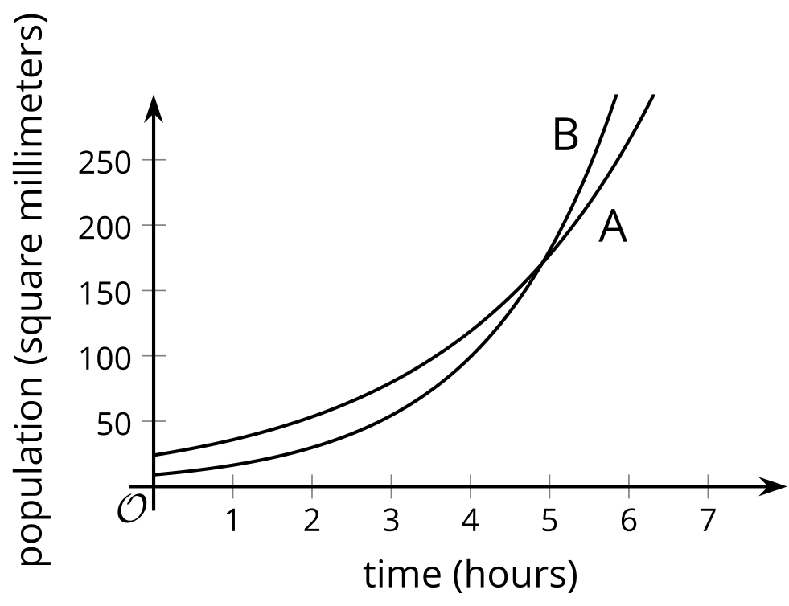
- In this situation, what does the point of intersection of the two graphs tell us?
- Suppose the population coordinate of the point of intersection is 171. Explain why we can find the corresponding time coordinate by:
  - solving $f\left(h\right)=171$ or $g\left(h\right)=171$
  - solving the equation $f\left(h\right)=g\left(h\right)$
- Solve either $f\left(h\right)=171$ or $g\left(h\right)=171$. Show your reasoning.
- Solve $f\left(h\right)=g\left(h\right)$. Show your reasoning.

Are you ready for more?
The functions $f$ and $g$ are given by $f\left(t\right)=10e^{0.5t}$ and $g\left(t\right)=8e^{0.4t}$.
- Is there any positive value of $t$ so that $f\left(t\right)=g\left(t\right)$? Explain how you know.
- When do $f$ and $g$ reach the value 1000?

16.3: Populations of Two Countries
The population, in millions, of Country C is given by the equation $f\left(t\right)=16⋅e^{\left(0.02t\right)}$. The population of Country D is given by $g\left(t\right)=17.5⋅e^{\left(0.025t\right)}$. In both equations, $t$ is the number of years since 1980.
- Will there be a time when the two populations are equal? Explain or show your reasoning.
- At some point in time, the population of Country C reached 30 million. When does this happen? Explain or show your reasoning.

Lesson 16 Summary
Graphs representing functions can help us visualize how two or more quantities are changing in a situation. Let’s consider the populations of two colonies of ants.
The population, in thousands, of a colony of carpenter ants and a colony of red wood ants can be modeled with functions $c\left(x\right)=8.1⋅e^{\left(0.03x\right)}$ and $r\left(x\right)=5.4⋅e^{\left(0.05x\right)}$, respectively. Here, $x$ is the time in months after the colonies were first studied.
From the equations, we can tell which colony had a greater initial population (carpenter ants, 8.1 thousand) and which had a greater growth factor (red wood ants, $e^{\left(0.05\right)}$). Will the colony of red wood ants eventually exceed that of the carpenter ants? If so, when might it happen? Graphs representing $y=c\left(x\right)$ and $y=r\left(x\right)$ can help us answer these questions.
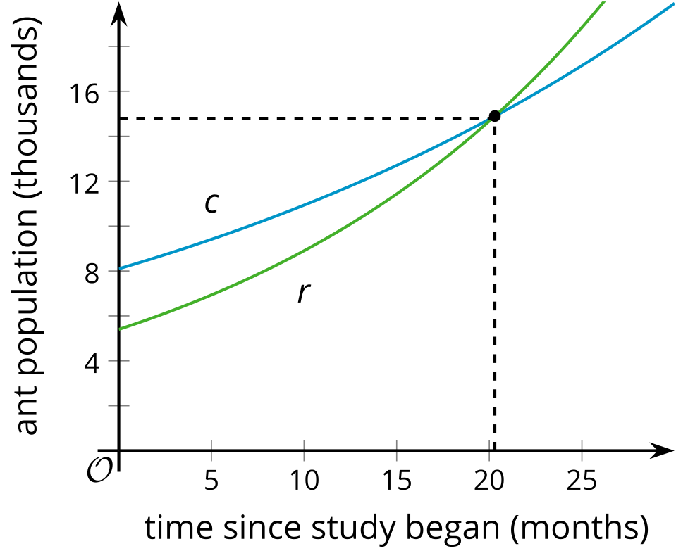
The intersection of the graphs tells us that about 20 months after the study began, the two colonies have the same population, about 15 thousand. After that point, the population of red wood ants is greater than that of carpenter ants. To find out more exactly when the two colonies have the same population, we can use graphing technology to find the coordinates of the intersection point more precisely.
Another way to find the point of intersection is using the equations for the functions. At the point of intersection of the graphs, the two functions have the same $y$-value, so we can write the equation $8.1⋅e^{\left(0.03x\right)}=5.4⋅e^{\left(0.05x\right)}$. Then we can solve this equation:
$\begin{matrix}8.1⋅e^{\left(0.03x\right)} & =5.4⋅e^{\left(0.05x\right)} \\ \frac{8.1}{5.4} & =\frac{e^{\left(0.05x\right)}}{e^{\left(0.03x\right)}} \\ 1.5 & =e^{\left(0.02x\right)} \\ ln\left(1.5\right) & =0.02x \\ \frac{0.405}{0.02} & ≈x \\ 20.3 & ≈x\end{matrix}$
This solution means that about 20.3 months after the study began, the two colonies have the same population.
© CC BY 2019 by Illustrative Mathematics®

